Honor the Heritage
Aligned to the following standards:
AG2: AG5; FFA.PL-A; FFA.PL-C; FFA.PL_E; FFA.PL-F; FFA.PG-I; FFA.CS-N; FFA.CS-P; CS.02; CS.05; CCSS.RI.9-10.2; CCSS.RI.9-10.3; CCSS.W.9-10.4; CCSS.L.9-10.6; CRP.04; CRP.05; CRP.06
Part 1
Directions:
Read the article “Honor the Heritage” in the fall 2021 issue of FFA New Horizons and complete the following activities.
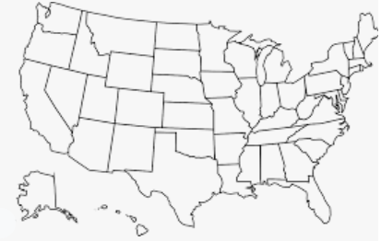
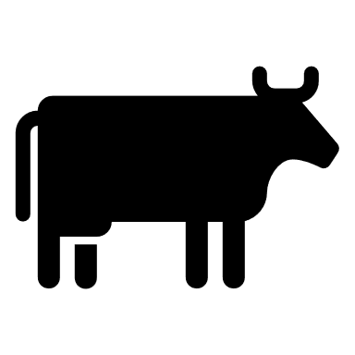
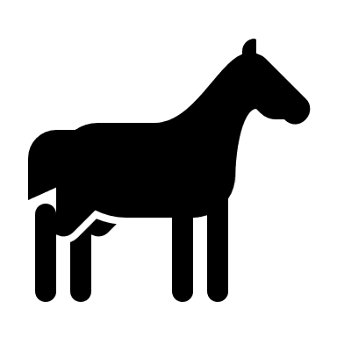
Place a on the two states the Duck Valley Indian Reservation spans.
Identify four skills Cummins has gained from his cattle operation.
1.
2.
3.
4.
What does Cummins enjoy about having his own herd?
What are three tasks Cummins completed in his SAE for his cattle operation?
1.
2.
3.
4.
What craft did Cummins learn from his dad?

___________________________
How many head of cattle does Cummins now manage?
- 10
- 20
- 30
- 40
- 50
What percentage of the Duck Valley FFA Chapter population is native?
- 25%
- 50%
- 75%
- 100%
What are two physical characteristics of this breed of cattle? Tip: Use this resource to help you: http://afs.okstate.edu/breeds/cattle/.
1.
2.
What breed of cattle does Cummins raise?
- Angus
- Hereford
- Simmental
- Holstein

Part 2
Directions:
Leather is a by-product of the meat-animal industry. Complete the following activities to gain a better understanding of the production process that goes into producing leather.
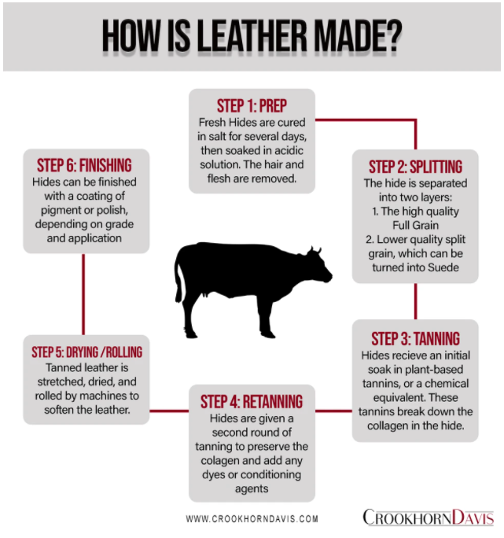
Why do you think leather is such a common product in our homes/lives?
Step 4:
Step 5:
Step 6:
Step 3:
Step 2:
Step 1:
Using this resource, https://www.trafalgarstore.com/blogs/news/how-is-leather-made-1, and the chart below, answer the following questions about each step:
- Why is this step performed?
- What would happen if this step was skipped?
Think about the things in your house. Identify
five items that are made of leather.
1.
2.
3.
4.
5.

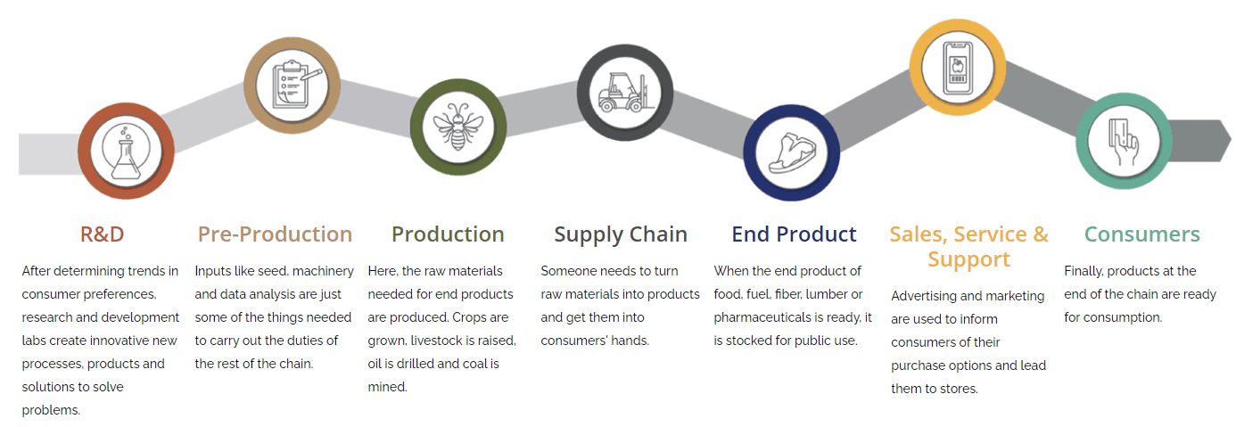
Directions:
Using the Agriculture, Food and Natural Resources (AFNR) Value Chain (shown below), identify where the following processes in leather making would occur along the AFNR Value Chain by drawing arrows to the different steps.

- Hide salting and curing
- Hair and flesh removed
- Initial hide soak
- Consumer purchases the leather product/good
- Hide finished with coating

- Stretching and drying
- Second round of tanning
- Hide made into leather goods
- Leather product/good marketed to the consumer
- Hide separated
- Leather stocked in stores for sale
Directions:
Use this resource, https://www.trafalgarstore.com/blogs/news/how-is-leather-made-1, to answer the following questions. Use the underlined letters to unscramble the hidden word.

- The hides are packed in salt to prevent ____________l_______g.
- Liming helps to break down the stiffened ___________a________.
- ____________i_____ is the final step to turn the hide into a useable leather product.
- One form of tanning is ____________________e tanning, which is the oldest form of tanning.
- Today, many leather products are tanned by using C_______________u______.
- This process of tanning is faster: ______r_________u________.
- Lastly, leather may receive a coating of ___________________t to mask any imperfections.

_______ _______ _______ _______ _______ _______ _______ _______ _______ _______ _______

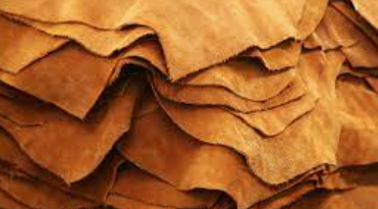
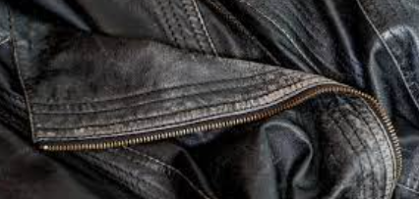
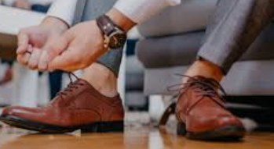
In two to three sentences, describe the leather production process and its impact on the economy and our day-to-day lives.
What role does leather production have in the agriculture industry? What would happen if we did not produce leather?
Using AgExplorer.FFA.org, identify three careers that exist in leather production and the tasks performed within those careers.

- __________________________:

- __________________________:

- __________________________:
What personality traits do you think you should have if you want to work in the leather production industry? Identify a minimum of three.

1.

2.

3.
How does the leather industry impact you every day?
What would life be like without leather?

