Appendix 8: Devoted to #DairyStrong
Aligned to the following standards:
FFA.PL-A; FFA.PL-E; FFA.PL-F; FFA.PG-J; FFA.CS-M; FFA.CS-N; CCSS.RI.9-10.2; CCS.RI.9-10.3; CCSS. RI.9-10.4; CCSS.WHST.9.10.4; CCSS.ELA.W.9-10.2; CCSS.ELA.W.9-10.4; CCSS.SL.9-10.2; CCSS.SL.9-10.4; CRP.02; CRP.04; CRP.07; CRP.08;CS.02
Part 1
directions:

Read the article “Devoted to #DairyStrong” in the spring 2021 issue of FFA New Horizons and complete the following activities.

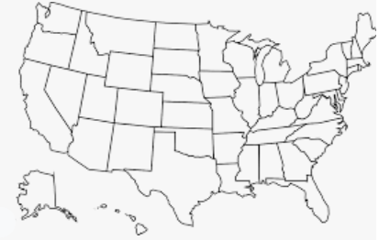
- What is the name of the FFA chapter this article is about? Where are they located? Color in the state on the map.

- What chapter event was canceled due to COVID-19?

- Explain how they turned the challenges into opportunities.

4. How much money did the chapter start with for this project?
5. What did they do with the startup money?
7. How has the chapter adapted to the new normal?

5. How did the project expand?

7a. What did they learn?

Part 2
directions:

After reading the article, take what you have learned and apply it in your community. Answer the questions below.
3. Use this space below to design an informational post card to help advocate for the dairy industry (or other industry of your choice). Use this site to help you find information to include on the card.

- What types of agriculture are present in your community or area? For example, our community has a lot of row crop farmers, beef cattle farmers and vegetable producers.

- Brainstorm ways that you can help agriculture in your community (or surrounding area). For example, start a social media campaign and post one fact a week about the soybean industry (products that contain soy, etc.).

Part 3
directions:

Answer the questions below to learn about a day in the life of a dairy farmer. Use this website to help answer the questions: https://www.usdairy.com/news-articles/a-day-in-the-life-of-a-dairy-farmer-audrey-donahoe.


- This article is about a _______-generation dairy farmer from ___________, New York, located in the __________ region of the state.
2. What time does their day start?
3. How are responsibilities and duties handled on the farm?
4. Why do they have daily management meetings?
5. What topics are discussed during the meetings?
6. What percent of our country’s dairy farms are family owned?
Next, choose a career in another industry (or a career within agriculture) and map out the general responsiblities/duties of that career. Use the spaces to record your answers.
Industry: _____________________________________

Career Title/Position: ______________________________

Duties/Responsibilities:
Record the websites you used to conduct your research:

