Advocacy Chat with Courtenay DeHoff
Part 1
Directions:
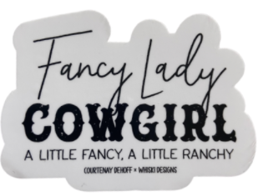
In the space provided, draw a picture of what you think an agricultural advocate looks like. We will refer to this picture later.

Part 2
Directions:
Watch the video “Courtenay DeHoff #SpeakAg Chat – Part 1” at https://vimeo.com/480972033. While watching the video, complete the following activities.


What is Courtenay’s story? On the timeline, identify five points in her life that led to her brand of being a #FancyLady Cowgirl.

What is the TV industry’s resume called?

D______________ R______________
What are the three components of the cowboy code?
- I_______________________________
- M______________________________
- H______________________________
How many views did her wildfire story
get in one night?

____________________________________
Where is Courtenay from?

- Nebraska
- Oklahoma
- Kansas
- Texas


What is the minimum number of people you need to reach to be considered an advocate?

- 1
- 10
- 100
- 1,000
- None of the above
Name five methods for advocacy that Courtenay identifies. Provide an example for each.

- ________________________________________
  - Example:

- ________________________________________
  - Example:

- ________________________________________
  - Example:

- ________________________________________
  - Example:

- ________________________________________
  - Example:

Examine your drawing. How would you change this picture based on what you have learned?

- Choose one of the advocacy methods above and write it here: _________________________________________

- Identify something that you are passionate about that someone else may not understand or may have misconceptions about. This can be anything important to you. Record it here:

__________________________________________________________________________________________________________________

- In the space provided, develop a plan of how you are going to use the advocacy method identified in Question 1 to advocate for the issue you identified in Question 2. Be sure to include specifics such as who, what, when, where and why.

How does advocacy impact you? Give a specific example.
Why is advocacy important in any industry?
Draw an emoji to describe your feelings about advocacy.

