Embrace Your Story
Aligned to the following standards:
FFA.PL-B; FFA.PL-D; FFA.PL-F; FFA.PG-H; FFA.PG-K; CCSS.ELA-LITERACY.SL.9-10.1; CRP.01; CRP.04; CRP.06; CRP.09; CRP.12
Part 1
Directions:
Complete the following activities while watching the retiring address of 2021-22 National FFA President Cole Baerlocher, “You. Belong. Here.” The video is available at https://vimeo.com/779370136.


1) What “tea” did Cole spill as he came out on stage? Who is his excuse?

2) What does Cole say he spends all his money on?

3) Cole says that when you are comfortable, you are __________________________________.

4) Cole states that, to him, clothing is how you express who you are and what your values are. Do you agree? Why or why not?

“While there is power in a name, there is more power in being authentically YOU!”

5) What is Cole’s favorite outfit of all time?

6) Cole tells the audience that his FFA jacket makes him feel more like himself. How does wearing an FFA jacket (yours or borrowed) make you feel? (If you are not in FFA, think about something similar — school uniform, letterman jacket, etc.) Why do you think you feel that way?

7) Who did Cole’s first FFA jacket originally belong to?

8) What two things does Cole say the blue jacket symbolizes?
a)

b)
“We need to realize that it isn’t a name or a title that makes you great — it’s you!”

9) Cole tells a story about a time when he felt a little “in over his head.” Think
about a time you have felt this way and describe it below. What did you do to overcome this feeling?

“Belonging is not about finding a place; belonging is about creating a space.”

10) Cole says that creating space means that we meet others where they are at and we understand that all of us are different. Has anyone ever done this for you? How?

11) What state did Cole visit for summer camp?

12) What types of milestones in our lives does Cole say we should focus on?


13) Fill in four milestones from your life in the stones below. These can be serious, major milestones or fun, small milestones.

1.
4.
3.
2.

Part 2
Directions:
Decorate the locker below to represent who you are. Draw five things that represent who you are and your likes and interests, or write your favorite quotes that impact you and your values (or include both drawings and quotes!).
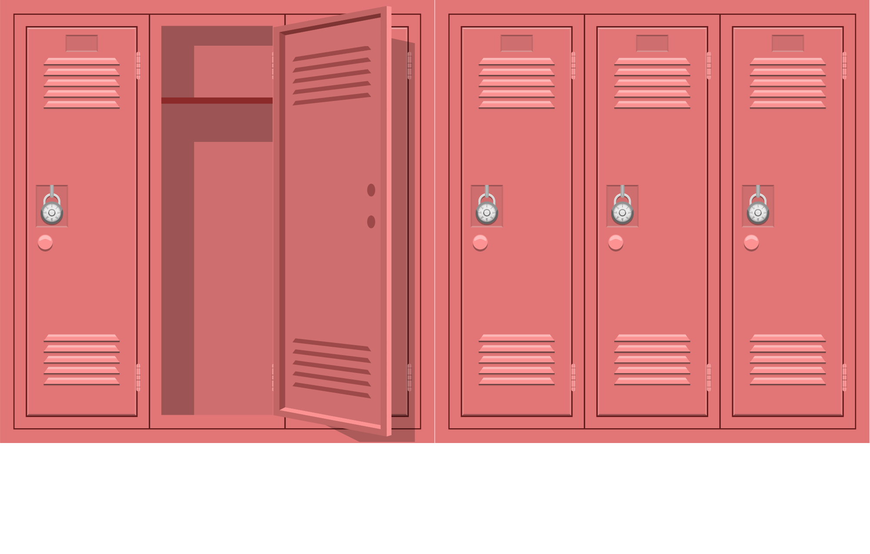
Why did you choose these items?
Item/Quote 1: | Why this item/quote?
Item/Quote 2: | Why this item/quote?
Item/Quote 3: | Why this item/quote?
Item/Quote 4: | Why this item/quote?
Item/Quote 5: | Why this item/quote?


Answer the three questions below. These questions were asked by Cole at the end of the video.
How will you embrace your story?
What will you do to create space for others to belong?
How will you maximize your potential HERE (at school, in FFA, on a team, etc.)?

