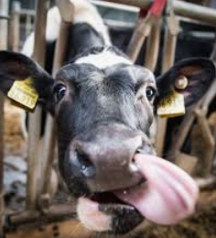
A Dairy Good Celebration
Directions:
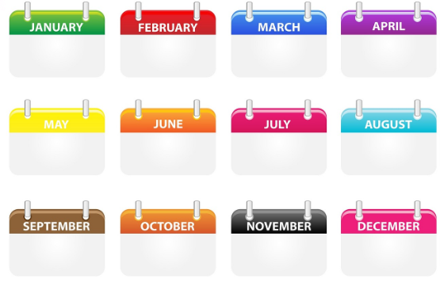




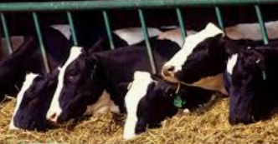
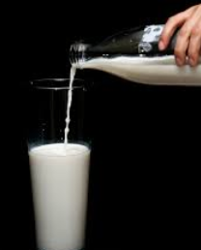
The dairy industry plays a crucial role in the economy, and each year we highlight and recognize the industry for all that it provides in each of our communities. Watch the video FFA — Domino’s, https://vimeo.com/nationalffa/review/431807699/c2c2f8a05d, and complete the following activities.
Circle the month we celebrate the dairy industry.
How does Domino’s Pizza rely on the agriculture industry? Give three examples.

Domino’s Pizza uses _____________ million pounds/year of cheese!
Identify four ways innovation is occurring in the dairy industry every day.
What percentage of the U.S. population lives within 100 miles of a dairy farm?

- 52%
- 71%
- 89%
- 97%
Use the “Where Is My Milk From?” resource to find the closest dairy to you! Write the name here.

________________________
How has the dairy industry impacted you today?
How can you advocate for the dairy industry? Give two specific examples. Explain your answer.

(1)

(2)
The dairy industry provides jobs for roughly three million people. Using AgExplorer, identify three careers that are directly related to the dairy industry that are not a farmer.

(1)

(2)

(3)

How do these innovations impact you and those in your community? Give two specific examples.

