Welcome Home
Aligned to the following standards:
FFA.PL-A; FFA.PL-D; FFA.PL-F; FFA.PG-K; CRP.01; CRP.04; CRP.06; CRP.09.
Part 1
Directions:
Answer the following questions while watching the retiring address of 2023-24 Western Region Vice President Emily Gossett, “Welcome Home.” The video is available at https://vimeo.com/1023621234.

- How did the words “we are moving” impact Emily?

- What does the number 1,773 represent?

- Emily was invited to sit next to someone in class. How did that change her mindset?

- Why is acceptance important?

- Fill in the blank:
Acceptance partnered with community builds a _____________.

- Why was it okay to pack up all the memories from Emily’s childhood?

- Why is it important to show up?

- Fill in the blank:
A __________ is only as good as the _____________ in it.
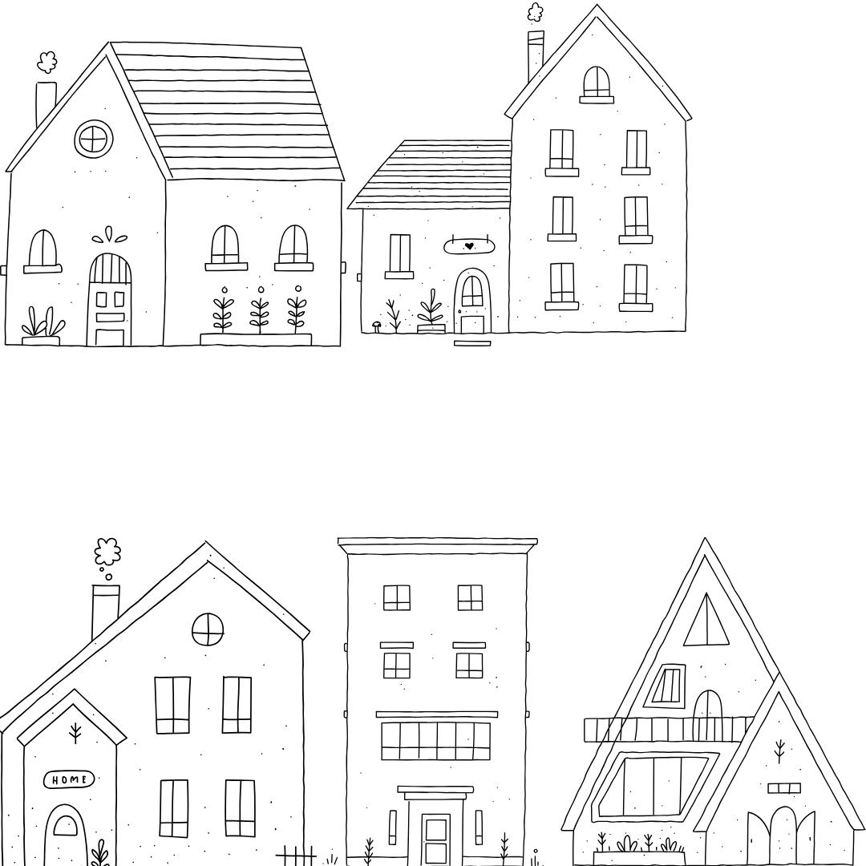
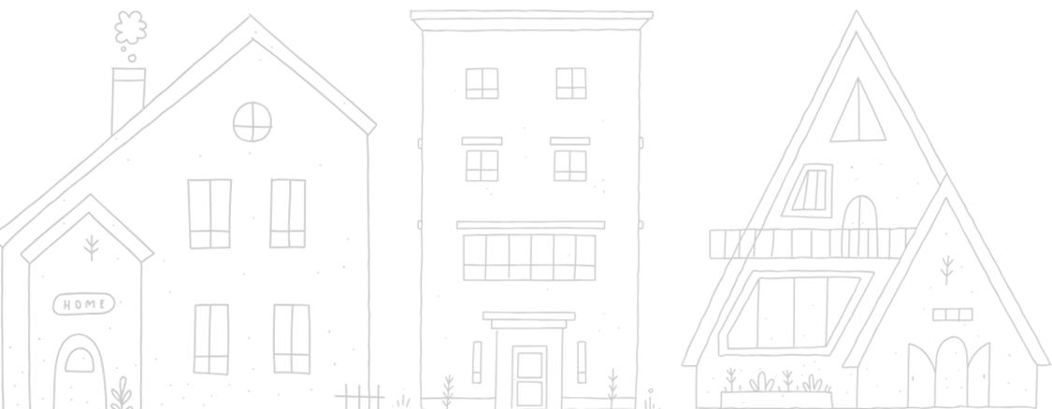

- What is the difference between a house and a home?

- Fill in the blank:
_______ will take you far, but ______ will lead you home.

Part 2
Directions:
In Emily Gossett’s retiring address, she shares the importance of making people feel “at home" when they are around you. In this activity, you will go through five scenarios and share two techniques you could use to make that person feel comfortable.

Scenarios | Techniques
Example:  Hugo is a new student who has joined your plant science class. | Example:  - Introduce myself and ask him to sit with me during lunch or group work.  - Share tips about the school and offer to walk him to his next class.
Your classmate Olivia sits alone at lunch every day.
Your teammate Demari is struggling during soccer practice and seems frustrated or withdrawn.
Jacob is a new student who has recently moved to your town and isn’t familiar with the community.
Your friend Jody is going through a tough time and seems distant.
Charlie is attending their first FFA meeting and looks unsure of what to do.

- What are some common themes you noticed in your techniques?

- How does inviting someone create a sense of belonging?

- Reflect on a time that you did not feel “at home.” What would have made you feel more comfortable?

