Aligned to the following standards:
CS.01; CS.02; CS.05; CS.06; FFA.PL-A; FFA.PL-C; FFA.CS.M; FFA.CS-N; AG1; AG2; AG5; AG6; AGC09.02; AGC10.03; CCSS.ELA.RI.9-10.1; CCSS.ELA.RI.9-10.2; CCSS.ELA.RI.9-10.3; CCSS.ELA.W.9-10.2; CCSS.ELA.SL.9-10.2; CCSS.ELA.SL.9-10.4; CCSS.ELA. RST. 9-10.7; CCSS.ELA.RST.9.10.8; CCSS.ELA.WHST.9.10.6; HS-ETS1-3; AFNR Career Cluster, Statement 2; CRP.04; CRP.05; CRP.06; CRP.07; CRP.08
Fundamentals of Feeding the World
Directions:
One of the biggest challenges facing the future is if/how/when individuals involved with the food, fiber and natural resources industries can feed the world. Feeding the world is the first step in addressing the global hunger and food challenge. To analyze how to address global hunger, we must first understand our own perspective of what feeding the world means.

Define and illustrate below what feeding the world means to you. Think bigger than just food production and farming. Get creative. To help you define and illustrate what feeding the world means to you, it might be helpful to think about the following:

- What do agriculturists currently do to feed the world?
- What ways can agriculturists increase food production in an innovative and sustainable way?
- What can consumers and individual households do to help feed the world?
- How can policymakers be involved with the feeding the world initiative?
- How can we conserve natural resources while also increasing food production?

Define what feeding the world means to you:

Illustrate what feeding the world means to you:

List 2 to 3 examples of how agriculturists, consumers and policymakers can make a difference feeding the world.

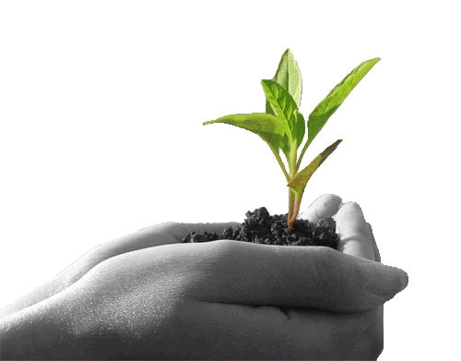
Agriculturists:

Example: Agriculturists can install drip irrigation systems in row crop farms to help reduce water consumption.

Example 1:

Example 2:

Example 3:

Consumers:

Example: Consumers can find ways to get involved with the food movement by planting backyard gardens or windowsill vegetables.

Example 1:

Example 2:

Example 3:

Policymakers

Example: Policymakers can write bills to support research efforts that are focused on conservation programs to help farmers make changes on properties.

Example 1:

Example 2:

Example 3:

Aligned to the following standards:
CS.01; CS.02; CS.05; CS.06; FFA.PL-A; FFA.PL-C; FFA.CS.M; FFA.CS-N; AG1; AG2; AG5; AG6; AGC09.02; AGC10.03; CCSS.ELA.RI.9-10.1; CCSS.ELA.RI.9-10.2; CCSS.ELA.RI.9-10.3; CCSS.ELA.W.9-10.2; CCSS.ELA.SL.9-10.2; CCSS.ELA.SL.9-10.4; CCSS.ELA. RST. 9-10.7; CCSS.ELA.RST.9.10.8; CCSS.ELA.WHST.9.10.6; HS-ETS1-3; AFNR Career Cluster, Statement 2; CRP.04; CRP.05; CRP.06; CRP.07; CRP.08

Food Insecurity Basics
Directions:
Food insecurity should not be confused with hunger or famine. The Food and Agriculture Organization (FAO, 2018) defines food insecurity as “limited access to food, at the level of individuals or households, due to lack of money or other resources” (p. 142).

Review Figure 1 and use FAO’s (2018) “State of Food Security and Nutrition Around the World” website (http://www.fao.org/state-of-food-security-nutrition/en/) to answer the following questions.

Figure 1. Reprinted from FAO’s (2018, para. 15) “State of Food Security and Nutrition Around the World” website, available at http://www.fao.org/state-of-food-security-nutrition/en/.

- Think critically about the components in Figure 1. Multiple descriptions exist for each food insecurity and food consumption element (see left and center-left side of Figure 1). However, using context clues from Figure 1 and FAO’s (2018) “State of Food Security and Nutrition Around the World” as resources, write your personal definitions of the basic elements of food insecurity and food consumption. (The full report can be downloaded from http://www.fao.org/state-of-food-security-nutrition/en/; pages 26 through 35 may be particularly helpful.)

  - Access to food:

  - Quantity of food consumption:

  - Quality of food consumption:

  - Continuity of food consumption:

- How can unbalanced food consumption (quantity, quality or continuity) influence intake of calories, protein, vitamins and minerals?
- What would happen if the elements of food consumption (quantity, quality or continuity) are too low?
- What would happen if these elements were too high?

- Define malnutrition. What are some possible causes of malnutrition? What are some possible consequences of malnutrition?

- Describe (in detail) three concerns you have as a young agriculturist, scientist, natural resource advocate, etc. regarding food insecurity and food consumption across the globe. (Use the “State of Food Security and Nutrition Around the World” website, http://www.fao.org/state-of-food-security-nutrition/en/, as a reference):



  - Why are these concerns? What can be done to address these concerns?

  - What efforts (if any) currently exist to help address these needs?

Feeding the World Globally
Aligned to the following standards:
CS.01; CS.02; CS.05; CS.06; FFA.PL-A; FFA.PL-C; FFA.CS.M; FFA.CS-N; AG1; AG2; AG5; AG6; AGC09.02; AGC10.03; CCSS.ELA.RI.9-10.1; CCSS.ELA.RI.9-10.2; CCSS.ELA.RI.9-10.3; CCSS.ELA.W.9-10.2; CCSS.ELA.SL.9-10.2; CCSS.ELA.SL.9-10.4; CCSS.ELA. RST. 9-10.7; CCSS.ELA.RST.9.10.8; CCSS.ELA.WHST.9.10.6; HS-ETS1-3; AFNR Career Cluster, Statement 2; CRP.04; CRP.05; CRP.06; CRP.07; CRP.08

Directions:
Analyzing the extent of food insecurity starts at the global level. FAO (2018) estimated the number of undernourished people in the world, i.e., those facing chronic food deprivation, increased from approximate 804 million in 2016 to nearly 821 million in 2017. Review FAO’s (2018) “State of Food Security and Nutrition Around the World” website, available at http://www.fao.org/state-of-food-security-nutrition/en/.

Complete the following:
- Review the chart “Prevalence of Undernourishment in the World, 2005–2017” in Paragraph 4 on the website.
  - If you download the “State of Food Security and Nutrition Around the World” report from the website (http://www.fao.org/state-of-food-security-nutrition/en/) the needed chart is listed on Page 4.
- Highlight and label a region of the world.
- Research food insecurity issues in the selected region using the internet and available external resources.

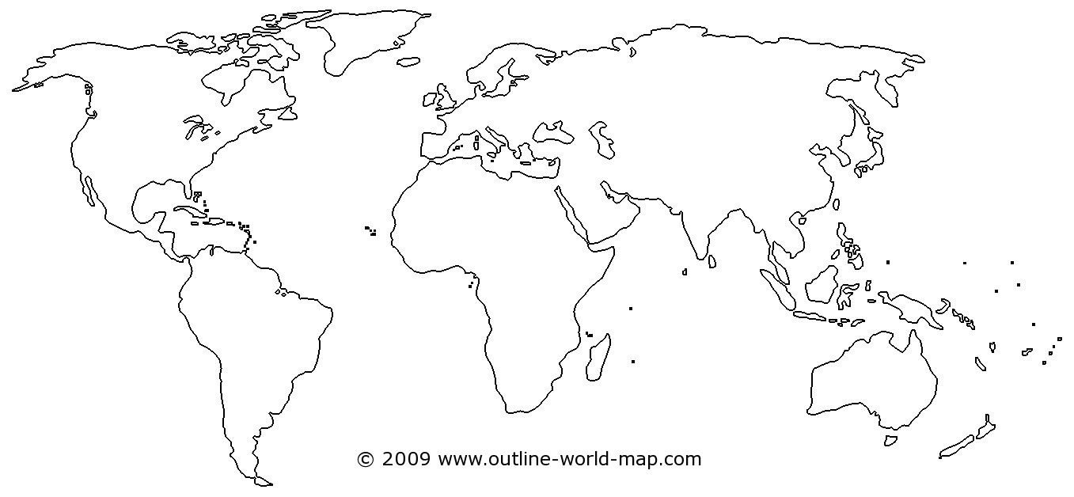

- Name of country or region: _____________________________________________________________________.

- What were the percentages of undernourishment in the selected region during each of the years listed below?

  - 2005: ________________________________________________.
  - 2010: ________________________________________________.
  - 2012: ________________________________________________.
  - 2014: ________________________________________________.
  - 2016: ________________________________________________.

- Analyze the challenges in your selected region using the four key elements of food insecurity and food consumption. What challenges or barriers might your region face in the following food insecurity categories?

Access to Food: | Quantity: | Quality: | Continuity:

Feeding the World Nationally
Aligned to the following standards:
CS.01; CS.02; CS.05; CS.06; FFA.PL-A; FFA.PL-C; FFA.CS.M; FFA.CS-N; AG1; AG2; AG5; AG6; AGC09.02; AGC10.03; CCSS.ELA.RI.9-10.1; CCSS.ELA.RI.9-10.2; CCSS.ELA.RI.9-10.3; CCSS.ELA.W.9-10.2; CCSS.ELA.SL.9-10.2; CCSS.ELA.SL.9-10.4; CCSS.ELA. RST. 9-10.7; CCSS.ELA.RST.9.10.8; CCSS.ELA.WHST.9.10.6; HS-ETS1-3; AFNR Career Cluster, Statement 2; CRP.04; CRP.05; CRP.06; CRP.07; CRP.08

Directions:
Hunger is not just a global problem. It is a national problem. Food insecurity is more prevalent in the United States than it has been in previous years.

Complete the following:
- Watch “Feeding America's Map the Meal Gap” (Feeding America, 2018). The video is available at https://www.youtube.com/watch?v=fQ0DXatbk3A&feature=youtu.be.
  - Optional: If watching YouTube is not an option, visit the Feeding America (2018) “Hunger in America” website, available at https://www.feedingamerica.org/hunger-in-america?s_src=WXXX1MTMG
&_ga=2.142209842.185763605.1546865895-1598350509.1546577041.
- Visit Feeding America’s (2018) “Food Insecurity in The United States” website (http://map.feedingamerica.org).
  - Answer trends in the full country before clicking on an individual state. Scroll to the middle of the website’s homepage to find the most recent national statistics within the United States.
- Review the statistics for food insecurity in the United States and complete the following questions.

- How many food insecure people are in the United States? ______________________________________________

- What is the food insecurity rate in the United States? _________________________________________________
Draw a pie chart to illustrate this percentage of food insecurity in the United States.

- What are the estimated percentages of program eligibility among food insecure people in the United States?

____________ % | % Above Other Nutrition Programs—  Threshold of 185% Poverty
____________ % | % Between 130% and 185% Poverty
____________ % | % Below SNAP Threshold—  130% Poverty

- What is the average meal cost? ___________________________________________________________________

- What is the annual food budget shortfall? ___________________________________________________________

- Of these statistics, what is the most surprising or alarming to you? Why?

- Using Feeding America’s (2018) “Food Insecurity in The United States” website (http://map.feedingamerica.org), select a state to investigate trends and statistics for food insecurity. Highlight and label the selected state.

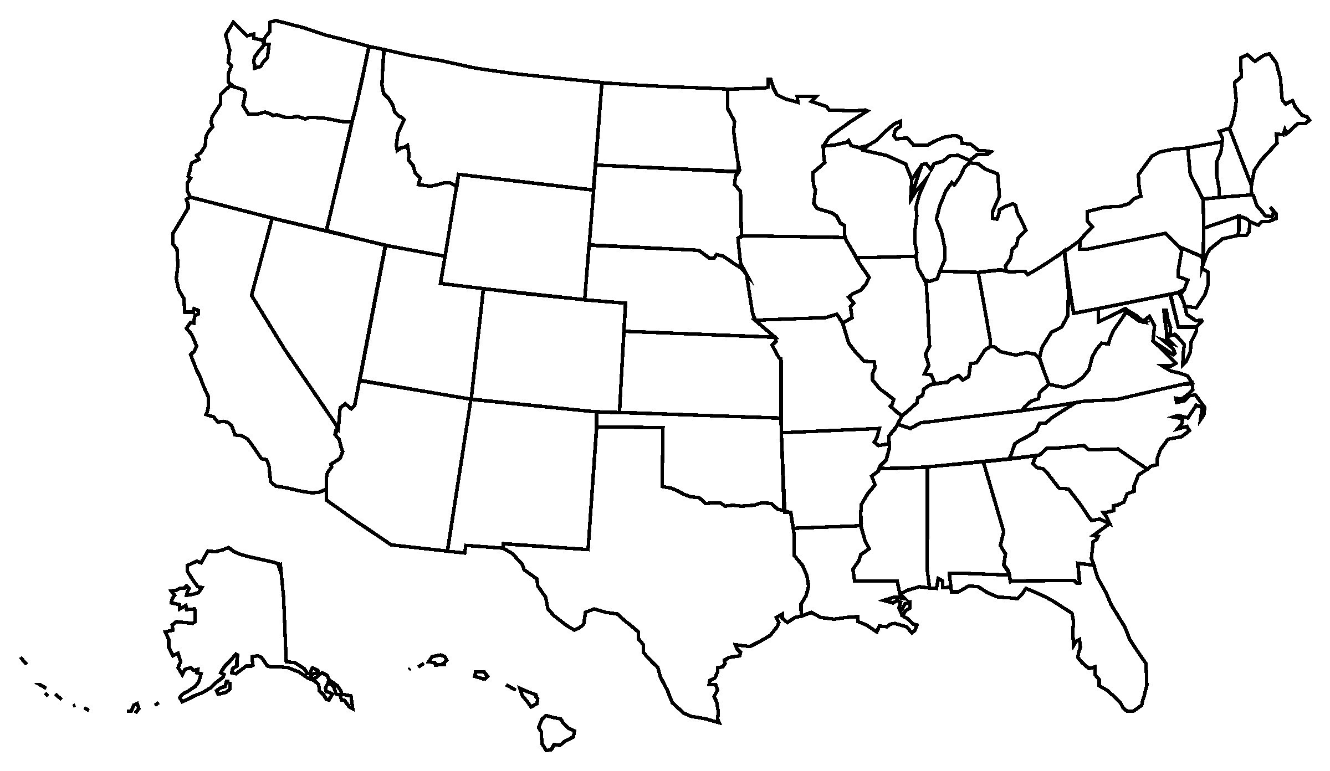

Name of selected state: _______________________________________________________________

- When you click on a selected state, each state should have a statistical printout that looks similar to this:
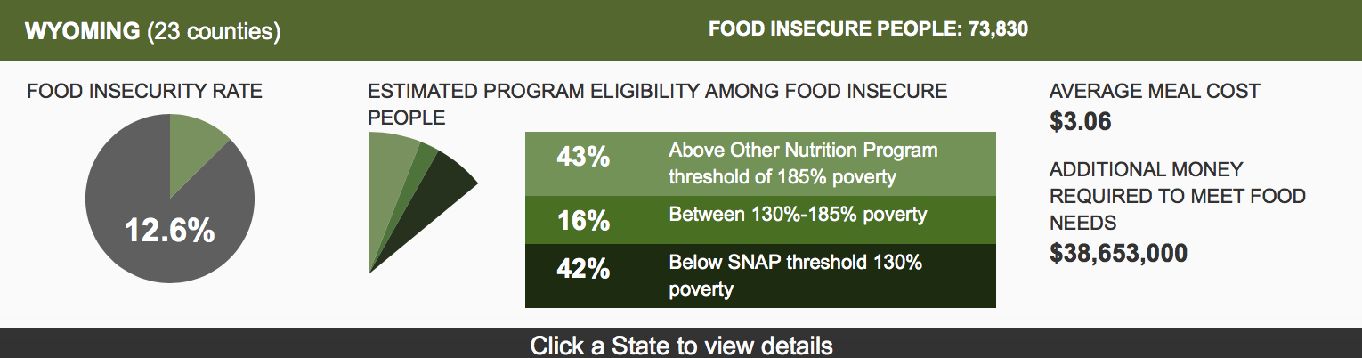
Figure 2. Example state printout.

Using your selected state, complete the following information:

- Number of food insecure people: ____________.
- Food insecurity rate: ____________.

- What are the estimated percentages of program eligibility among food insecure people in your selected state?

____________ % | % Above Other Nutrition Programs—  Threshold of 185% Poverty
____________ % | % Between 130% and 185% Poverty
____________ % | % Below SNAP Threshold—  130% Poverty

- What is the average meal cost?
________________________
Additional money required to meet food needs: ________________________

Aligned to the following standards:
CS.01; CS.02; CS.05; CS.06; FFA.PL-A; FFA.PL-C; FFA.CS.M; FFA.CS-N; AG1; AG2; AG5; AG6; AGC09.02; AGC10.03; CCSS.ELA.RI.9-10.1; CCSS.ELA.RI.9-10.2; CCSS.ELA.RI.9-10.3; CCSS.ELA.W.9-10.2; CCSS.ELA.SL.9-10.2; CCSS.ELA.SL.9-10.4; CCSS.ELA. RST. 9-10.7; CCSS.ELA.RST.9.10.8; CCSS.ELA.WHST.9.10.6; HS-ETS1-3; AFNR Career Cluster, Statement 2; CRP.04; CRP.05; CRP.06; CRP.07; CRP.08

Feeding the World Locally
Directions:
Regardless of the extent of food insecurity in individual communities, alleviating hunger and raising awareness for food challenges lies within the local level.

Complete the following:
- Use Feeding America’s (2018) “Food Insecurity in The United States” website to click on your local area to review the statistics in your selected county. The URL is http://map.feedingamerica.org.
- Using information you discover about your selected county, complete the following questions.

When you click on a selected county, each county should have a statistical printout that looks similar to this:
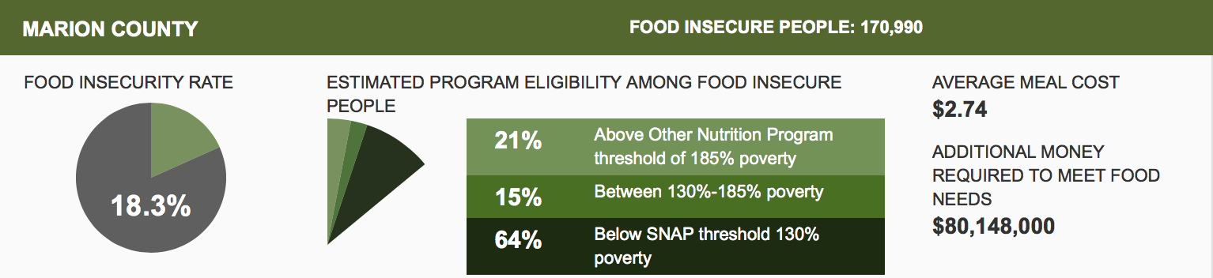
Figure 3. Example county printout.

Using your selected county, provide the following information:

- Number of food insecure people: ____________.
- Food insecurity rate: ____________.

- What are the estimated percentages of program eligibility among food insecure people in your selected state?

____________ % | % Above Other Nutrition Programs—  Threshold of 185% Poverty
____________ % | % Between 130% and 185% Poverty
____________ % | % Below SNAP Threshold—  130% Poverty

- What is the average meal cost?
________________________
- Additional money required to meet food needs: ________________________

- Think critically about the statistics for your selected county. What are some ideas to help reduce local food insecurity? What businesses or individuals could help spread the mission?

- In what ways can your agricultural education class or FFA chapter promote hunger awareness in your community or school?

Aligned to the following standards:
CS.01; CS.02; CS.05; CS.06; FFA.PL-A; FFA.PL-C; FFA.CS.M; FFA.CS-N; AG1; AG2; AG5; AG6; AGC09.02; AGC10.03; CCSS.ELA.RI.9-10.1; CCSS.ELA.RI.9-10.2; CCSS.ELA.RI.9-10.3; CCSS.ELA.W.9-10.2; CCSS.ELA.SL.9-10.2; CCSS.ELA.SL.9-10.4; CCSS.ELA. RST. 9-10.7; CCSS.ELA.RST.9.10.8; CCSS.ELA.WHST.9.10.6; HS-ETS1-3; AFNR Career Cluster, Statement 2; CRP.04; CRP.05; CRP.06; CRP.07; CRP.08

Feeding the World Superheroes
Directions:
Critical challenges, such as feeding the world, require a full team of “superheroes” who can address the needs of hunger and food insecurity. Many careers in these fields must consider the environmental, social and economic impact of decisions and can include a team of scientists, engineers, computer programmers, mathematicians, artists, communicators, educators and numerous others. Feeding the world requires many “superheroes.”

Visit AgExplorer (AgExplorer.ffa.org) and review the career focus areas. Consider the environmental, social and economic impact of feeding the world and then identify a team of at least four superheroes (types of careers) you would hire to help feed the world.

Superhero (Job) Title:

Which career focus areas could help prepare you for this type of career?
Refer to AgExplorer (AgExplorer.ffa.org) for a list.

What are their specific “superpowers”? How could they contribute to helping feed the world?

Superhero (Job) Title:

Which career focus areas could help prepare you for this type of career?
Refer to AgExplorer (AgExplorer.ffa.org) for a list.

What are their specific “superpowers”? How could they contribute to helping feed the world?

Superhero (Job) Title:

Which career focus areas could help prepare you for this type of career?
Refer to AgExplorer (AgExplorer.ffa.org) for a list.

What are their specific “superpowers”? How could they contribute to helping feed the world?

Superhero (Job) Title:

Which career focus areas could help prepare you for this type of career?
Refer to AgExplorer (AgExplorer.ffa.org) for a list.

What are their specific “superpowers”? How could they contribute to helping feed the world?

