Just Peachy
Aligned to the following standards:
FFA.PL-A; FFA.PL-F; AG3; CS.03; CCSS.ELA-LITERACY.RI.9-10.1; CCSS.ELA-LITERACY.W.9-10.2; CCSS.MATH.PRACTICE.MP1; CRP.02; CRP.04; CRP.06; CRP.07; CRP.08; CRP.11
Part 1
Directions:
Watch the SAE video “Fruit Production SAE | William Martin,” https://vimeo.com/857649991, and answer the questions below.
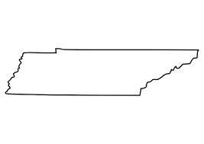
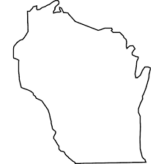
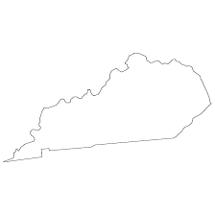
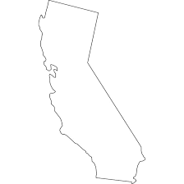
- Label each state and then circle the one William is from.

- How many peach trees does William have?

- How much time does it take from planting to producing a “considerable” amount of peaches?
  - 1 year
  - 2 years
  - 3 years
  - 4 years

- List one skill that he learned in his SAE.

- What does PPE stand for?

- Using the figure below, draw and label three examples of PPE.


- What has he learned the most?

- What advice does he give to students starting their SAE?

- After watching the SAE video, share one thing you learned and one thing you still have questions about.

Just Peachy
Part 2
Directions:
Let’s create a plan to start your own orchard. Answer each question below.
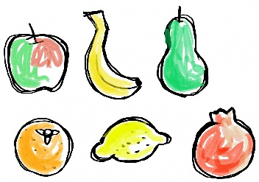
- Create a list of your favorite fruits that you would want to plant in your orchard:
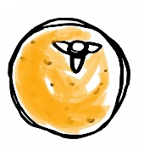
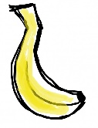

- According to the United States Department of Agriculture, a Plant Hardiness Zone Map is the standard by which gardeners and growers can determine which perennial plants are most likely to thrive at a location. Examine the map available at https://planthardiness.ars.usda.gov/. What is the hardiness zone of where you live?

- Which of your favorite fruits identified above could you grow in your zone? If none are applicable, list the types that can.

- Select one tree from your zone and research the optimal conditions for growth and production. Writing in complete sentences, describe how much sun and water the tree should receive, ideal soil conditions and how far the trees should be spaced apart. Be sure to cite your sources.



- Imagine you have a rectangular orchard where you want to plant peach trees. The length of the orchard is 120 meters, and the width is 80 meters. You decide to plant peach trees in rows with equal spacing between them. If each peach tree needs to be planted 5 meters apart in each row, how many peach trees can you plant in each row along the length of the orchard?

- How can you apply what you learned today in a real-life scenario?

