Life’s Real Passengers
Aligned to the following standards:
FFA.PL-A; FFA.PL-D; FFA.PL-E; CRP.01; CRP.04.
Part 1
Directions:
Answer the following questions while watching the retiring address of 2023-24 National FFA Secretary Grant Norfleet, “Life’s Real Passengers.” The video is available at https://vimeo.com/1023058399.

- How much does Grant’s luggage weigh?


- What is one thing that Grant learned while serving as a national officer?

- What is one of Grant’s favorite things to do to pass time in the airport?

- Circle the person you would give the parachute to (the farmer, the tennis player, the garbage man, the nurse or yourself). Explain why in two or three sentences.






- What age did Grant and his brother start showing cattle?

- What two jobs are always left to do in the barn?

- Why was Grant making his brother scoop poop every time?

- Fill in the blank:
When we only see the __________, we lose sight of the fact that __________ deserves a parachute.

- After listening to Grant’s speech, does your answer change about who to give the parachute to? Why or why not?

- What is one key takeaway from this retiring address?

Part 2
Directions:
In Grant Norfleet’s retiring address, he emphasizes that each and every one of us are real people with unique life experiences. In this activity, you will explore your unique traits that make you who you are today.
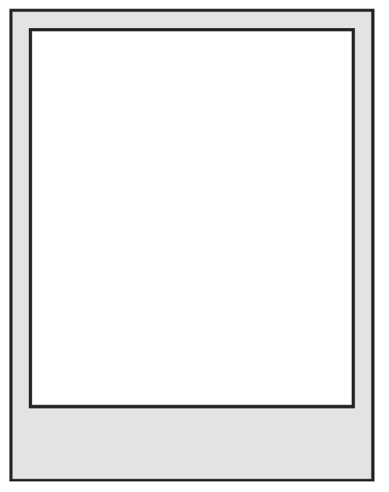
My Self Portrait
3. Describe yourself in three words.

2. List three skills or talents you have.

1. What is one experience or moment in your life that has shaped who you are today? Why was it impactful?
6. What two values or beliefs are most important to you?

a. How do they guide your actions?
7. How do you express your individuality in your daily life (e.g., through hobbies, style or actions)?

5. Who has had the biggest influence on your life so far, and what did they teach you?
4. Describe a challenge you’ve faced. What did you learn about yourself from overcoming it?

8. What is one thing about yourself that you are proud of and why?

9. What do you think people misunderstand about you, and what do you wish they knew?

