Count Joy
Aligned to the following standards:
FFA.PL-A; FFA.PL-D; FFA.PG-J; CCSS.ELA-Literacy.W.9-10.4; CRP.02; CRP.04
Part 1
Directions:
Answer the following questions while watching the retiring address of 2022-23 National FFA Central Region Vice President Karstyn Cantrell, “Count Joy.” The video is available at https://vimeo.com/883072933.

- Karstyn shared four jobs she had around her family farm. What were they?
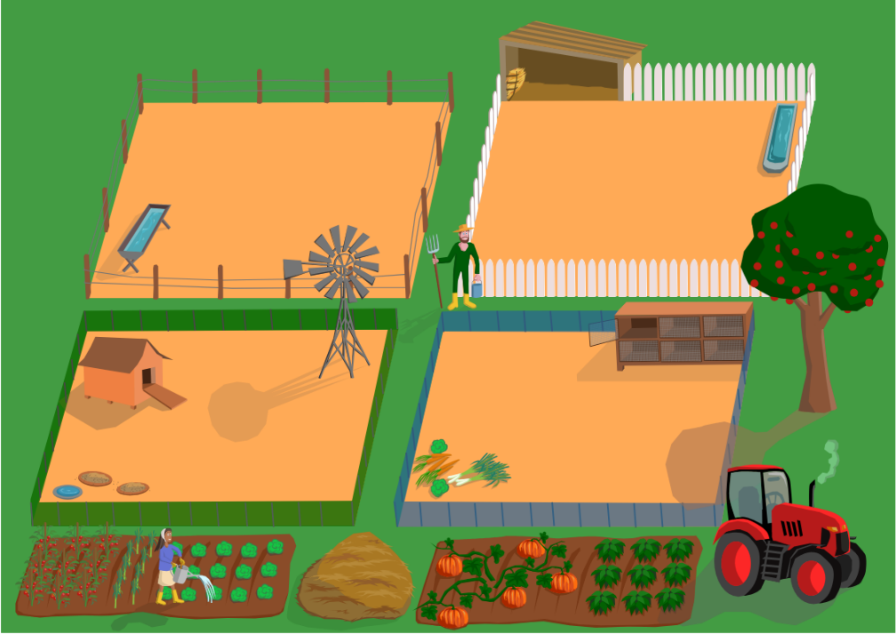

2.
1.

4.
3.

- What was one of Karstyn’s least favorite jobs around the farm?

- How do you count joy in the simple things?

- Karstyn shared the names of nine FFA members who not only count joy but share joy as well. List the names and stories of three members.

- Who in your life has shared joy with you? What did they do?

- How do you share joy with those around you?

- Ryan Best, one of Karstyn’s trusted mentors, once told her that “nothing comes in or out of a closed fist.” What does this mean?

- What does actively living “palms up” mean to you?

Part 2
Directions:
Karstyn Cantrell, 2022-23 National FFA Central Region Vice President, challenged us to count our joys. She shares in her retiring address that she keeps a journal to count her joys. In the space provided, reflect on this past year and create a scrapbook page centered around items you counted as joy. Please provide specific instances and pictures.


- Why is finding, counting and sharing joy important?

