Growing the Future
Aligned to the following standards:
BS.01; CS.01; FFA.PL-A; FFA.PL-E; FFA.PL-F; FFA.PG-I; FFA.PG-J; FFA.CS-M; FFA.CS-N; AG1; AGC10.03; AGC10.04; CCSS.ELA.RI.9-10.2; CCSS.ELA.RI.9-10.4; CCSS.ELA.RI.9-10.8; CCSS.SL.9-10.1; CCSS.ELA.SL.9-10.2; CCSS.ELA.SL.9-10.4; CCSS.ELA.RST.9.10.8; CCSS.EL.RST.9.10.9; MP1; MP3; MP5; MP6;HS-ETS1-3; CRP.02; CRP.04; CRP.05; CRP.06; CRP.07; CRP.08; CRP.11
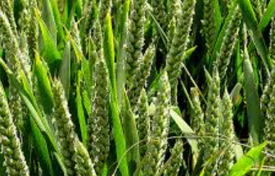
Part 1
Directions:
Draw and label a picture of your favorite meal below. Be sure to include the sides (ex. mashed potatoes). Use food labels or the internet to complete the questions below your picture.

Create a list of all of the raw crops used to make the meal you drew above (ex. corn, apples).

Where are each of the crops grown in the United States?

Aligned to the following standards:
NRS.01; AGPE01.01; CCSS.RI.9-10.3; CCSS.SL.9-10.1; RST.9.10.1; RST.9.10.2; RST.9.10.4; RST.9.10.5; RST.9.10.6; RST.9.10.8; RST.9.10.9; WHST.9.10.7; WHST.9.10.9; MP3; MP6; AG-NR2; HS-LS2-6; HS-LS2-7

Part 2
Directions:
As you can see from Part 1, our food comes from commodities found all over the U.S. and sometimes the world! You and a partner are going to become an expert on the production of one of the major commodities in your state and somewhere else in the U.S.

- Using the map below, color and label your state.
- Using the USDA website, https://www.ers.usda.gov/StateFacts/, select one of the top five crops produced in your state. Record the crop in the box provided.
- Using the map below, in a different color, color and label a second state of interest (do not select a neighboring state or one that someone else in the class has selected) and record it in the associated box.
- Using the USDA website, https://www.ers.usda.gov/StateFacts/, select one of the top five crops produced in the selected state. Record the crop in the box provided.
Crop selected in your state:
Crop selected in other state:
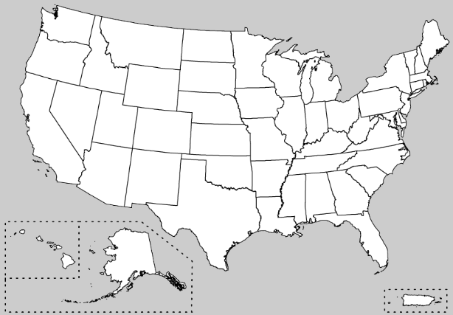
Why did you select this crop? What interests you about this crop?
Why did you select this crop? What interests you about this crop?

Part 3
Directions:
Watch the video “How to Make a Paper Slideshow,” available at https://youtu.be/E5RXynA_D3I. You will create a paper-slide video explaining your selected crop from outside of your state. Videos should last between 45 and 90 seconds. Use the space below to script your video. (Illustrations will go in the boxes and your narration on the lines.)
Slide 1: Describe the crop, its purpose and use.
Slide 2: Include information about planting, growth and care of the crop (i.e. watering, nutrition, pest management).
Slide 3: Explain how to harvest the crop, including techniques and machinery.
Slide 4: Describe the processing of the crop and foods created from the crop.
Slide 5: Include a list of five additional states that grow this crop.

Crop Name:

Slide One:
Narration:

__________________________________________

__________________________________________

__________________________________________

__________________________________________

__________________________________________

Slide Two:

Narration: Narration:

__________________________________________

__________________________________________

__________________________________________

__________________________________________

__________________________________________

Slide Three:
Narration:

__________________________________________

__________________________________________

__________________________________________

__________________________________________

__________________________________________

Slide Four:
Narration:

__________________________________________

__________________________________________

__________________________________________

__________________________________________

__________________________________________

Narration:
Slide Five:

__________________________________________

__________________________________________

__________________________________________

__________________________________________

__________________________________________

Part 4
Directions:
In each state on the map below, draw a picture of the crop based on information shared by your classmates. If a state is not large enough, draw a line and create your picture to the side in the gray space or on the back.
What role does crop production play in your everyday life?
Using what you learned today, identify three pieces of information that you consider new and interesting about crop production.

1.

2.

3.

The Science Behind My Food …
Aligned to the following standards:
BS.01; CS.01; FFA.PL-A; FFA.PL-E; FFA.PL-F; FFA.PG-I; FFA.PG-J; FFA.CS-M; FFA.CS-N; AG1; AGC10.03; AGC10.04; CCSS.ELA.RI.9-10.2; CCSS.ELA.RI.9-10.4; CCSS.ELA.RI.9-10.8; CCSS.SL.9-10.1; CCSS.ELA.SL.9-10.2; CCSS.ELA.SL.9-10.4; CCSS.ELA.RST.9.10.8; CCSS.EL.RST.9.10.9; MP1; MP3; MP5; MP6;HS-ETS1-3; CRP.02; CRP.04; CRP.05; CRP.06; CRP.07; CRP.08; CRP.11
Directions:
To meet the growing population’s food requirements across the globe, the need to find ways to grow more nutritious and abundant supplies of food has also increased. Watch the “What are GMOs?’ video from Purdue University to find out how agriculture is working to meet this need. Answer the questions as you watch the video. The video URL is https://youtu.be/QiHreVTjS58. If YouTube is unavailable, use this website: https://ag.purdue.edu/GMOs/Pages/WhatareGMOs.aspx.

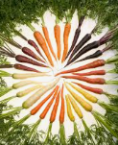

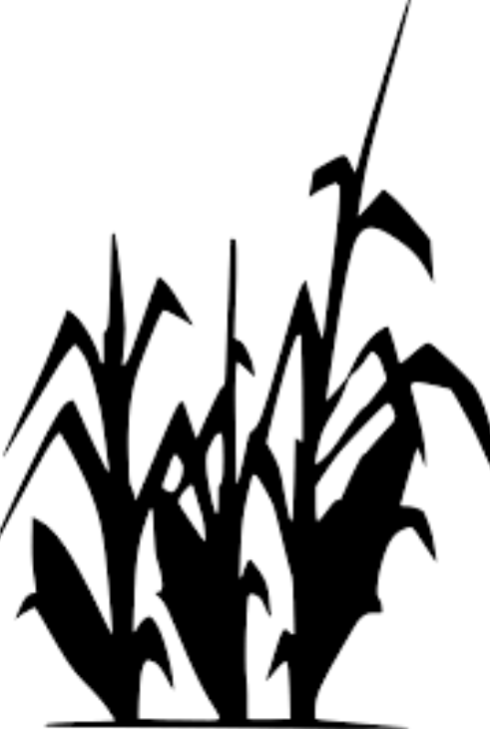
What does GMO stand for?

G____________________ M____________________ O____________________
The term “organism” refers to …

- what we eat.
- what we plant.
- any living thing.
How has this technology improved medical treatment?
What is an example of a pharmaceutical product that comes from GMOs?

_____________________
How has this development improved the lives of those with diabetes?
Which of the following vaccines have been developed utilizing GMO technology?

- Diabetes, Hepatitis B
- Cholera, Hepatitis B
- Cholera, Diabetes
- Hepatitis A, Cholera

What is the difference between conventional plant breeding and GMOs?
What are the top 4 GMO agronomic crops in the United States?

What does the term agronomic mean?

- Agricultural crops
- Only plants that are GMO.
- The transfer of information to get desired traits.

Directions:
Using this infographic from Purdue University, answer the following questions.
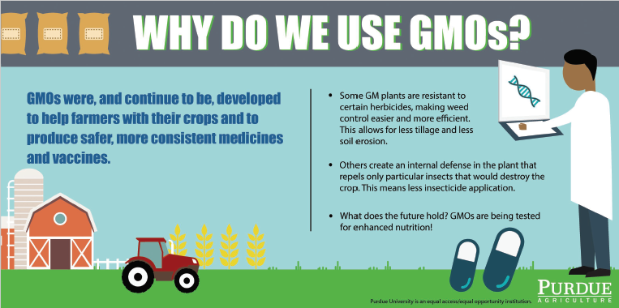
What are three ways that GMOs are used every day?

- ______________________________________________
- ______________________________________________
- ______________________________________________
With the need to feed a growing population and maintain its health, what role will GMOs have in the future?


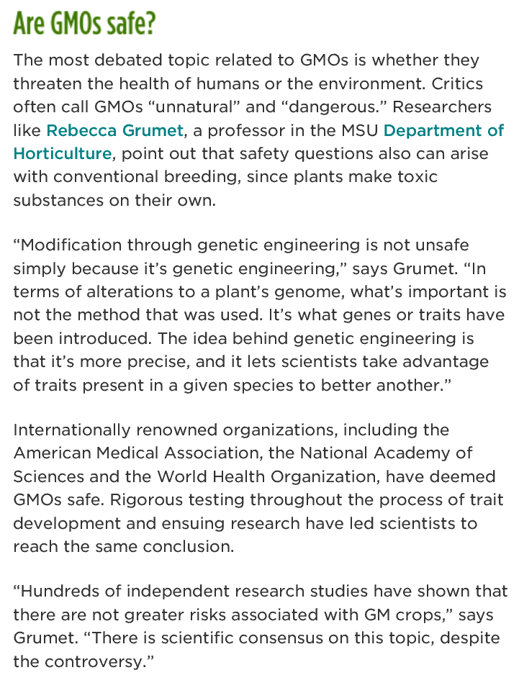
Directions:
Remembering that we have a great need to grow a more abundant and nutritious supply of food, read the passage below from Michigan State University. While reading, underline the four most important statements and answer the questions.
Why might people think GMOs are unsafe?
What evidence supports the safety of GMOs?
What would you say to a person who says GMOs are unsafe for consumption? Use what you have learned in your explanation.
Public Service Announcement
Aligned to the following standards:
BS.01; CS.01; FFA.PL-A; FFA.PL-E; FFA.PL-F; FFA.PG-I; FFA.PG-J; FFA.CS-M; FFA.CS-N; AG1; AGC10.03; AGC10.04; CCSS.ELA.RI.9-10.2; CCSS.ELA.RI.9-10.4; CCSS.ELA.RI.9-10.8; CCSS.SL.9-10.1; CCSS.ELA.SL.9-10.2; CCSS.ELA.SL.9-10.4; CCSS.ELA.RST.9.10.8; CCSS.EL.RST.9.10.9; MP1; MP3; MP5; MP6;HS-ETS1-3; CRP.02; CRP.04; CRP.05; CRP.06; CRP.07; CRP.08; CRP.11
Directions:
A public service announcement (PSA) is an announcement that is delivered to the public free of charge to educate them about an important topic. Public service announcements are beneficial in that they are short, educational and attract the attention of their audience. Today you are going to create a 1- to 2-minute public service announcement about GMOs. Watch this PSA, https://youtu.be/7LkuSm9kUEI, to help you generate ideas for your GMO PSA. Use the guidelines and template below to plan.

- Watch the PSA video, https://youtu.be/7LkuSm9kUEI.
- Brainstorm how to make your PSA creative.
- Complete any additional research needed. Be sure to use only valid resources. Examples: USDA, university websites, state grain grower associations (ex. Iowa Corn Producers).
- Practice!
- Record your PSA.


What is a GMO?
Why do we use GMOs?
Where can we find GMOs every day?
What impact do GMOs have on the ability to meet the food needs of a growing population?
Three additional facts about GMOs.
Crops and Me
Aligned to the following standards:
BS.01; CS.01; FFA.PL-A; FFA.PL-E; FFA.PL-F; FFA.PG-I; FFA.PG-J; FFA.CS-M; FFA.CS-N; AG1; AGC10.03; AGC10.04; CCSS.ELA.RI.9-10.2; CCSS.ELA.RI.9-10.4; CCSS.ELA.RI.9-10.8; CCSS.SL.9-10.1; CCSS.ELA.SL.9-10.2; CCSS.ELA.SL.9-10.4; CCSS.ELA.RST.9.10.8; CCSS.EL.RST.9.10.9; MP1; MP3; MP5; MP6;HS-ETS1-3; CRP.02; CRP.04; CRP.05; CRP.06; CRP.07; CRP.08; CRP.11
Directions:
Crops come in many varieties and are found in our everyday nutrition regardless of diet preferences (i.e. gluten free - for people that cannot eat gluten, vegan - people that do not consume animal or animal-based products/foods, vegetarian - for individuals that do not consume animal products, etc.). The government has determined the appropriate dietary guidelines can be represented visually using the MyPlate model. Utilizing the crops identified throughout the country in the “Growing the Future” activity, create a balanced meal for your family for dinner. You will create a recipe card for 3 dishes: one side dish (ex. mixed salad), one main course (ex. turkey meatloaf) and one dessert (ex. pudding). When crafting your recipe card, write the ingredients in the corresponding color as found on the MyPlate model (i.e., fruit = red, vegetable = green, protein = purple, grains = orange, blue = dairy). Additionally, based on what you have learned about GMOs, put an asterisk (*) next to the food that could be from a GMO source. Remember that a recipe card has ingredients with amounts needed as well as precise directions to make the dish.
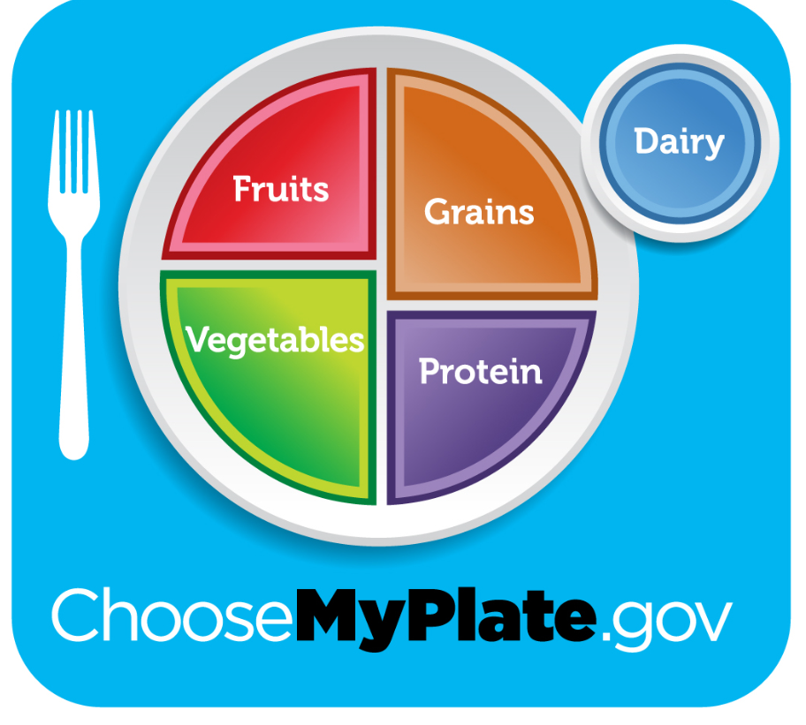
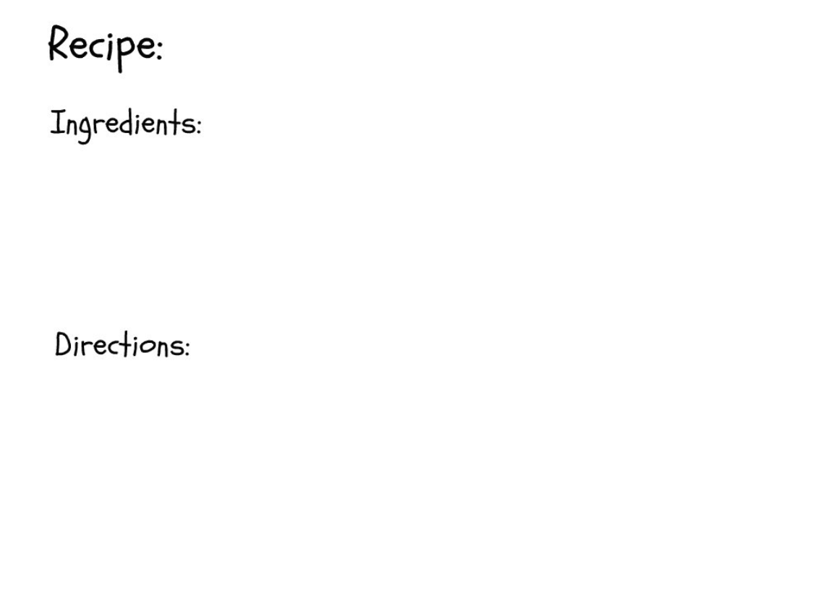

What is the role and importance of crops in your diet and for your nutritional needs?
Paper-Slide Video Rubric
Aligned to the following standards:
BS.01; CS.01; FFA.PL-A; FFA.PL-E; FFA.PL-F; FFA.PG-I; FFA.PG-J; FFA.CS-M; FFA.CS-N; AG1; AGC10.03; AGC10.04; CCSS.ELA.RI.9-10.2; CCSS.ELA.RI.9-10.4; CCSS.ELA.RI.9-10.8; CCSS.SL.9-10.1; CCSS.ELA.SL.9-10.2; CCSS.ELA.SL.9-10.4; CCSS.ELA.RST.9.10.8; CCSS.EL.RST.9.10.9; MP1; MP3; MP5; MP6;HS-ETS1-3; CRP.02; CRP.04; CRP.05; CRP.06; CRP.07; CRP.08; CRP.11
Area | 4 Points | 3 Points | 2 Points | 1 Point
Content | All content is accurate. There are no factual errors. | Most of the content is accurate, but there is one piece of information that seems inaccurate. | The content is generally accurate, but one piece of information is clearly inaccurate. | Content is confusing or contains more than one factual error.
Clarity and Neatness | The paper slide is easy to read, and all elements are clearly written, labeled and drawn. Creativity was used. | The paper slide is easy to read, and most elements are clearly written, labeled and drawn. Some creativity was used. | The paper slide is hard to read with rough drawings, labels and color. Little creativity was used. | The paper slide is hard to read, and one cannot tell what goes where or what the illustrations represent. No creativity was used.
Narration and Preparedness | The paper slide is clearly rehearsed and narrated with no mistakes.  Student spoke slowly and clear. | One mistake is heard in the paper-slide video. | Two mistakes are heard in the paper-slide video. | Three or more mistakes are heard in the paper-slide video.  Student spoke very fast and was unclear.
Time | Student stayed in the 45 to 90 seconds time frame. |  |  | Student was either under or over the allotted time frame.

Total: _____________
Comments:

___________________________________________________________________________________________________

___________________________________________________________________________________________________

___________________________________________________________________________________________________

___________________________________________________________________________________________________

___________________________________________________________________________________________________

___________________________________________________________________________________________________

___________________________________________________________________________________________________

___________________________________________________________________________________________________

