Forgotten Farmers
Aligned to the following standards:
FFA.PL-A; FFA.PL-C; FFA.PL-E; FFA.PG-J; FFA.CS-N; CCSS.ELA.W.9-10.4; CRP.02; CRP.04; CRP.06; CRP.08
Part 1
Directions:
Complete the following activities while watching “Forgotten Farmers,” the retiring address of 2021-22 National FFA Eastern Region Vice President Mallory White. The video is available at https://vimeo.com/777131643.

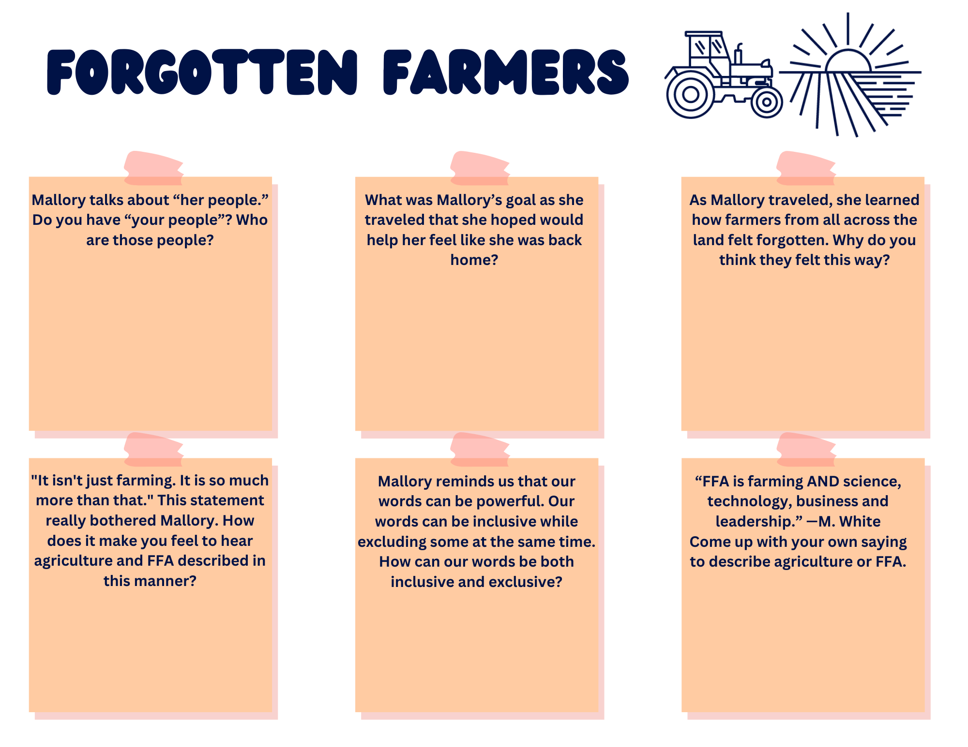
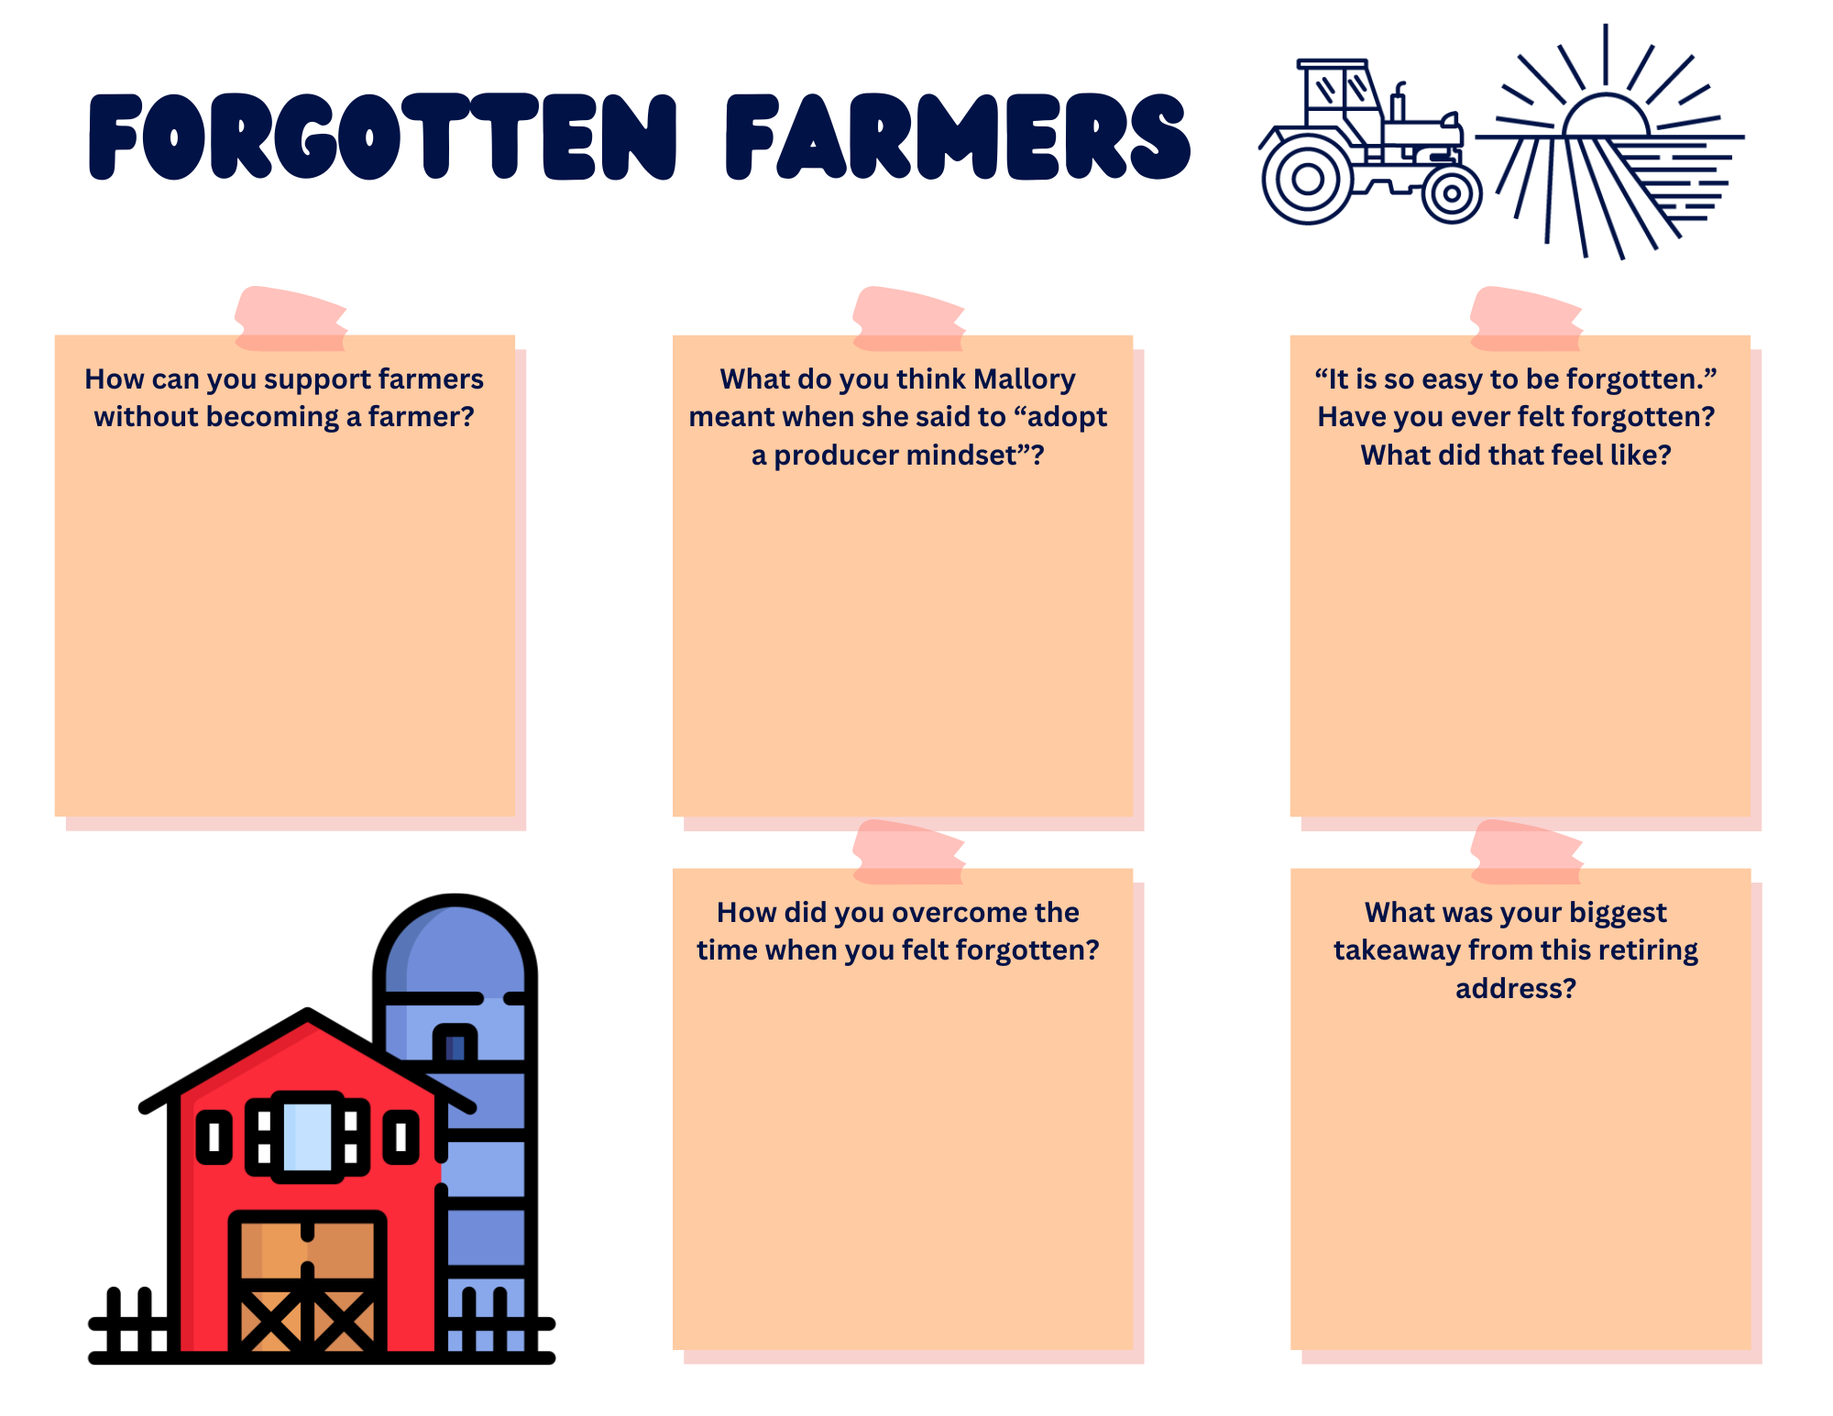
Part 2
Directions:
Think back to that time you felt left out. Think of a person or group of people in your school or community that may be easily forgotten. Work with your classmates to come up with a service project that can help honor or serve those that have been forgotten. Use the planning tool below to help you get started with your project. Follow the directions of your teacher for final steps and for putting your plan into action.

