The Gift to the Whole World
Aligned to the following standards:
FFA.PL-A; FFA.PL-D; FFA.CS-M; CCSS.ELA.SL.9-10.4; CCSS.ELA.SL.9-10.5; • CRP.04.
Part 1
Directions:
Answer the following questions while watching the retiring address of 2023-24 Eastern Region Vice President Morgan Anderson, “The Gift to the Whole World.” The video is available at https://vimeo.com/1023619551.

- What is Morgan's opening question?

- In one or two sentences, share what you think it means to be a good person.

- What phrase does Morgan sign her thank you cards with?

- Good does not equal ____________.

- When Morgan was explaining her painful experience in high school, what is one thing that she wishes she’d had in that moment?

- According to Morgan, what does it mean to be a good person?

- According to Morgan, good is a verb. How can you do good?



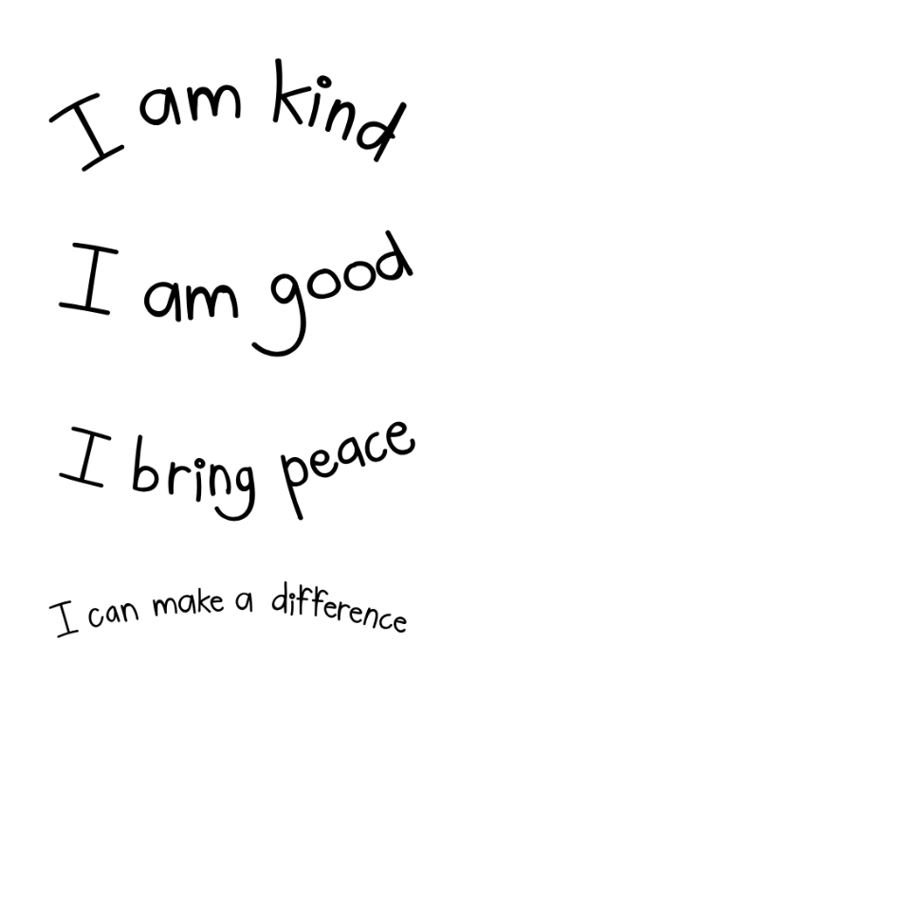
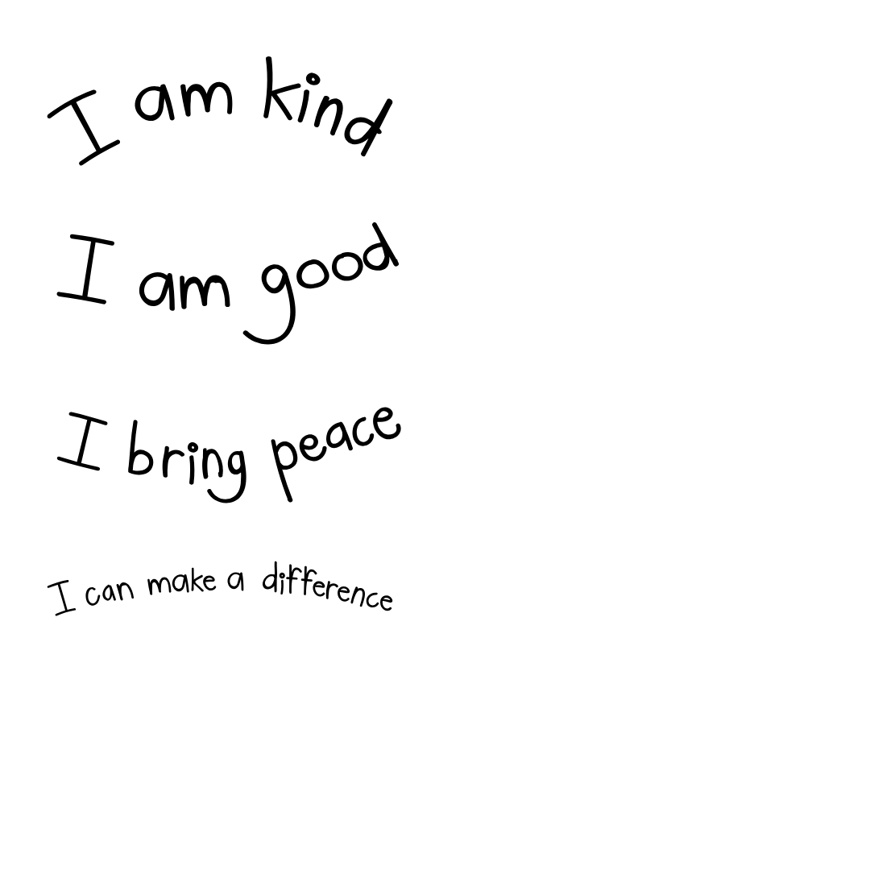
Part 2
Directions:
In Morgan Anderson's retiring address, she shares how being a good person is a gift to the whole world. In this activity, you will work in groups of three to reflect on the impact of personal actions on others and your community. Using the answers you come up with, you will create a kindness web for your classroom. Please answer the questions below.

- In the table below, share five examples of small, everyday acts of kindness that you have done (e.g., holding the door, helping with homework, smiling at someone) and how these actions positively influence others.

Acts of Kindness | Positive Impacts on Others

- Kindness Web: In the space below you will create a web chart. You will branch off the center labeled "Kindness." Each group member will need to share one act of kindness, writing it around the circle. Have each member pass their paper around the group to complete their act. For each act of kindness, discuss its potential ripple effects. Draw lines connecting the action to its impacts. Continue until the web shows a network of interconnected acts of kindness and their effects.
Helping a classmate
Boosts confidence
Improves school atmosphere

Kindness

- Describe a specific ripple effect that you have started or experienced before. What impact did this have on you and the other person(s)?

- How can you create more ripples of kindness in your school and community?

