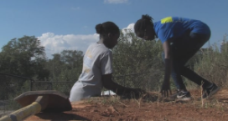
Five Tips and Tricks to Build Your SAE
Directions:
Watch the video “Advocacy and Literacy — Rabo AgriFinance,” https://vimeo.com/498150704, , and complete the following activities.
In your own words, describe a supervised agricultural experience (SAE).
What value exists in having an SAE? Give three specific examples that mean something to you.



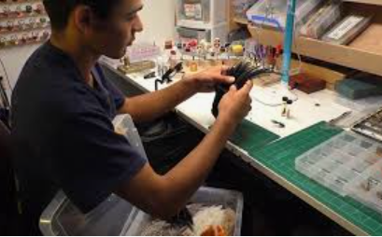

D__________________ the business and f________________________ goals of your SAE.

- What are three questions to ask yourself to help you develop a financial goal?
(1)

(2)

(3)

- According to the video, what are three ways to establish those financial goals?
(1)

(2)

(3)

Build a c__________________ f___________________.

- Explain why building a cash flow is important.
Why is it important to have financial goals?



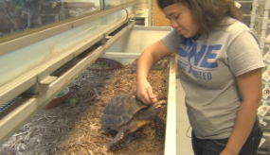
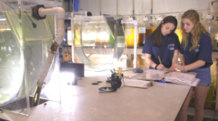
According to the video, what does “know your cost” mean?

Why is knowing your cost so important?
Marketing is important when it comes to being successful. Describe what marketing is and the role it can play in an SAE.
What are two pieces you need to consider to know your actual cost?
Be o_______________________________.

- Why is this step important for an SAE, or any business?



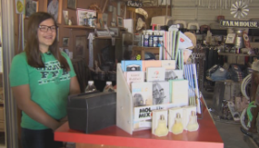

How can agricultural education students take these five tips and tricks and effectively work to apply them to their SAEs? How should they start?
Summarize the five tips and tricks you were just provided about SAEs.

