Sports Field Management
Aligned to the following standards:
CS.05; FFA.PL-A; FFA.PL-C; FFA.PL-E; FFA.PL-F; FFA.PG-I; FFA.CS-M; FFA.CS-N; FFA.CS-O; AG5; AGC09.02; RI.9-10.2; RI.9-10.3; W.9-10.2; SL.9-10.1; SL.9-10.2; CRP.02; CRP.04; CRP.07; CRP.08
Sports field management = sports turf management = athletic turf management
Part 1
Directions:
Read the article “HED: Collaborative Partnership Promotes Careers in Sports Field Management,” found at : Article: https://www.ffa.org/the-feed/a-new-opportunity-for-members-who-love-sports-and-ag/, and complete the following activities.
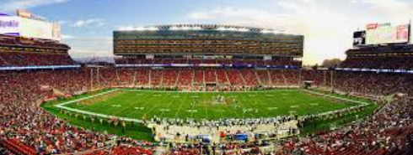
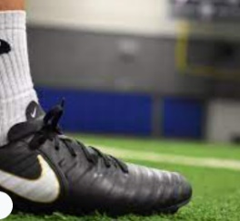

In your own words, what does an athletic turf manager do? Use AgCareers.com to help you.

Describe the type of person that would do well in this type of career.
What three professional organizations should you be a part of if you want a career in the athletic turf management industry?
- _________________________________
- _________________________________
- _________________________________
In 2021, what state held its first FFA Turfgrass Management CDE?
_______________________________________________
Which of the following states has NOT developed and implemented a turfgrass management CDE?
- Indiana
- New Jersey
- South Carolina
- Oklahoma
Which of the following was NOT a part of the turfgrass management CDE, according to the article?
- Oral presentation
- Multiple choice exam
- Seed identification
- Disease and insect identification
- Turfgrass species identification

Thinking about your state, identify five sports turfs, their locations and the sport that utilizes the turf that would require a person skilled in field turf management.
Ex. Busch Stadium, Missouri, Major League Baseball (MLB)
Turf Name Location Sport
1.

2.

3.

4.

5.
In this space draw the outline of your state. Now place a and label to identify where each of the sports turfs you identified are in your state.

Part 2
Directions:
So how can you prepare for a career in sports turf management? Read over and answer the questions below while you watch the video “Michael Netherton – SAE – Sports Turf Management,” available at https://vimeo.com/313687256, to learn more.
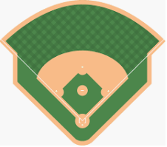


What does Michael like most about his SAE?
What other sport utilizes the stadium/turf where Michael works?

- Soccer
- Field hockey
- Lacrosse
- Little league

Where does Michael work?
- Louisville Slugger Stadium
- Churchill Derby Stadium
- Louisville Bats Stadium

Why might having a supervised agricultural experience (SAE) be helpful in achieving your career goals?
According to Michael, how will having a supervised agricultural experience (SAE) help him to prepare for his future career in sports turf management?
Identify three tasks that Michael needs to be able to complete to ensure the turf is ready for use.
1.

2.

3.
Part 3
Directions:


The Sports Turf Managers Association (STMA) is a professional organization geared toward assisting its members in the sharing of ideas and information about the sports turf management field. Using the STMA Job Board, https://www.stma.org/job-board/, find three different job posts and complete the activities below.
Job title: ___________________________________
Location: _________________________
Five responsibilities required:
1.
2.
3.
4.
5.

Education required:
Job title: ___________________________________
Location: _________________________
Five responsibilities required:
1.
2.
3.
4.
5.

Education required:
Job title: ___________________________________
Location: _________________________
Five responsibilities required:
1.
2.
3.
4.
5.

Education required:
Using AgExplorer, determine what types of skills an athletic/sports turf management career would require.

What would someone interested in an athletic/sports turf management career need to do in high school to prepare for a degree program?
Using what you have learned about a career in sports turf management, identify three other careers a person could have if they have the skills, education and talent required for a sports turf management career.
1.
2.
3.
What impact do those in a career in sports turf management have on the agriculture industry and overall economy?

