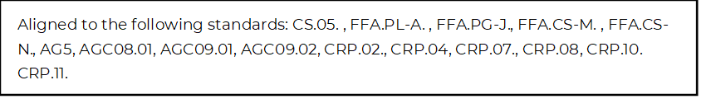
AFA WebQuest
Directions:
Use the Agriculture Future of America (AFA) website, found at https://www.agfuture.org/, to explore the opportunities available to young people wishing to pursue a career in the agriculture industry.

**Check out the About section (https://www.agfuture.org/about) of the website to complete the following questions.

Why does AFA exist? | What does AFA do? | How does AFA do it? | Who is AFA’s work for?

Look at the AFA Competencies (https://www.agfuture.org/about/afa-competencies) to learn more about the organization’s work of making transformational leaders. In the table below, identify the six themes or skills (called competencies) that employers are seeking in future employees.

Building and fostering healthy relationships | Innovatively influencing systems through critical thinking and problem solving | Working effectively with others toward a common goal
Performing well in diverse environments, with an inclusive bias | Relating to others with sensitivity and influence; a built-in bias toward leading and learning | Using exploration, feedback and reflection to manage yourself and your teams

*Head to the Partners section (https://www.agfuture.org/partners/industry) of the AFA website to learn more about who the organization has partnered with to support its career development and scholarship programs. List twelve partners below.

*Browse the Scholarships section (https://www.agfuture.org/scholarships) of the AFA website to discover those opportunities. Identify five key pieces of information you learned from reading this section of the website.
1.
2.
3.
4.
5.

*Diversity, Equity and Inclusion are an important part of the AFA’s mission. Review that section of the website (https://www.agfuture.org/about/diversity-equity-inclusion) to learn more about those efforts. Name three key things that AFA is committed to doing in the realm of diversity, inclusion and equity.
1.
2.
3.

*After learning more about what AFA has to offer, how do these opportunities personally benefit you and your future? Identify and explain two ways; be specific in your answer.
1.
2.

*Using an emoji, rate how useful you think the Agriculture Future of America organization could be to you in the future.

