Let’s Learn About Engines!
Aligned to the following standards:
FFA.PL-A; FFA.PL-C; FFA.PL-E; FFA.PG-J; FFA.CS-M; FFA.CS-N; AG5; CCSS.RI.9-10.2; CCSS. RI.9-10.4; CCSS.ELA.W.9-10.2; CCSS.ELA.W.9-10.4; CCSS.SL.9-10.2; CCSS.SL.9-10.4; CRP.02; CRP.04;CRP.06, CRP.08; CCSS.WHST.9.10.4; CCSS.WHST.9.10.6
Part 1
directions:

Read the article “From Shop Class to Fighter Jets” found at https://www.ffa.org/ffa-new-horizons/from-shop-class-to-fighter-jets/ and complete the following activities.

- Who is the article about, and what chapter is she from?
Color the state she is from:

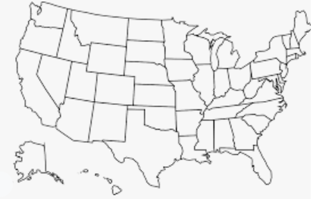

- How did she get started with FFA?

- What did she do for her SAE?

- Why did she join the military?

- Where is she currently stationed, and what is her role within the Air Force? Color the state where she is currently stationed:

- What were her favorite classes in high school, and how do
the skills learned from the class benefit her now?

- What is her encouragement to FFA members?


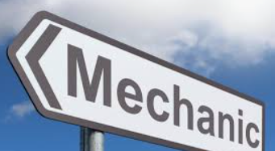
What career pathway would a jet mechanic fit?
Find and research three similarly related careers to jet mechanic/mechanics and describe those careers. Record the information below. Utilize AgExplorer.ffa.org to help with your research.

Career Title: ________________________________________________________

Responsibilities: ________________________________________________________________________________________________________________________________________________________________________________________________________________________

Career Title: ________________________________________________________

Responsibilities: ________________________________________________________________________________________________________________________________________________________________________________________________________________________

Career Title: ________________________________________________________

Responsibilities: ________________________________________________________________________________________________________________________________________________________________________________________________________________________

How can knowing about engines help you in your future?

Does one of these careers interest you? Explain why or why not.

Part 2
directions:
On the diagram of the gas turbine engine below, color-code the parts. For example, color the engine turbine purple and record that purple = engine block in the legend (beneath the first box). Use this website to help with your research: https://energyeducation.ca/encyclopedia/Internal_combustion_engine.
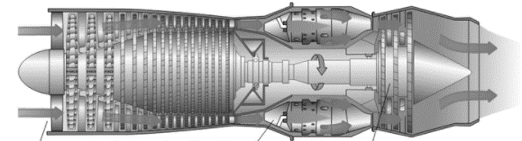
What is the purpose of the parts identified in the diagram above? Use these websites to help with research: https://www.britannica.com/technology/gas-turbine-engine/Major-components-of-gas-turbine-engines, https://energyeducation.ca/encyclopedia/Internal_combustion_engine

Part: _____________________ Purpose: ____________________________
_______________________________________________________________

Part: _____________________ Purpose: ____________________________
_______________________________________________________________

Part: _____________________ Purpose: ____________________________
_______________________________________________________________

Part: _____________________ Purpose: ____________________________
_______________________________________________________________

Part: _____________________ Purpose: ____________________________
_______________________________________________________________

Legend:
Engine picture from https://energyeducation.ca/encyclopedia/Internal_combustion_engine



Part 3
directions:
Answer the questions below to learn more about different types of engines.
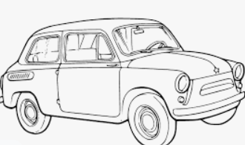
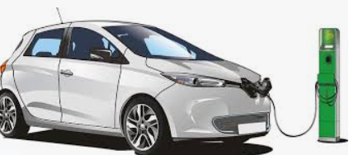
Describe in your own words the difference between gasoline and diesel engines: https://auto.howstuffworks.com/engine.htm#pt9
What is the difference between 4-cylinder and V6 engines? https://auto.howstuffworks.com/engine.htm#pt2
What is your “dream” car/SUV/truck? ____________________________________________

What type of engine does it have? ________________
Describe in your own words the difference in hybrid and electric engines: https://www.carsdirect.com/green-cars/what-is-the-difference-between-a-hybrid-car-and-an-electric-car#:~:text=The%20primary%20difference%20between%20a,%2Demission%20vehicle%20(ZEV).

Imagine that you own the dream car you identified above. You go out and start it up one morning, but it will not start. What are potential causes of this problem? Explain each cause. https://auto.howstuffworks.com/engine.htm#pt8

