Aligned to the following standards: CS.01., FFA.PL-A., FFA.PL-F., FFA.PG-I., FFA.CS-N., CCSS.ELA.W.9-10.2, AG1, CRP.02., CRP.04., CRP.05., CRP. 06., CRP. 08.

Appendix 1: Community Change
Part 1
Directions:
Read the article “Conversations Spark Community Change” in the fall/winter 2024 issue of FFA New Horizons and answer the questions below.

- Fill in the blanks:
Minnesota FFA members helped pass ____________ to provide ____________ funding for after-school programming in their state.

- List the names of the two Minnesota state representatives the Grand Rapids FFA members worked with.

- What position did Emma Bradford hold in her FFA chapter?

- What was the purpose of the Minnesota Department of Education bill that the group supported?


- What year did the bill pass?
  - 2022
  - 2023
  - 2024
  - None of the above

- Explain the idea of “Eighth Hour.”

- What position did Kaiya Grossman hold in her FFA chapter?

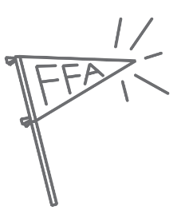
- Kaiya Grossman credits FFA with helping her build the confidence to speak in front of Minnesota state senators. What has FFA helped you do?

- List three things you learned from this article.

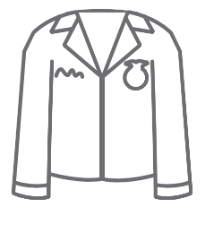

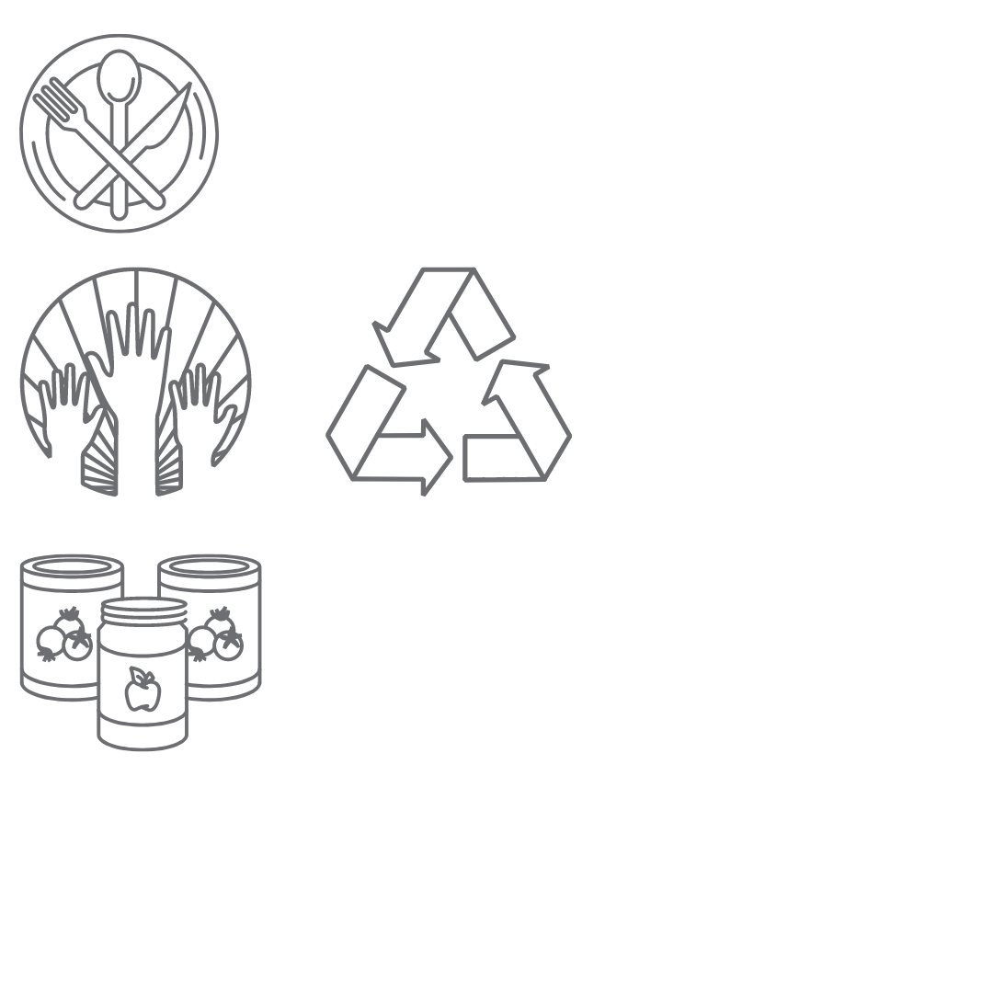
Part 2
Directions:
National FFA Living to Serve Grants provide an opportunity for FFA chapters (middle school, high school or alumni/collegiate) and state FFA associations/foundations to seek funding to support various types of service projects through a competitive application process.
Applicants must identify a community need that falls within one of four focus areas:
- Community Safety: Addresses concerns regarding the safety of community members and the preparation, response and recovery efforts that relate to emergency preparedness and natural disasters
- Hunger, Health and Nutrition: Addresses unmet food insecurity needs, increasing physical activity and improving healthy habits to promote physical and mental well-being of the community
- Environmental Responsibility: Addresses issues regarding air and water quality, energy and water efficiency, at-risk ecosystems and conservation to protect and sustain the natural systems upon which all life depends
- Community Engagement: Addresses matters related to heritage and traditions, connections between community members and civic responsibility throughout the community

For this activity, choose one of the focus areas listed above and answer modified questions from the grant application below.

- Focus Area:

- Short Overview of Project
Provide a short overview of your project. It should include the identified community need and how it will be addressed through service and educational outreach. (two to four sentences)

- INVESTIGATE:
Provide information on the community need your chapter will address over the course of the year.
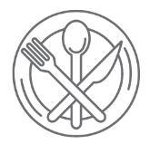
  - How was the community need identified?
(Examples: surveying the community, speaking with city officials or community organizations, etc.)

  - How is the issue affecting the community? Include one to three statistics about the need.

- SERVE and EVALUATE:

Detail how your FFA chapter plans to take action throughout the school year. Below are examples of information that could be included, but this is not a complete list so don’t let it limit you.
  - project planning
  - any activities occurring in the classroom
  - service activities, educational outreach
  - project evaluation

- Circle the AFNR career pathway(s) that apply to your project (circle all that apply).
- Agribusiness Systems
- Animal Systems
- Environmental Service/Natural Resources Systems
- Food Products and Processing Systems
- Plant Systems
- Power, Structural and Technical Systems


- How will the project be infused into classroom learning?

- Use the space below to break down the $3,000 budget total. Only include items that will be purchased using grant funds from National FFA. See the funding guidelines.

Funding Guidelines:
Allowable Expenses* | Non-Allowable Expenses*
- Substitute teacher pay  - Transportation to and from service sites  - Copying and marketing costs  - Educational outreach materials  - Portable storage  - Vegetation  - Small equipment purchases  - Other expendable materials | - Any one item over the cost of $1,500  - Stipends or scholarships to students or the chapter  - Indirect costs (cost of administering the grant funds)  - Acquisition or construction of buildings or facilities (does not include chicken coops)  - Travel to or from national convention or other state or national FFA trainings  - Meals or food for volunteers or events  - Giveaways (Ex. T-shirts, food, small manipulatives, etc.)
*Not an exhaustive list

- In three sentences, explain why grants are important.

