Appendix 1: On the Record: Eric Shanks
Aligned to the following standards:
CS.02; FFA.PL-A; FFA.PL-E; FFA.PL-F; FFA.PG-J; FFA.CS-N; AG2; CRP.02; CRP.04; CRP.07; CRP.08
Created: Fall 2020 by the National FFA Organization
Part 1
Directions:
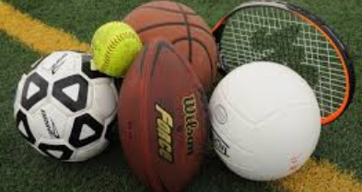
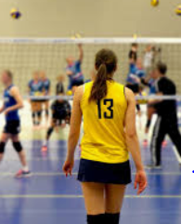
Read the article “On the Record: Eric Shanks” in the fall 2020 issue of FFA New Horizons and complete the following activities.
What does Eric Shanks do?

_________________________
Where is Eric Shanks from?

- San Francisco, CA
- Brazil, Indiana
- New Orleans, Louisiana
- Baltimore, Maryland
What major event does Shanks spend a large part of the year helping plan?

- World Series
- Stanley Cup
- Olympics
- Super Bowl
What role did FFA have in preparing Shanks for his career?
What advice does Shanks provide for FFA members?
Give a specific example of how you could use this advice in your life.
What link connects athletics and agriculture? Give an example.

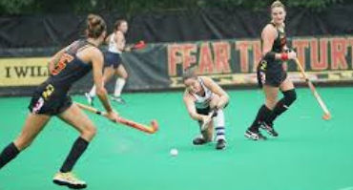
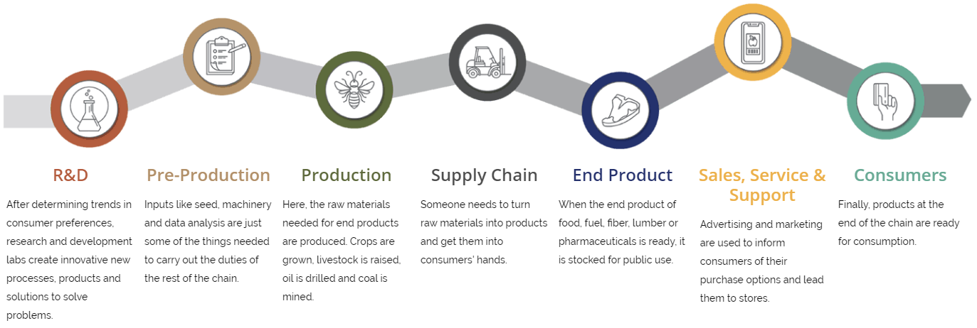
Product Selected: _____________________
Part 2
Directions:
Athletics and agriculture have a very close tie. Complete the following activities to learn how agriculture and the items we associate with athletic competitions really tie together.
- Review the Agriculture, Food and Natural Resources (AFNR) Value Chain below.
- Select a school-appropriate, product-based favorite Super Bowl commercial (ex. Doritos).
- Identify and describe how that product fits into each step of the AFNR Value Chain. Add your description to each step of the diagram. Tip: Use the following website for more information on each step in the AFNR Value Chain: FFA.org/value-chain/.

