Aligned to the following standards: AS.02; AS.05; AS.06; AS.08; FPS.04; FPS.06; FFA.PL-A3; FFA.PL-A4; FFA.PL-F3; FFA.PL-F5; FFA.PG-J1; FFA.PG-J4; FFA.CS-M1; FFA.CS-N2; CCSS.ELA.RI9-10.1; CCSS.ELA.W9-10.2; CCSS.ELA.W9-10.3; CCSS.ELA.W9-10.4; CCSS.ELA.W9-10.7; CCSS.ELA.W9-10.9; CCSS.ELA.SL9-10.2; CCSS.ELA.L9-10.6; CRP.02; CRP.07; CRP.08
Appendix 2: Hooked on Conservation
Part 1
Directions:
Read the article “Hooked on Conservation” in the spring/summer 2026 issue of FFA New Horizons and answer the questions below.

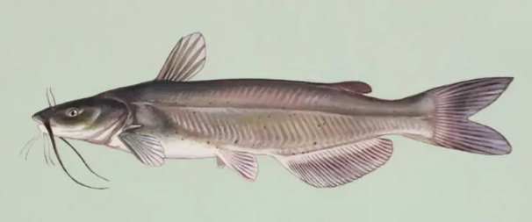
- How long are the channel catfish fingerlings when they arrive at Shanksville-Stonycreek School in October each year?
How long are they when the students release them in May?

- Which government agency does the school collaborate with for this project?
  - Pennsylvania Department of Agriculture
  - Pennsylvania Animal Control
  - Pennsylvania Fish and Boat Commission
  - Pennsylvania Department of Conservation and Natural Resources

- Where do students raise the catfish at the school?
- What are three pieces of equipment necessary for raising the catfish? What are their functions?
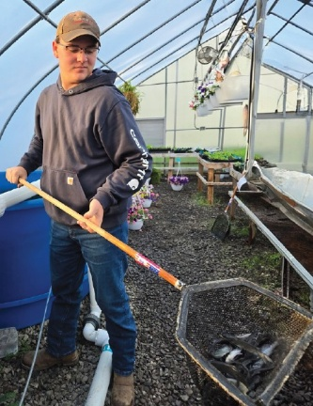

- What are four tasks the students perform while raising the fish?

- Fill in the quote from advisor, Britton Stutzman, below.
"They learn about _________________, _____________________, ________________ and all of the aspects that affect _______________ ____________________. If a __________________ __________________ isn't done, they can see the ________________ firsthand, and they are learning how ________________________ it is to take care of the ______________________________ we have."
- What activities do students participate in when it comes time to release the fish?
- What impact does Don Anderson, district commissioner with the Pennsylvania Fish and Boat Commission, hope this program has on students who participate?

Part 2
Directions:
Choose a freshwater fish species native to your area and research it using the table below.

Common Name: |  | Scientific Name:
Natural Habitat: |  | Regions It's Located In:
Typical Adult Size: |  | Preferred Water Temperature Range:
Diet: |  | Natural Predators:  (if any)
Describe the fish’s natural environment (water movement, clarity, depth).
Why is this fish important in the local ecosystem? What role or function does it serve?
Draw or paste a picture of your fish below.

Part 3
Directions:
Do additional research on your selected fish species and how it can be raised in a controlled environment. Create a plan for an aquaculture system design that could be used to raise this fish at your school.
System Type: (circle one) | Tank Pond Recirculating System
System Size: (in gallons)
How will water temperature be controlled? |  | How will oxygen be supplied?
What type of filter will your system use?  Why did you choose this filter? |  | Explain how your fish will be fed. What food will you use? How often will you feed? How will you feed?
What additional equipment or tools would be helpful in raising this species in an aquaculture setting? |  | Are there any government agency programs in your area like the one described in the article? If so, describe them below.
What is one challenge you might encounter in raising this fish species?
What is a possible solution to the challenge you identified?
Conclusion Questions:
- Why might raising native fish be better than raising nonnative fish?
- How could aquaculture help support food systems and/or conservation efforts?

