Aligned to the following standards: FFA.PL-A; FFA.PL-D; FFA.PL-E; FFA.PL-F; FFA.PG-H; FFA.PG-K; CCSS.ELA.RI.9-10.7; CRP.01; CRP.04; CRP.09
Appendix 3: Finding Focus in FFA
Part 1
Directions:
Read the article “Finding Focus in FFA” in the fall/winter 2024 issue of FFA New Horizons and answer the questions below.
- What condition were Faith and Caleb Snapp diagnosed with?
- What livestock species did the Snapp twins begin raising when they were in third grade?
a. Cattle b. Sheep c. Goats d. Chickens
- What is included in the process of being matched with a guide dog through Guide Dogs for the Blind?


- What kinds of things does Faith’s guide dog, Prim, help her do?

- List all the FFA activities the Snapp twins and their guide dogs participated in, as mentioned in the article.
Faith (and Prim) | Caleb (and Grit)
 | 

- Fill in the two quotes from the Snapp twins with the missing words:

"Even when I was kind of _______________________, my ag teachers were always _____________ _______________________ and pushed me ___________________ than I ever thought I could ever go, including the _________ ___________ _________.
—Caleb Snapp

"I want to be a voice of ________________________ to anybody who’s wanting to run for an ______________ _____________, ___________ an __________________ or even take an ___________________________ class. I will always _________________ for others and always _________________ ____________________ of FFA … because I wouldn’t be here _____________________ all the things I’m doing if it weren’t for the ____________________________ that ___________________________ me.
—Faith Snapp
- What are each of the twins doing now that their time in FFA helped to prepare them for?

Part 2
Directions:
Use the American Kennel Club’s page on service dogs (https://www.akc.org/expert-advice/training/service-dog-training-101/) to answer Questions 1 to 6. Then, perform your own research about organizations in your state or region to answer Questions 7 to 9.


- According to the Americans with Disabilities Act, what is a service dog?

- What are three examples of types of service dogs, and what is each trained to do?

- Are there any breed restrictions to be considered a service dog? Why or why not?

- What identification requirements exist for service dogs?

- What are the characteristics of a good service dog candidate?
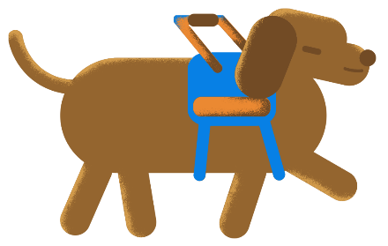

- In one or two sentences, summarize “The Epidemic of Fake Service Dogs.”

Do some research on service dog organizations in your own state or region and answer the following questions.
- List two organizations in your state or region that assist in training and/or providing guide dogs for individuals. Provide their websites as well.

- Pick one of the organizations you listed above. What are the qualifications/requirements for individuals wishing to raise or train guide dogs?
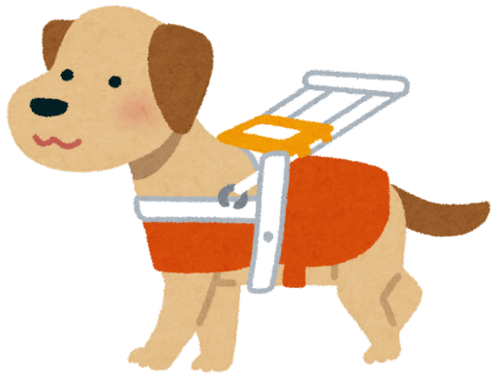

- What are two questions you have for this organization?

Part 3
Directions:
Throughout the article, the Snapp twins explain how much their FFA community made them feel welcomed and included. Review the FFA Value Statements below. For each value statement, explain, using an example from the article, how it was demonstrated in the Snapp twins’ experiences in FFA.

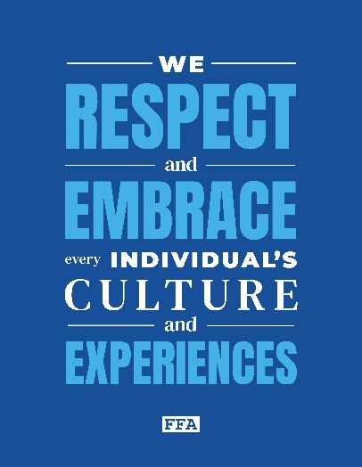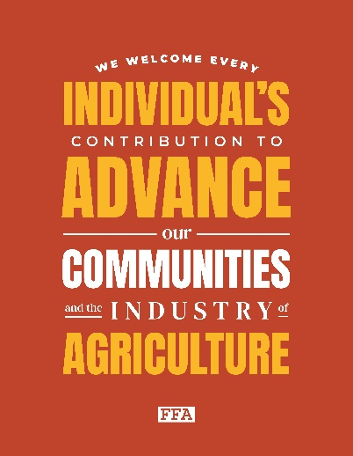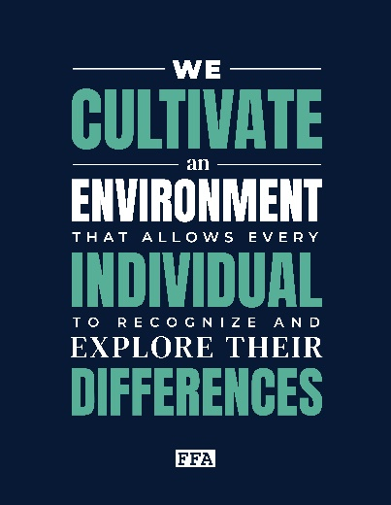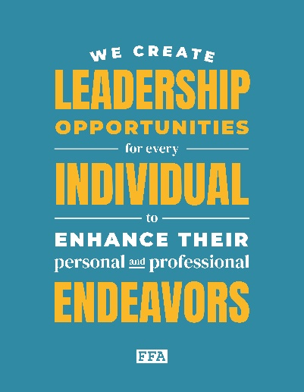

Value Statement:
We respect and embrace every individual’s culture and experiences.
Example from the article:

Value Statement:
We welcome every individual’s contribution to advance our communities and the industry of agriculture.
Example from the article:

Value Statement:
We cultivate an environment that allows every individual to recognize and explore their differences.
Example from the article:

Value Statement:
We create leadership opportunities for every individual to enhance their personal and professional endeavors.
Example from the article:

How have you seen any of the value statements represented in your own FFA chapter or agriculture class?

