Appendix 3: Leading the Change
Aligned to the following standards: CS.05, FFA.PL-A., FFA.PL-C., FFA.PL-E., FFA.PL-F., FFA.PG-I., FFA.PG-J., FFA.CS-M., FFA.CS-N., CCSS.ELA-Literacy.RI.9-10.2, CCSS.ELA-Literacy.RI.9-10.4, CCSS.ELA-Literacy.SL.9-10.1, CRP.02, CRP.04, CRP.07, CRP.08

Part 1
Directions:
Read the article “Leading the Change” in the spring 2023 issue of FFA New Horizons and complete the following questions.

1. In which state was Hodge an FFA member? Highlight the correct answer in YELLOW.
Iowa | Michigan | Texas | Washington, D.C.

2. What was unique about Hodge’s earning the American FFA Degree?

3. What was a potential limitation female FFA members, prior to Hodge, had earning their American degrees?

4. How did Hodge get started with the USDA?

5. What is the purpose of Hodge’s role with the USDA and NASS?

6. Hodge states her position is impactful. How do you plan on being impactful in your future career?

7. What does it mean to be a public servant?

8. How could you be a public servant in your community?
Part 2
Directions:
Using the American FFA Degree handbook, website and other references listed below, complete the activities to learn more about earning your American FFA Degree.

The Gold Standard: Earning the American FFA Degree
Resources to Use
American FFA Degree Website: FFA.org/participate/awards/american-ffa-degree/

American FFA Degree Handbook: https://ffa.app.box.com/s/li1lsntok48fxy5khgqur6t8srd1id6w

Introduction
*The American degree is the ___________ degree an FFA member can achieve. It is the _________________ in an FFA degree system that encourages personal growth and achievement. The degree is a high and ________ honor, less than __________________ of FFA members earn it.

It requires commitment and hard work to attain, but you don’t have to be ____________________________________________ to reach this goal. The FFA degree system is organized so that all FFA members have _____________________________ at the American FFA Degree, no matter where they come from.

The American FFA Degree requires at least __________________ to meet the requirements. Plan and set goals early to earn the degree.

Why Earn the Degree?
*________________________________: Many members have said that there is no greater satisfaction than walking across the stage at the National FFA Convention to receive their American FFA Degree key and certificate. In addition, recipients’ names are listed in the American FFA Degree convention booklet and the official proceedings of the convention.
*________________________________: An SAE that leads to an American FFA Degree provides training and experience that enables members to enjoy a useful, interesting and challenging career later in life. Listing the receipt of the American FFA Degree on a job resume stands out to employers in agricultural career areas.
*___________________________________________: Everyone must compete to secure a job or a position to start a career and make a difference in the world. Meeting the degree requirements teaches members to reach career goals and provides learning experiences that complement classroom education.

Qualifications
When do you earn the American FFA Degree?
Who can earn the American FFA Degree?

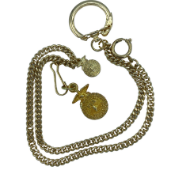

How long must you have been an active member in the FFA to receive the American degree?
What degree must be earned prior to receiving the American degree?

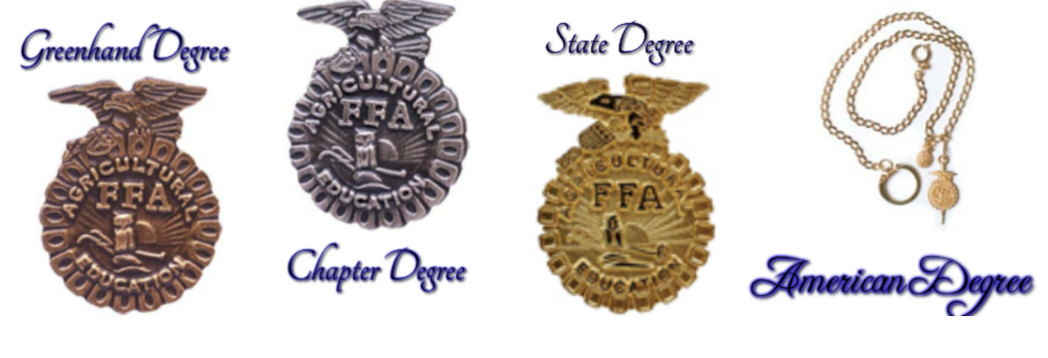

What are the educational requirements for earning the American degree?

Hours:

Graduation:

Scholastic record:

Community service:

What are the SAE financial requirements for earning the American FFA Degree?

An SAE that demonstrates _____________________________________, managerial and financial expertise.

Option 1: earned _____________ and productively invested at least ____________, through an eligible SAE

Option 2: earned and productively invested at least ___________ and worked _____________ in excess of scheduled class time in an eligible SAE

Option 3: Any combination of hours times a factor of ________ plus any dollar amount of student earnings and investments must be equal to or greater than _______________________.

*Identify two goals that can help you earn the American FFA Degree.
1.

2.

Part 3
Directions:
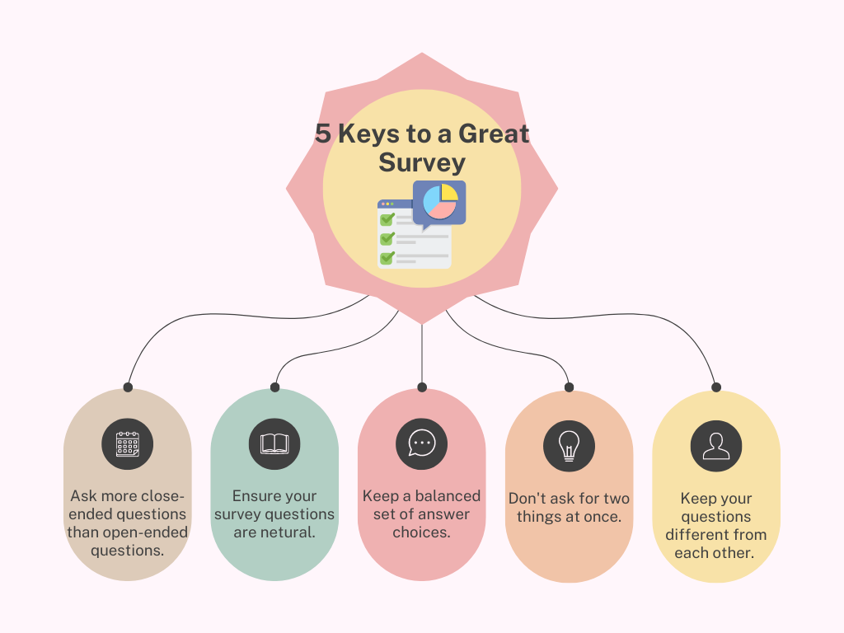
Think about the work Mrs. Hodge does at the NASS with statistics and surveys. Now, you’ll develop your own survey about an agricultural topic using the tips shown below that you could administer to your classmates and other peers within your school and community. Use the brainstorming section to help you create this survey and then follow your teacher’s direction for putting the survey into the format they prefer, such as a Google Forms, JotForm or SurveyMonkey.

Survey Brainstorming

Survey Topic:

Why is this topic relevant or important?

What is your end goal with the data you will gather from the survey?
(Examples: Agriscience fair project, SAE, FFA chapter project, community service project, etc.)

Who is your target audience?

Demographic Questions to Include: (Examples: age, gender, ethnicity, rural/urban/suburban)

Questions Specific to Topic:

*Why are surveys important to you and your family? Cite two examples of a survey that could impact you and/or your family.

