Aligned to the following standards: CS.02; CS.05; FFA.PL-A; FFA.PL-C; FFA.PL-E; FFA.PL-F; FFA.PG-I; FFA.PG-J; FFA.CS-M; FFA.CS-N; CCSS.ELA.RI.9-10.2; CCSS.ELA.RI.9-10.4; CCSS.ELA.W.9-10.2; CCSS.ELA.W.9-10.3; CCSS.ELA.W.9-10.4; CCSS.ELA.SL.9-10.1; CCSS.ELA.L.9-10.6; AG2; AG5; CRP.02; CRP.04; AGC09.02
Appendix 3: Attention Future Ag Teachers
Part 1
Directions:
Read the article “Attention Future Ag Teachers” in the fall 2023 issue of FFA New Horizons and answer the questions below.

- When is National Teach Ag Day in 2023?

- Fill out the sticky notes below with information from the article.


2. _____ ___ _______________
“Teaching is not just an ______ to ______ job, ____________________ for ag teachers.”

- What does Mr. Davenport say one can expect as an agriculture teacher?

- How does he say agriculture teachers “prepare students for life in general”?
1. ________ ______ __________
“You ______________ know what you might _________________.”

- What topics could agriculture teachers end up teaching about?
- What other kinds of classes does Mr. Davenport say could be beneficial to future agriculture teachers?



Draw an icon below to go with each piece of Mr. Davenport’s advice.
3. _____ ________________
“Be willing to _____________ and ___________ _________________________ of the box and go with the _____________ to maximize the ________________ of your program.”

- What does Mr. Davenport credit for the increased community awareness and involvement in his program?

Part 2
Directions:
Find a college or university in your state or a neighboring state that offers a degree in agricultural education. Create a banner about that institution using the template below. Information you could add to your banner:
- Name of institution and logo
- Campus information (number of students, location, amenities, etc.)
- Cost of attendance
- Admission requirements
- Contact information for the department that offers the agricultural education degree
- Other selling points for the school

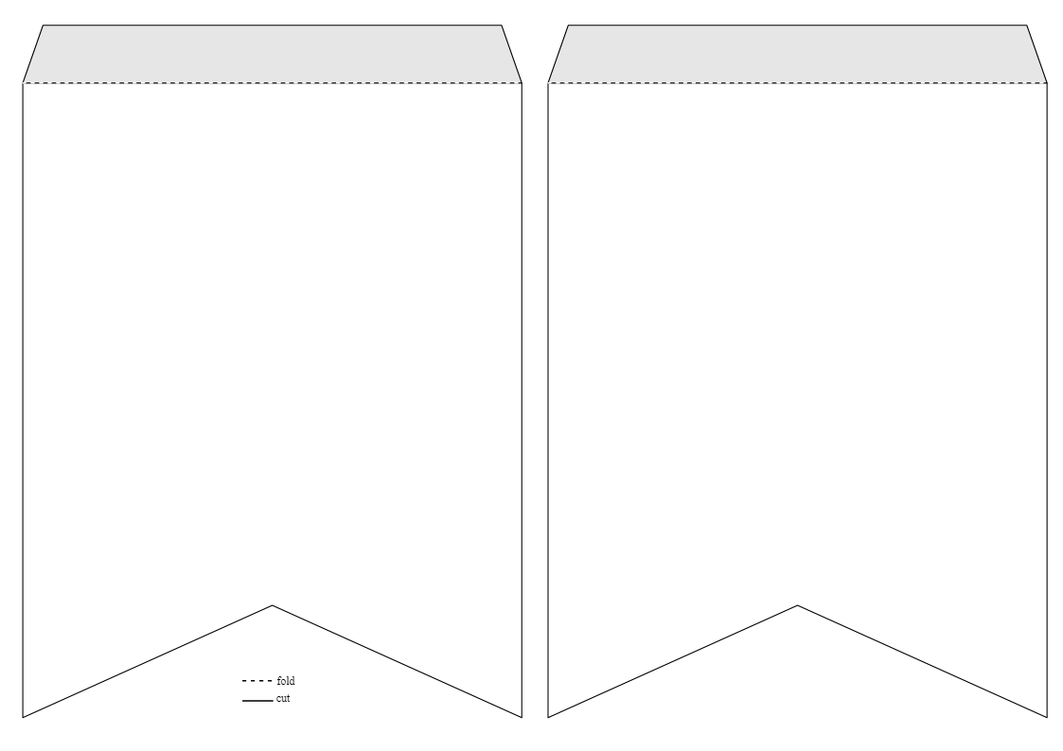

Part 3
Directions:
Using the template below, create a job post for an agriculture teacher. You may use AgExplorer.FFA.org/career/agriculture-science-teacher-secondary/ to help you create the post.

Job Post: Agriculture Teacher
School Name/Location:
Job Description:
(four to six sentences)
Job Requirements:  (Education, training, experience, certification, etc.) |  | Job Responsibilities:
Salary:

- What are two reasons we need to recruit quality agriculture teachers?

- Based on your experience in agricultural education courses, what would be one additional piece of advice you would give to someone pursuing a career as an agriculture teacher?

