Aligned to the following standards: AG1; AG5; AG6; CS.01; CS.05; CS.06; FFA.PL-A; FFA.PL-C; FFA.PL-E; FFA.CS-P; CCSS.RI.9-10.1; CCSS.RI.9-10.2; CCSS.W.9-10.2; CRP.02; CRP.05; CRP.07; CRP.08; AS.01
Appendix 4: For the Love of Livestock
Part 1
Directions:
Read the article “For the Love of Livestock” in the spring/summer 2024 issue of FFA New Horizons and answer the questions below.
- Draw pictures of the two livestock animals that Casey started showing in middle school:
Animal 1 | Animal 2

- 2. Which event changed Casey’s mind about pursuing a career in agriculture?
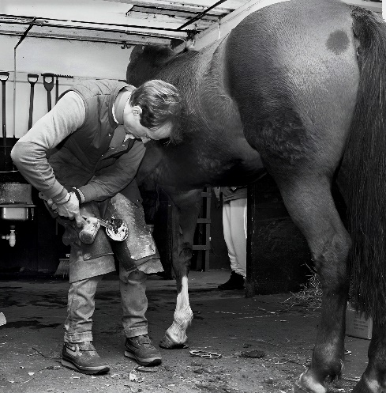
A. National FFA Convention
B. California State FFA Convention
C. California State Leadership Conference
D. NextGen Conference
- In 2020, what business did Casey start that involved horses?

- Casey says, “Even if it was something I wasn’t 100% into, I gave it a shot, and a lot of time it turned out to be a great experience.” Describe a time in your life to which you can apply that quote (this can be in school, FFA, work, etc.).

- What college did Casey apply to and ultimately get accepted into?

- What were his two majors in college?

- During his sophomore year in college, which team did Casey join?
A. Livestock Evaluation Team
B. Livestock Showing Team
C. Meats Judging Team
D. Meat Grilling Team

- Label the countries shown below where Casey has competed with his college:

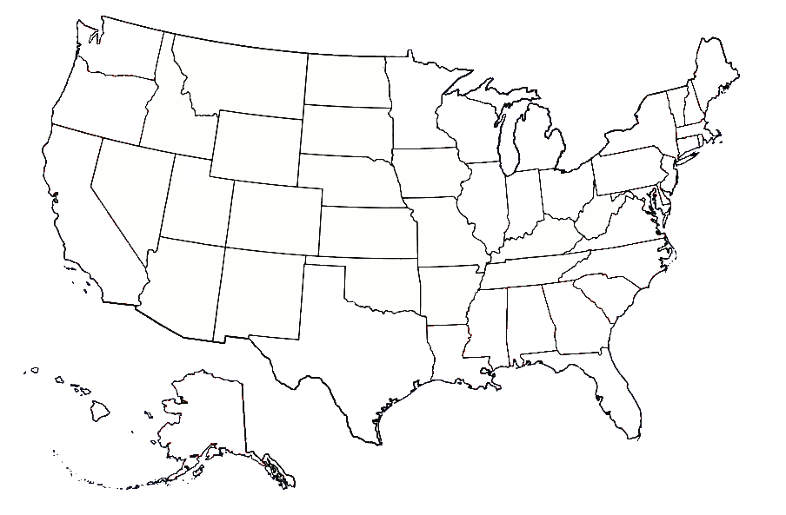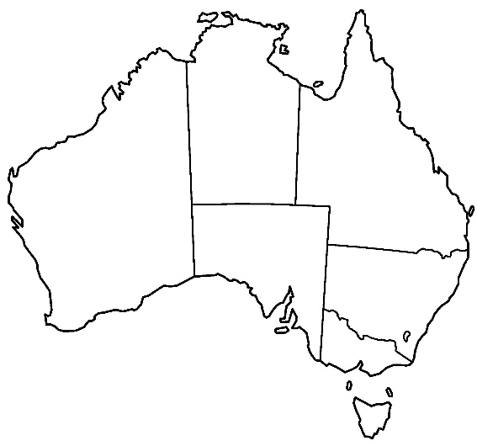

- While competing in Australia, what happened to Casey?

- When did Casey earn his American FFA Degree?

- Based on this article, name two potential supervised agricultural experiences (SAEs) that you think Casey used on his American FFA Degree application:
(Learn more about SAEs here, https://saeforall.org/.)

- Who does Casey say helped him build his confidence and explore agriculture more?

Part 2
Directions:
Using the American Meat Science Association website (https://meatscience.org/students/meat-judging-program), answer the following questions.
3. Contests for the IMJP have been held every year since it started, except 1942-1945. Why was it not held in those years?
1. The Intercollegiate Meat Judging Program (IMJP) started in which year?
A. 1969
B. 1926
C. 1990
D. 1928

4. Today, there are six contests.
List them:

2. Where did the Intercollegiate Meat Judging Program start?
5. Meat judging programs are an effective tool for what?
6. Fill in the blanks on how participating on a meat judging team can benefit someone:
- Learn how to determine the _______________ of meat
- Learn how to determine the ____________ meat yield of a carcass or wholesale cut
- Serves as a _____________________ tool for youth and college students
- The deep-rooted __________________ of the meat industry

Scroll to the bottom of the page. There is a section that has logos of sponsors. Choose one logo and click on it. Browse the website for that sponsor. Below, explain in your own words why you think this company is sponsoring the Intercollegiate Meat Judging Program. Think of what benefit this company could receive.

Part 3
Directions:
Getting started in meat judging requires basic knowledge of where retail cuts of meat come from. Use the Certified Angus Beef site to help you with this activity: https://www.certifiedangusbeef.com/cuts/.

Below is a beef steer with sections marked to help you learn where retail cuts of meat come from. For each section, draw a line to the empty space around the steer and list two retail cuts of meat from that section.

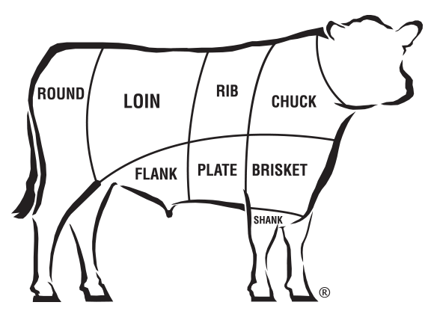

Now, using the same website as the previous activity, draw a line to match the beef retail cut with its correct name.

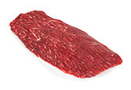
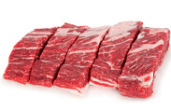
Ribeye Roast

Flat Iron

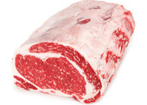
Whole Brisket
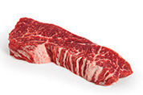

Boneless Country Style Ribs

Inside Skirt

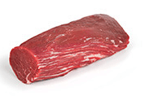
Filet Mignon
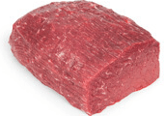

Tri-Tip Steak

Cowboy Steak

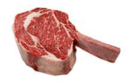

Top Round Roast
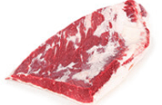

Tenderloin Roast

