Aligned to the following standards: FFA.PL-A; FFA.PL-C; FFA.PG-I; FFA.CS-N; FFA.CS-O; FFA.CS-P; CS.01; CS.02; CCSS.ELA.RI.9-10.1; CCSS.ELA.W.9-10.1; CCSS.ELA.W.9-10.7; CCSS.ELA.W.9-10.8; CCSS.ELA.W.9-10.9; CCSS.ELA.L.9-10.6; CRP.02; CRP.05; CRP.06
Appendix 4: Starting From Scratch
Part 1
Directions:
Read the article “Starting From Scratch” in the fall/winter 2024 issue of FFA New Horizons and answer the questions below.

- Fill in the facts about the Weeping Water FFA Chapter.

What year was the chapter established? | How many active members do they have? | Why was an FFA chapter needed? | What are the two main focuses of the chapter?

- What is the main reason students decided to pursue creating the Limestone Coffee Co.?

- Why was important for students to answer the following key questions before starting the business: What will be on the menu? What is our profit margin? How will we market it?

- Describe two benefits of the Limestone Coffee Co. (for students and/or the community).

  - Benefit 1:

  - Benefit 2:

- Student Katie Meyer says two skills they learned were leadership and organization. Name three other skills you think students learned from this business.





Part 2
Directions:
The Limestone Coffee Co. serves Starbucks Coffee. Let’s learn more about the coffee from Starbucks. Answer the questions below by exploring the Starbucks website: https://www.starbucks.com.cn/coffee-blog/en/the-origin-of-coffee-and-its-cultivation/.

The Origin of Coffee and Its Cultivation
1. What three things influence the distinctive flavors of coffee beans?
a. ______________________________
b. ______________________________
c. ______________________________

2. Color in the three global coffee-growing regions on the map below.
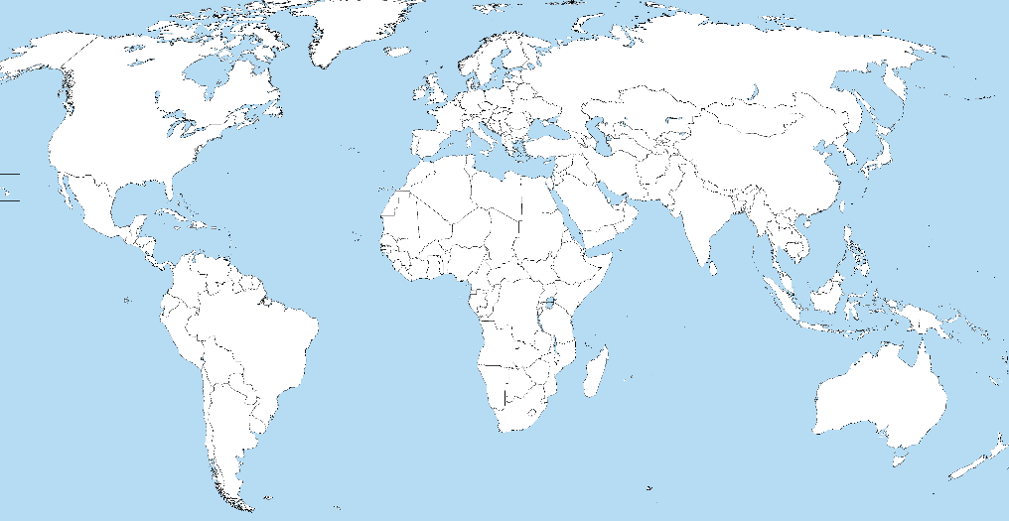
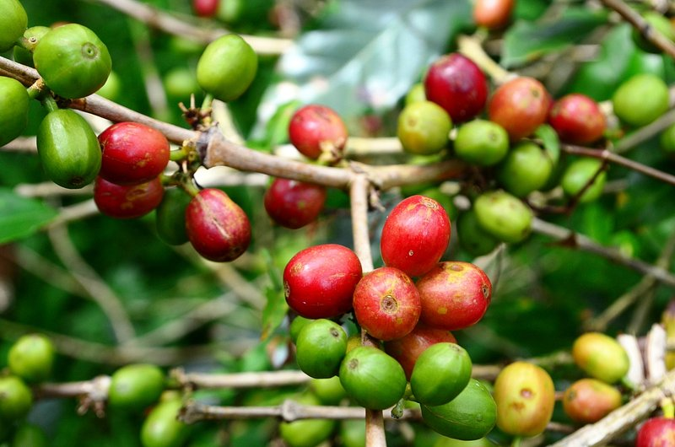
All About Arabica Coffee
6. List three facts about arabica coffee.
a. _____________________________________________________________________________
b. _____________________________________________________________________________
c. _____________________________________________________________________________

YUM!
3. How tall can some coffee trees grow?

4. How long does it take a tree to produce what most people can enjoy in a single week?

5. Name the two commercially important coffee species:
a. ____________________________________
b. ____________________________________
All About Canephora (robusta) Coffee
6. List three facts about canephora (robusta) coffee.
a. _____________________________________________________________________________
b. _____________________________________________________________________________
c. _____________________________________________________________________________

7. Draw and color in a coffee cherry correctly, indicating it is ready for harvest.

8. Label the coffee cherry with the following parts: skin, fruit, protective pocket, coffee bean (pit).
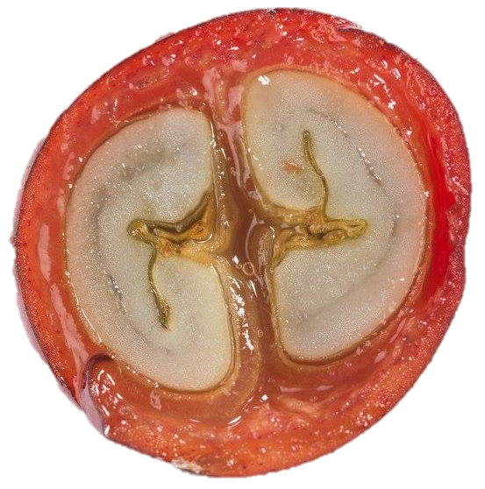

9. Based on what you’ve read, why do you think coffee is not commonly grown in the United States?

10. Even though our country does not grow a lot of coffee, how do you think coffee production makes an impact in our economy?

Part 3
Directions:
Starbucks Coffee ensures they are using only the highest quality arabica coffee beans for their coffee products. Using the comic strip space below, draw images that represent the steps the company takes to make sure their beans meet their standard. Use this website to help you: https://www.starbucks.com.cn/coffee-blog/en/starbucks-higher-arabica-standards/.
6.
5.
4.
3.
2.
1.
Why do you feel that Starbucks uses arabica coffee more than canephora coffee? (Give three reasons.)

