Appendix 4: Protecting Pollinators
Aligned to the following standards:
CS.01; CS.02; CS.05; FFA.PL-A; FFA. PL-E; FFA.PL-F; FFA.PG-I; FFA.PG-J; FFA.CS-M; FFA.CS-N;FFA.CS-O; AG1; AG2; AG5; CCSS.RI.9-10.2; CCSS.RI.9-10.4; CCSS.SL.9-10.4; CRP.02; CRP. 04; CCSS.W.9-10.2; CCSS.W.9-10.4
Created: Fall 2020 by the National FFA Organization

Directions:
Part 1
Read the article “Protecting Pollinators” in the fall 2020 issue of FFA New Horizons and complete the following activities.

- Populations of the iconic pollinator have experienced significant _____________ over the last _________ years.

- A group of scientists, conservationists, corporate leaders and farmers are working to increase them through habitat creation and restoration. What is the group known as? ____________________________________

  - What groups are part of this collaboration? _______________, ___________ Agriscience and _________________

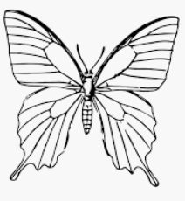
- In the space below, explain what each of these companies has done for the pollinator initiatives:

Summarize the article in one sentence:
4.
Directions:
Part 2

Use the following website, or a similar one, to label the different parts of the butterfly: https://www.enchantedlearning.com/subjects/butterfly/allabout/.
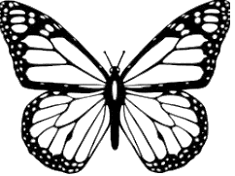

What is the life cycle of a butterfly? Draw each step of the life cycle in the boxes below (one in each box). Then, describe each step.

What type of habitats are most butterfly species found in?

Directions:
Part 3

Use the space below to design a pollinator garden. Use the following websites, or similar ones, to aid in your research and design: https://www.basf.com/us/en/media/featured-articles/Sustainability/BASF-gets-farmers--golf-courses-on-board-to-revive-monarch-butterfly-population.html, https://www.fws.gov/midwest/news/PollinatorGarden.html and https://www.gardeners.com/how-to/pollinator-garden-design-for-bees/9144.html.

Before designing your garden, let’s do some research about what you will need. Use this website to help with your research: https://www.fws.gov/midwest/news/PollinatorGarden.html.
What is the best location for your garden?
What is the best type of plants and why?
What do you need to know to prep your garden area?
Use this space to design your pollinator garden.

List the supplies (specific plants) you will need for your garden:

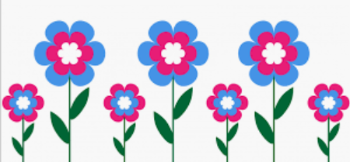
Research where you can buy the supplies needed for the butterfly pollinator garden. What is one place you can purchase the items from?

Directions:
Part 4

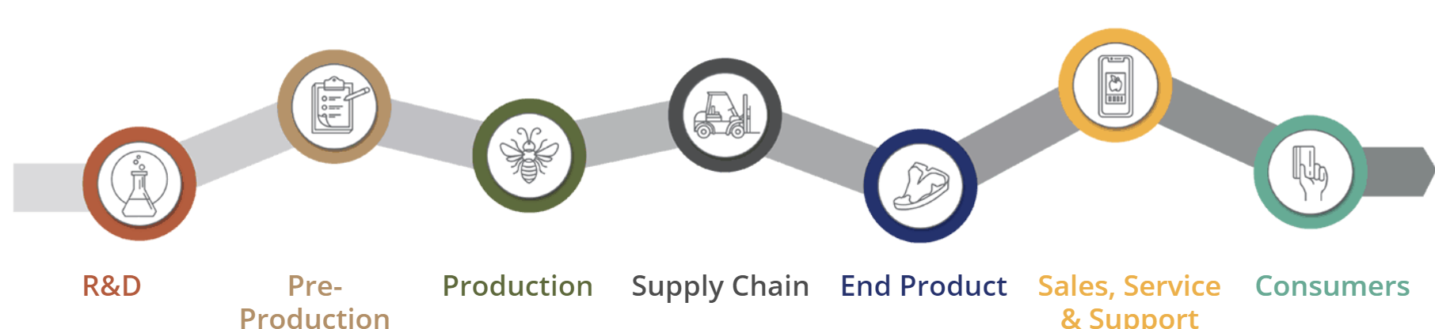
Use the following website to complete the activities below: FFA.org/value-chain/.

Complete the questions below to learn the impact of a pollinator garden on the Agriculture, Food and Natural Resources (AFNR) Value Chain.

- What role/impact do pollinators have in each step of the chain? Provide your answer next to each step of the chain identified below.



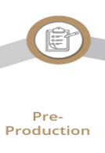



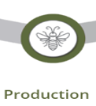

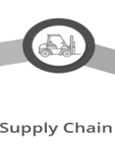



What is one fact you learned about the AFNR Value Chain?



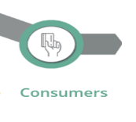
After reviewing and learning about each step in the value chain, what is one question that you still have?

Aligned to the following standards:
CS.01; CS.02; CS.05; FFA.PL-A; FFA. PL-E; FFA.PL-F; FFA.PG-I; FFA.PG-J; FFA.CS-M; FFA.CS-N;FFA.CS-O; AG1; AG2; AG5; CCSS.RI.9-10.2; CCSS.RI.9-10.4; CCSS.SL.9-10.4; CRP.02; CRP. 04; CCSS.W.9-10.2; CCSS.W.9-10.4

