Appendix 7: Bulrush in the Bayou
Aligned to the following standards:
FFA.PL-A; FFA.PL-E; FFA.PL-F; FFA.PG-I; FFA.PG-J; FFA.CS-M; FFA.CS-N;FFA.CS.O; CCSS.ELA.W.9-10.2; CCSS.ELA.W.9-10.4; CCSS.RI.9-10.2; CCSS.RI.9-10.4; CCSS.SL.9-10.2; CCSS.SL.9-10.4; CRP.02; CRP.04;CS.05;AG5

Created: Fall 2020 by the National FFA Organization

directions

Part 1
Read the “Bulrush in the Bayou” article in the Fall 2020 issue of FFA New Horizons answer the following questions.

- The ___________ FFA Chapter is helping to ________ Louisiana _________.

- What is the goal of the students when they step into the swamps?

- Where did the chapter receive their grant from? How much was the grant for?
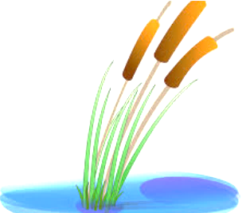

- What did the students do with the funds received from the grant?

Who did the chapter partner with?

5. During the 2019 field day, the Springfield chapter planted _________
California bulrush weeds?
- 5,000
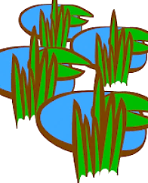
- 7,000
- 12,000
- 10,000

6. How did COVID-19 affect the 2020 plans, and what do they plan to do to overcome it?

What supplies do the students take with them to the swamp?

Part 2
Go to AgExplorer, AgExplorer.ffa.org, to learn about careers related to wetlands. Research five careers that are associated with wetlands and/or environmental service systems and complete the information below about each of the careers.

Career:

Recommended High School Courses:

Education/Training Required:

Career:

Recommended High School Courses:

Education/Training Required:

Career:

Recommended High School Courses:

Education/Training Required:

Career:

Recommended High School Courses:

Education/Training Required:

Career:

Recommended High School Courses:

Education/Training Required:

Does one of these careers interest you?
Explain your answer. If none interest you, what career field does interest you and why?

Part 3
Go to this website or one similar, https://www.nps.gov/subjects/wetlands/why.htm#:~:text=Wetlands%20are%20highly%20productive%20and,provide%20wildlife%20habitat, and answer the questions below to learn more about wetlands.

- Overall, why are wetlands important?

- What are seven specific reasons why wetlands are important?

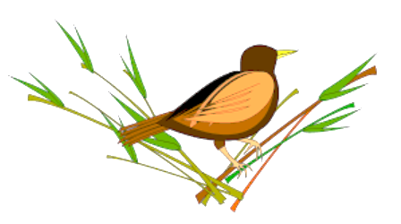

- What type of wildlife habitat do wetlands provide?
__________________________________________________________________________________
__________________________________________________________________________________
__________________________________________________________________________________
____________________________________________________________________________________

- Explain the habitat for threatened and endangered species.

Use these sites to help with your answer: https://www.neefusa.org/nature/land/wetlands-united-states and
https://www.fws.gov/wetlands/data/Mapper.html. (Click on wetlands mapper at the bottom of the page, check the wetlands box to the left and click the legend.)
Do you know of a wetland in your state or area?
If so, where is it located?
Part 4
Design your own wetland (for your backyard or an area in your town). Take what you have learned thus far and design your own wetland. Utilize the following website, or one similar, to design your wetland: https://www.nwf.org/Magazines/National-Wildlife/1997/How-to-Create-a-Mini-Wetland.

Read the article on the above website, and apply the steps/guidelines to design your own wetland. Use the space below to sketch out your plan.

What plants did you chose to include in your wetland and why?

How can you take what you have learned about wetlands and use it in your life (future career, home, etc.)?

