Sensational Soy
Aligned to the following standards:
FFA.PL-A; FFA.PL-E; FFA.PL-F; FFA.PG-I; FFA.CS-M; FFA.CS-N; CCSS.RI.9-10.2; CCSS.RI.9-10.4; CCSS.SL.9-10.2; CCSS.SL.9-10.4; CCSS.WHST.9.10.4; CRP.02; CRP.04; CRP.05; CRP.07; CRP.08; CRP.11
Part 1
Directions:
Bell Ringer: Circle the products below to identify what you have used and/or consumed.
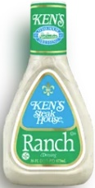

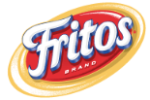
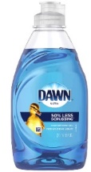


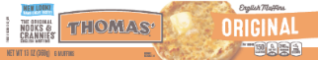
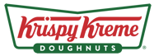
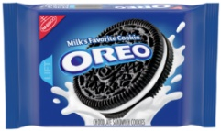

- How many items did you circle? _____/7
- What do you think each of these products have in common?

Directions: To better understand where soybean oil comes from, let’s take a look at the soybean. Use the NC Soybeans Producers Association website: https://ncsoy.org/media-resources/uses-of-soybeans/.
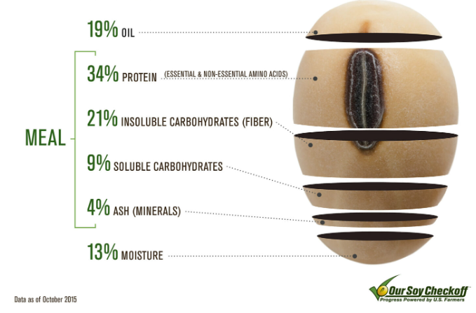
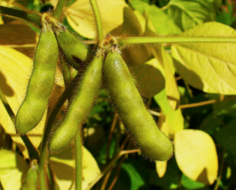
How much oil comes from the soybean seed? _________%
- What are some uses for soybean oil?
- ________________________________________________________________
- ________________________________________________________________
How much meal comes from the soybean seed? _________%
- What is one of the largest uses of soybean meal?

How much moisture does the soybean contain? __________%
Pods that hold the growing soybean.

- Who is Henry Ford? _____________________________________
- Watch the video available at https://youtu.be/kS6e797W4iA, and summarize the use of soy by Henry Ford.

- What do you think would have changed if the war had not interrupted Henry Ford’s work? Give an example that would impact you today.
Identify three products that contain soybean oil that you use or are impacted by regularly.

- ___________________________________
- ___________________________________
- ___________________________________

Directions: Let’s put Henry Ford’s research into action on a smaller scale.
- Supplies Needed:
  - 1 small Ziploc bag
  - 1 tablespoon cornstarch
  - 1 tablespoon water
  - 1/8 teaspoon soybean oil
  - 2-3 drops food coloring of choice
  - Microwave
  - Eye dropper or pipette
  - 1-tablespoon measuring spoon
  - 1/8-teaspoon measuring spoon
- Directions:
- Open the Ziploc bag.
- Add cornstarch, water, soybean oil and food coloring.
- Remove all the air from the bag and zip it closed.
- Using your hands, mix the ingredients until thoroughly mixed.
- If the mixture is dry, add a small amount of water.
- Open one inch of the zipper on the baggie to serve as a vent.
- Place the vented bag in the microwave for 20 to 30 seconds.
- Carefully remove bag from microwave. Use caution to avoid burning your hands.
- Once cool, open the bag away from your face in case there is more steam contained in the bag.
- Answer the questions below.
Answer the following questions based on what you just made.

- What did you make? _______________________________________________
- Describe your creation.

- How do you think this compares to what Henry Ford created?

- How can soybean oil impact the way we live every day?

- Imagine soybean oil did not exist. What would be the impact on the world and/or your life? Give at least one specific example.

Part 2
Directions: Now that we have a better understanding of soybeans, let’s take an even closer look. Soybeans are a crucial staple in the agriculture industry, but they also play a large role in what we do every day. Use the U.S. Soy website, https://ussoy.org/, to learn about the various uses and benefits of soybean oil.
Food and Lifestyle
- How does soy impact you through the food you eat and the lifestyle you live?

- Identify a food or lifestyle item that is currently in your bag, in your current space or that you interacted with today.

______________________________________________________
- Watch the following video: https://youtu.be/LYjkZXbjHWE. Why is soybean oil considered healthy?

- Find a food label that includes soybean oil and attach it here.
Animal Nutrition
- Describe the role that soy plays in the world of animals.

- List two animals that benefit from soy production.
(1)

(2)

- How does the impact of soy on animals impact you?

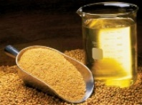
Sustainability
- How is sustainability being considered when thinking about soybean production?
Around the World
- Select an article about soy. Based on what you have read, describe the impact and role of soy.
Innovation
- What types of innovations exist that utilize soy? Give one specific example.

Soybean oil is one of the main products of soybeans. Use the USDA chart below to learn about soybean oil supply and demand.

- According to the chart, is soybean oil production increasing or decreasing? (Circle the correct response.)

- Roughly, how much soybean oil was produced in 2021-22? _____________________ million pounds

- How much soybean oil was used for food and other uses in 2021-22? ______________________ million pounds

- How much has soybean oil production increased in total from 2017-18 to 2021-22?
________________________ million pounds

- Which type of oil is utilized the most for biofuels in the U.S. in 2021-22? ____________________ at ________%

- In one to three, sentences describe the data displayed in the charts above.

- Identify three more products that contain soybean oil that you use or are impacted by regularly.

- ______________________________________________
- ______________________________________________
- ______________________________________________

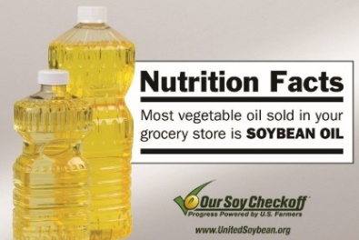
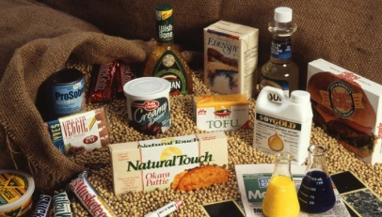
Part 3
Directions:
Develop a 90- to 120-second video/reel that explains and depicts the importance of soybeans and soybean oil in our everyday lives. Be sure to use examples. Use the space below to plan your video/reel.

Area | 4 Points | 3 Points | 2 Points | 1 Point
Content | All content is accurate. There are no factual errors. | Most of the content is accurate, but there is one piece of information that seems inaccurate. | The content is generally accurate, but one piece of information is clearly inaccurate. | Content is confusing or contains more than one factual error.
Clarity and Creativity | The video is easy to understand, and all elements are clearly written or spoken. Creativity was used. | The video is easy to understand, and most elements are clearly written or spoken. Some creativity was used. | The video is hard to understand with very quiet speaking or very hard to read writing. Little creativity was used. | The video is hard to understand, and one cannot follow the thought process. No creativity was used.
Narration and Preparedness | The video is clearly rehearsed and presented with no mistakes.  Student spoke slowly and clearly. | One mistake is heard in the video. | Two mistakes are heard in the video. | Three or more mistakes are heard in the video.  Student spoke very fast and was unclear.
Time | Video was 90 to 120 seconds in length. |  |  | Student was either under or over the allotted time frame.

