Name: ________________________________________
Aligned to the following standards:
CS.02; FFA.PL-A; FFA.PL-E; FFA.PG-J; FFA.CS-M; FFA.CS-N; AG2; CCSS.ELA.RI.9-10.4; CCSS.W.9-10.1; CCSS.ELA.W.9-10.2; CCSS.ELA.SL.9-10.1; CCSS.ELA.SL.9-10.2; CCSS.ELA.SL.9-10.4; CCSS.ELA.RST.9-10.1; CCSS.ELA.RST.9-10.7; MP1; MP2; MP4; CRP.02; CRP.04; CRP.05; CRP.06; CRP.07; CRP.08; CRP.11
It’s All About Relationships
Part 1
Directions:
During the growing season and following the harvest of soybeans, what happens? There are key individuals who are responsible for advising and purchasing the soybeans and getting them where they need to go. Using both the video provided and AgExplorer, learn about key careers needed to make these processes happen.

Commodity Procurement/Merchandiser | Originator
- Video: https://youtu.be/F7t2fdUod1g?si=zhkr-eYjeZX3ToVa  - AgExplorer: AgExplorer.FFA.org/career/commodity-procurement-merchandiser/ | - Video (stop at 4:33): https://youtu.be/YFflOAgIeHs?si=xdlryyScV3baRGaj  - AgExplorer: AgExplorer.FFA.org/career/originator/
- In your own words, describe this career.  - What is the importance of this career to our food and product supply chain?  - Identify three specific skills you need to be successful as a commodity procurement/merchandiser.  - ______________________________________________________  - ______________________________________________________  - ______________________________________________________  - Using AgExplorer, identify a college/university you could attend in your state to prepare you for this career. | - In your own words, describe this career.  - What is the importance of this career to our food and product supply chain?  - Identify three specific skills you need to be successful as an originator.  - _________________________________________________  - _________________________________________________  - _________________________________________________  - Using AgExplorer, identify a college/university you could attend in your state to prepare you for this career.
- Using a Venn diagram, compare and contrast these two careers.
Commodity Procurement/Merchandiser
Originator

Part 2
One of the most important skills needed in any career is the ability to build professional relationships. But how is this done effectively? Complete the following activity to learn how to build professional relationships.

Using the dictionary, define the word RAPPORT: | Draw a picture that depicts the word rapport to you.
Describe why you think rapport is important in both your personal and professional life.
How do you think rapport could impact personal and professional relationships you currently have or are hoping to build?

Read the article available at https://www.betterup.com/blog/how-to-build-rapport. Complete the following activities to learn tips and tricks for building rapport. Note: There will be a gallery walk activity!
“If people like you, they’ll listen to you, but if they trust, you they’ll do business with you.” —Zig Ziglar


- Make a Good ____________________.
- In your own words, why is this important?

- What are three statements you could make to make a good first impression?

2. A________________ L _______________
- In your own words, why is this important?

- What are three ways you can exhibit this skill in a conversation?
(1)

(2)

(3)

3. Ask __________________________ Questions.
- In your own words, why would this be important in relationship building?

- What are three questions you could ask that would help you get to know someone better?





Find C___________________ G__________________.
- Why do you think it is important to do this when building professional relationships?

- What are three ways you could do this with a new individual you are trying to build a professional relationship with?
(1)

(2)

(3)
Lead With Empathy and Respect.
Using the dictionary, define empathy.

Using the dictionary, define respect.
How can you show empathy?

How can you show respect?
4. Be Aware of Your B___________ l_______________________.
- In your own words, what does this mean?
Give three examples of poor body language.

(1)
(2)
(3)
Give three examples of good body language.

(1)
(2)
(3)
Directions:
Next, you are going to put your rapport-building knowledge to the test! You are going to be paired with someone in your class that you don’t regularly talk to. You are going to need to build rapport with that classmate. Use the space below to plan some of the specific things you are going to do and say to ensure you are building a positive rapport with that person. In this space, you should have ideas from each of the major areas you learned from the previous activity. Use the attached rubric to understand how you will be evaluated.

- How are you going to make a good introduction?

- What are you going to do to demonstrate you are actively listening?

- What specific engaging questions are you going to ask? Tip: Consider school activities you both enjoy such as FFA, athletics, favorite food, etc.

- What types of body language do you need to be aware of when building rapport with your classmate?

- What specifically are you going to say and do to find common ground? Tip: Consider school activities you both enjoy such as FFA, athletics, favorite food, etc.

- What specifically are you going to do and say to lead with empathy and respect?

- Final thoughts?

 | Strong Evidence of Skill (5–4) | Moderate Evidence of Skill (3–2) | Weak Evidence of Skill (2–1) | Skill Not Demonstrated (0) | Points Earned
Brainstorm | Thoroughly completed all aspects of brainstorming | Four or more aspects of brainstorming completed | Less than four aspects of brainstorming completed | Brainstorming was vague or not completed.
Good Introduction | Thorough introduction | Introduction was made but could have more thought. | Minimal thought was put into making a good introduction. | No introduction was made.
Active Listening | Demonstrated proficient active listening | Moderate active listening skills exhibited | Weak active listening skills exhibited | Active listening was not demonstrated.
Engaging Questions | More than four engaging questions were asked. | Three or four engaging questions were asked. | One or two engaging questions were asked. | No engaging questions were asked.
Body Language | High positive body language for building a positive professional relationship | Moderate positive body language for building a positive professional relationship | Weak positive body language for building professional relationships | Unengaged, little to zero positive body language used for building positive professional relationships
Finding Common Ground | Found two points of common ground | Found one point of common ground | Attempted to find common ground | No attempt made
Leading With Empathy | Clear demonstration of empathy | _________________ | _________________ | No empathy shown
Leading With Respect | Clear demonstration of respect | _________________ | _________________ | No respect shown
Total: ________/40
Comments:

Reflection Questions:
- What went well when you were working to build rapport? Give at least three specific examples.

- What did not go well? Give two specific examples.

- How do you think originators and commodity procurement/merchandisers use rapport building to be successful in their careers?

Part 3:
Directions:
Once rapport has been built, soybeans can be sold through careers like an originator and commodity procurement/merchandiser. Soybeans must then travel to the processing facility. Complete the following activities to learn about the movement of raw materials.
Using the map from the United Soybean Board, what are the two major routes of transport for soybeans?
- ___________________________________________
- ___________________________________________

If there is no access to transportation from the above two methods, what third method do you think is most likely used to transport soybeans directly or to one of the above-mentioned methods? (Hint: You see this transport method every time you ride in a car.)

- __________________________________________________________

Imagine you have purchased a large number of soybeans and need to deliver those soybeans to the closest possible shipping port. Using the map below, complete the following:

- Place a star where you or your school is located.
- Draw a path on the map that depicts the path you will take to deliver the soybeans most efficiently to the closest port.
- In the remaining space below this question, draw a flow chart that identifies the methods of transportation you will be using in the order you will be using them. Tip: Research local major driving routes if ground transportation is needed. Check out a road atlas!

Flow Chart Here!

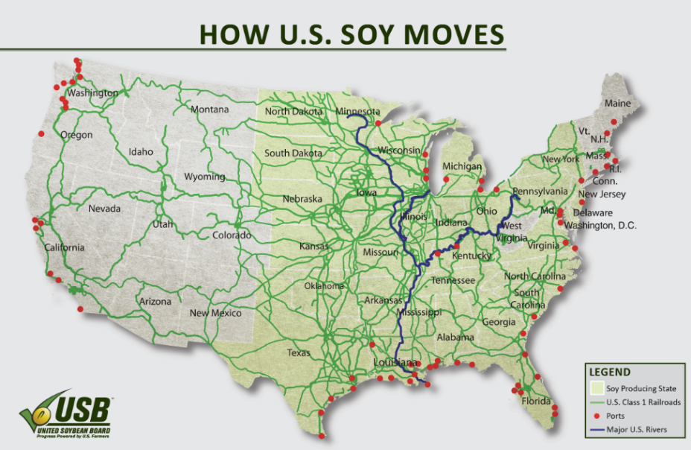
What role do you think transportation plays in the transport of soybeans?

How does the transportation of soybeans in the U.S. and world impact you?

Directions:
Once transportation has occurred, soybeans will be either processed locally or sent overseas. Using the chart and space below, identify the top purchasers of soybeans from the U.S. and create a graph to depict the top 10 purchasers and the value being purchased. Be sure to use different colors for each country and the appropriate labels.
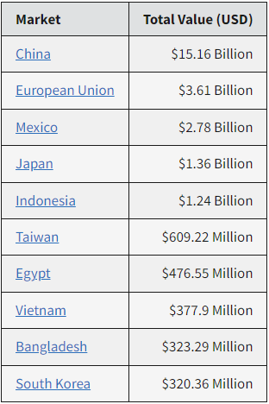
Sourced from the USDA Foreign Agricultural Service (FAS) – Exports from 2023
- Describe why you chose the type of graph you did.

- What other types of graphs could have been used?
- What would you tell someone about the various careers involved in the transportation and sales of soybeans in the U.S.? What impact can be seen in your everyday life?

- Who purchased the most from the U.S. in 2022? ________________________
- What is the difference between the top purchaser and the 10th? ________________________________________
- How does global agricultural sales impact the economy?

