What Happens to the Soybeans?
Aligned to the following standards:
CS.02; Cs.05; FFA.PL-A; FFA.PL-F; FFA.CS-M; FFA.CS-N; AG2; AG5; CCAA.ELA.W.9-10.2; CCSS.ELA.SL.9-10.2; CCSS.ELA.SL.9-10.4; CCSS.ELA-RST.9-10.7; CCSS.ELA.WHST.9.10.4; CRP.02; CRP.04; CRP.06; CRP.07
Part 1
Directions:
What happens to the soybeans after they are purchased from farmers and transported? Watch the video from Maryland Farm and Harvest (https://youtu.be/vZfePWrcm7Y?si=dq9Y8CNfheXs4oOY) to see the process soybeans undergo when they arrive at a processing facility. Use the space below to write down information you learn as you watch. Things to consider: steps of processing, the purpose of each step and what the product created at each step can be used for.
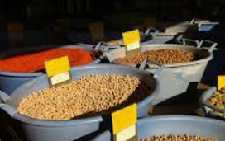
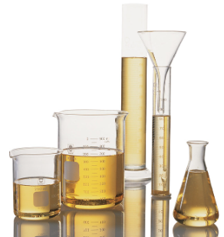
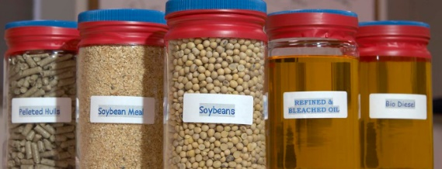
Steps of Processing | Purpose of Each Step | Product Created
1.

2.

3.

4.

5.

6.

7.

8.

Additional Thoughts/Questions

Soybean Processing Steps
Directions:
- Cut out each of the steps and descriptions on the next page.
- On this page, in the space below, assemble the steps in the correct order.
- Have your teacher check your order to ensure it is correct.
- Paste each step and draw arrows in between to depict the process flow.
- In green, circle the useable products created. Tip: There are seven.
  - Next to each green circle, identify one specific use of that product.
- Using AgExplorer (AgExplorer.FFA.org) identify two or three careers that would be involved in the processing of soybeans.
- (1) Career: ________________________________ (2) Career: ________________________________
- (3) Career: ________________________________
  - Draw a red square. In the square, include the following:
    - The title of the careers identified above.
    - A brief description in your own words.
    - Three skills needed.
    - Why this career is important.
- Share your careers with another classmate. Record their careers on your chart using purple.
- Next to each step, draw an image to represent it.
Cut and Paste Processing Steps
Soybean oil removed from flakes
Made from soybean oil and used in human and animal feed
Used in food products for human consumption
Made from soybean oil used in other products utilized by humans
What comes in from the farmer
Source of fiber for animal feed
Cracked soybeans are flaked
Flakes heated, dried and ground for animal feed
Soybean Hull Pellets
Soybean Spent Flakes
Soybean Meal
Crude Soybean Oil
Glycerin Production
Soybean Cracks
Whole Soybeans
Soybean Hulls
Soybean Flakes
Soy Lecithin
Refined/Bleached/Decolorized Soybean Oil
Soy Biofuels
Made into small pieces
Made from soybean hulls
Flakes that oil has been removed from by a solvent
Fuel for engines

Part 2
Directions:
Create a parody of a school-appropriate song about the process of soybean production and processing. Use the space below to develop your song. See the attached rubric for requirements.

Parody Rubric
Area | 3 points | 2 points | 1 point | 0 points
Time | At least 3 minutes of the original song were used. | 2 to 2:30 minutes of the original song were used. | 30 second to 1 minute of the song was used. | Less than 30 seconds of the original song were used.
Appropriate | An appropriate song was used. | _______________ | ______________ | Song was not appropriate.
Presentation | Students presented the entire parody. | _______________ | _______________ | Students refused to present.
Total | __________/9

Conclusion Questions:
- What surprised you about the processing of soybeans?

- How do you think scientists learned how to process soybeans efficiently?

- How does this process impact you and what you do every day? Give three examples.

- In a maximum of three sentences, describe the processing of soybeans, its importance and why someone should care. Write in a way that would make sense to someone who does not know anything about soybeans and their processing.

