Food Product Development
Aligned to the following standards:
CS.02; FFA.PL-A; FFA.PL-E; FFA.PG-J; FFA.CS-M; FFA.CS-N; AG2; CCSS.ELS.RI.9-10.4; CCSS.ELA.W.9-10.1; CCSS.ELA.W.9-10.2; CCSS.ELA.SL.9-10.1; CCSS.ELA.SL.9-10.2; CCSS.ELA.SL.9-10.4; CCSS.ELA.RST.9-10.1; CCSS.ELA.RST.9-10.7; MP1; MP2; MP4; CRP.02; CRP.04; CRP.05; CRP.06; CRP.07; CRP.08; CRP.11
Part 1
Directions:
After soybeans are processed, it is time for them to be used for various products, including food! But how do we develop new foods? Use this Kansas State Extension and Research website (https://www.ksre.k-state.edu/kvafl/development.html) to learn more and complete the activities below.
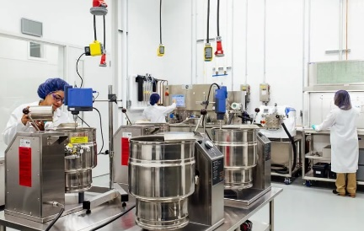
Identify and describe, in your own words, the four steps in food product development.

- S_____________________
  - Description:

- F_____________________
  - Description:

- T_________ M__________________
  - Description:

- C_____________________
  - Description:
- About how many new food products are developed each year? _____________

- What percentage of food products are considered failures? __________%
  - Develop a pie chart that shows this percentage. Label and color code it.

- On average, how long does it take to develop a new food product? ________
- Does anything about these numbers surprise you? Why or why not?
One career that plays a large role in new product development is a F________ S________________. Use AgExplorer to learn more about this amazing career!

- In your own words, what does a food scientist do?

- What skills do you need to have to be a food scientist? Identify three.
(1)
(2)
(3)

- What would happen if we didn’t have this career? Watch this video from IFT to find out!

Let’s take a closer look at the second step in the food product development process!
Part 2
Directions:
Prior to new food products being ideated and prior to launch to everyday consumers, the product must be developed on a small scale and then tested. Complete the activities below to learn about this process.
Go to the Purdue University pilot plant main page, look through the equipment and take the virtual tour of the pilot plant. Answer the following questions as you explore.

- In your own words, describe the purpose of the pilot plant.

- What are two initial thoughts as you explore the pilot plant?

- Identify three pieces of equipment the pilot plant uses and describe the function of each in your own words.

  - _____________________________________________:

  - _____________________________________________:

  - _____________________________________________:

  - Why do you think there are so many different types of equipment in the pilot plant?

- What role do you think a pilot plant plays in the development of new food products?

- Using this resource from Bunge (https://northamerica.bungeloders.com/en/lets-create-together/creative-experience), learn about their Food Solutions Center.

- In your own words, describe the purpose of the food solutions center.

- Identify one product Bunge has developed in their food solutions center.

- What do the Purdue University pilot plant and the Bunge Food Solutions Center have in common?

- What problem do you think the development of this product solved?
Part 3
Directions:
The next step is testing the food products that are created in the development phase and then produced in a pilot lab on a small scale. Complete the following activities to learn the next steps.

- Acquire three samples from your teacher and place them in the appropriate numbered section on your paper below.

647
381
992

- Which sample did you like the best? Circle your answer above.
- Why did you pick that sample number as your favorite?

- In the space provided, draw a graph that depicts the class results. Be sure to use proper labels and colors!

- What did you do to determine the sample you liked the best?

- Identify five keywords you would use to describe how you selected your favorite sample. Example: taste.

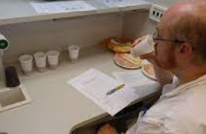
If you had to summarize the keywords you and your classmates listed in one word, what word would it be? Unscramble the letters to find out!
ENSSES

__________ __________ __________ __________ __________ __________

Record the five senses of food sensory evaluation and under each arrow, add a description in your own words.

A_________________ A_______________ S___________________ T___________________ F________________

Part 4
Now that we know our senses play such a large role in our food preferences, let’s try another sensory evaluation test called a triangle test.
716
433
250

- Get three samples from your teacher and place them on the correct number above.

- Write down the exact steps you are going to use to evaluate your samples. Tip: This should be a numbered list, and you should consider each of the senses identified above.

- Using your sense, identify which sample out of the three is DIFFERENT. Circle the number above.
- Describe how you felt during this process.

- How do you think sensory evaluation impacts new food product development? What would happen if this step was skipped when developing new food products?

- In a minimum of two sentences, how would you describe the purpose and process of food sensory evaluation?

Part 5
Directions:
Now that you have an understanding of soybeans, soybean products and food science, let’s brainstorm a new product you would want to develop. Using the space below, you will develop a new food product and share your idea through an advertisement for the product. The product can be anything (Ex. Frozen food, breakfast food, side dish, snack, etc.) as long as it does not already exist. Include the following items in your advertisement:
- Picture of the product
- Color
- Name of the product
- Slogan
- Food product does not already exist on the market
- Food contains soybeans/soy in some way
- Any additional information the customer should know to want to purchase the product

