Diving Into an Agriculture Career With No Ag Background
Directions:
Read the article “Working in Agricultural Jobs Without an Agricultural Background” (https://www.agcareers.com/career-guide/2022/US/#24) to complete this activity.

*After reading the article, develop a one-page infographic that could be used to interest people not involved in agriculture into looking for a career in the agriculture industry.

What to Include:
-Title
-Two or more pictures
-Why should they look at careers in agriculture
-Example careers they could do without an agriculture background
Remember to keep it visually appealing!

*Use the spaces below to help you plan your infographic.
Picture Ideas
Title Ideas

Career Ideas

Why should they look at careers in agriculture?

Facts or Statistics to Draw Interest
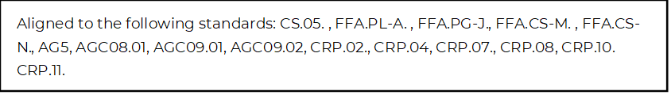
Key Info From Article

