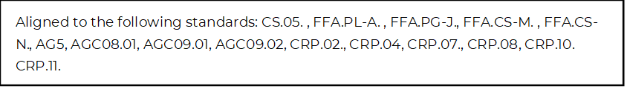
Employer Pathway Connections
Directions:
Complete this worksheet by utilizing each of the companies’ websites and the Career Guide on the AgCareers.com website. For each of the companies, identify which career focus areas their organization aligns with by shading each box red. Additionally, add the logo for each company that is missing.
Company: Bayer |  |   Logo:
Agribusiness Systems | Agricultural Education | Agriculture Technology | Animal Systems
Biotechnology Systems | Environmental Service Systems | Food Products and Processing Systems | Natural Resources Systems
Plant Systems | Power, Structural and Technical Systems | Skilled Trades | Sustainability

Company: Becks |  | Logo:
Agribusiness Systems | Agricultural Education | Agriculture Technology | Animal Systems
Biotechnology Systems | Environmental Service Systems | Food Products and Processing Systems | Natural Resources Systems
Plant Systems | Power, Structural and Technical Systems | Skilled Trades | Sustainability

Company: CLAAS |  | 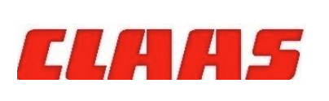  Logo:
Agribusiness Systems | Agricultural Education | Agriculture Technology | Animal Systems
Biotechnology Systems | Environmental Service Systems | Food Products and Processing Systems | Natural Resources Systems
Plant Systems | Power, Structural and Technical Systems | Skilled Trades | Sustainability

Company: Consolidated Grain and Barge |  | Logo:
Agribusiness Systems | Agricultural Education | Agriculture Technology | Animal Systems
Biotechnology Systems | Environmental Service Systems | Food Products and Processing Systems | Natural Resources Systems
Plant Systems | Power, Structural and Technical Systems | Skilled Trades | Sustainability

Company: Corteva Agriscience |  | 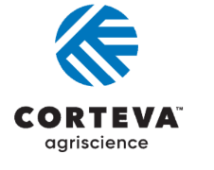  Logo:
Agribusiness Systems | Agricultural Education | Agriculture Technology | Animal Systems
Biotechnology Systems | Environmental Service Systems | Food Products and Processing Systems | Natural Resources Systems
Plant Systems | Power, Structural and Technical Systems | Skilled Trades | Sustainability

Company: Didion |  | Logo:
Agribusiness Systems | Agricultural Education | Agriculture Technology | Animal Systems
Biotechnology Systems | Environmental Service Systems | Food Products and Processing Systems | Natural Resources Systems
Plant Systems | Power, Structural and Technical Systems | Skilled Trades | Sustainability

Company: Hartung Brothers Inc. |  | Logo:
Agribusiness Systems | Agricultural Education | Agriculture Technology | Animal Systems
Biotechnology Systems | Environmental Service Systems | Food Products and Processing Systems | Natural Resources Systems
Plant Systems | Power, Structural and Technical Systems | Skilled Trades | Sustainability

Company: Lallemand |  | Logo:
Agribusiness Systems | Agricultural Education | Agriculture Technology | Animal Systems
Biotechnology Systems | Environmental Service Systems | Food Products and Processing Systems | Natural Resources Systems
Plant Systems | Power, Structural and Technical Systems | Skilled Trades | Sustainability

Company: Oxbo Inc |  | Logo:
Agribusiness Systems | Agricultural Education | Agriculture Technology | Animal Systems
Biotechnology Systems | Environmental Service Systems | Food Products and Processing Systems | Natural Resources Systems
Plant Systems | Power, Structural and Technical Systems | Skilled Trades | Sustainability

Company: Simplot |  | Logo:
Agribusiness Systems | Agricultural Education | Agriculture Technology | Animal Systems
Biotechnology Systems | Environmental Service Systems | Food Products and Processing Systems | Natural Resources Systems
Plant Systems | Power, Structural and Technical Systems | Skilled Trades | Sustainability

Company: Syngenta |  | 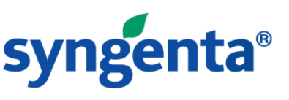  Logo:
Agribusiness Systems | Agricultural Education | Agriculture Technology | Animal Systems
Biotechnology Systems | Environmental Service Systems | Food Products and Processing Systems | Natural Resources Systems
Plant Systems | Power, Structural and Technical Systems | Skilled Trades | Sustainability

Company: Wilbur-Ellis |  |   Logo:
Agribusiness Systems | Agricultural Education | Agriculture Technology | Animal Systems
Biotechnology Systems | Environmental Service Systems | Food Products and Processing Systems | Natural Resources Systems
Plant Systems | Power, Structural and Technical Systems | Skilled Trades | Sustainability

*Which career focus area do you think could be applicable to all the companies in the activity? ________________________

*Pick four of the companies from the first part of this activity above to discover more about career opportunities with these organizations and complete the tables below.

Name of Company: | Headquarters Location:
**Identify two current job openings this company has and answer the questions below about each

Job Opening 1  Title of Position: ________________________________________  Educational Requirements: ____________________________  Salary Range: __________________________________  Location of Job: _________________________  Primary Responsibilities of Position | Job Opening 2  Title of Position: ________________________________________  Educational Requirements: ____________________________  Salary Range: __________________________________  Location of Job: _________________________  Primary Responsibilities of Position

Name of Company: | Headquarters Location:
**Identify two current job openings this company has and answer the questions below about each.

Job Opening 1  Title of Position: ________________________________________  Educational Requirements: ____________________________  Salary Range: __________________________________  Location of Job: _________________________  Primary Responsibilities of Position | Job Opening 2  Title of Position: ________________________________________  Educational Requirements: ____________________________  Salary Range: __________________________________  Location of Job: _________________________  Primary Responsibilities of Position

Name of Company: | Headquarters Location:
**Identify two current job openings this company has and answer the questions below about each.

Job Opening 1  Title of Position: ________________________________________  Educational Requirements: ____________________________  Salary Range: __________________________________  Location of Job: _________________________  Primary Responsibilities of Position | Job Opening 2  Title of Position: ________________________________________  Educational Requirements: ____________________________  Salary Range: __________________________________  Location of Job: _________________________  Primary Responsibilities of Position

Name of Company: | Headquarters Location:
**Identify two current job openings this company has and answer the questions below about each.

Job Opening 1  Title of Position: ________________________________________  Educational Requirements: ____________________________  Salary Range: __________________________________  Location of Job: _________________________  Primary Responsibilities of Position | Job Opening 2  Title of Position: ________________________________________  Educational Requirements: ____________________________  Salary Range: __________________________________  Location of Job: _________________________  Primary Responsibilities of Position

*Which of these companies do you think you would be most interested in a potential career with? Explain your choice.

