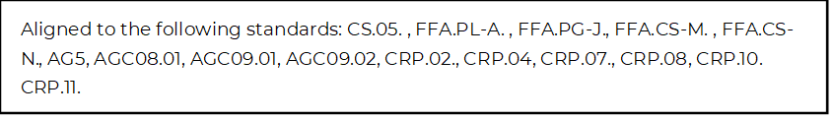
Fine Tune Your Resume Skills
Directions:
Using the article “Tailoring Your Resume” (https://www.agcareers.com/career-guide/2022/US/#8), complete the activities below.

Pre-Reading Questions
1. Do you have a resume? ___________________
2. Why do you need a resume in high school? _____________________________________________________________
Post-Reading Questions
1. What is the purpose of a resume? ___________________________________________________________________________________

2. Pick the three most important tips from the article and explain how you can use them on a personal level.

A.

B.

C.

3. Read the article “How to Decode a Job Advertisement.” This article is available at https://www.thebalance.com/how-to-decode-a-job-advertisement-2061002. Identify the parts of a job description and what is included in each part. Record your answers below.

Part of Job Description | What Is Included

4. Review the job posting below and then review the sample resumes provided to determine which candidate is more ideal for this job based on their resume.

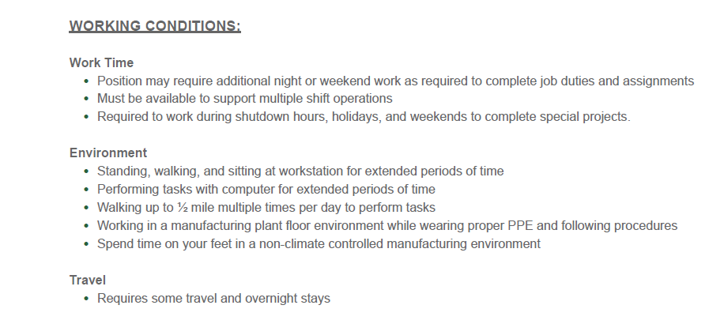
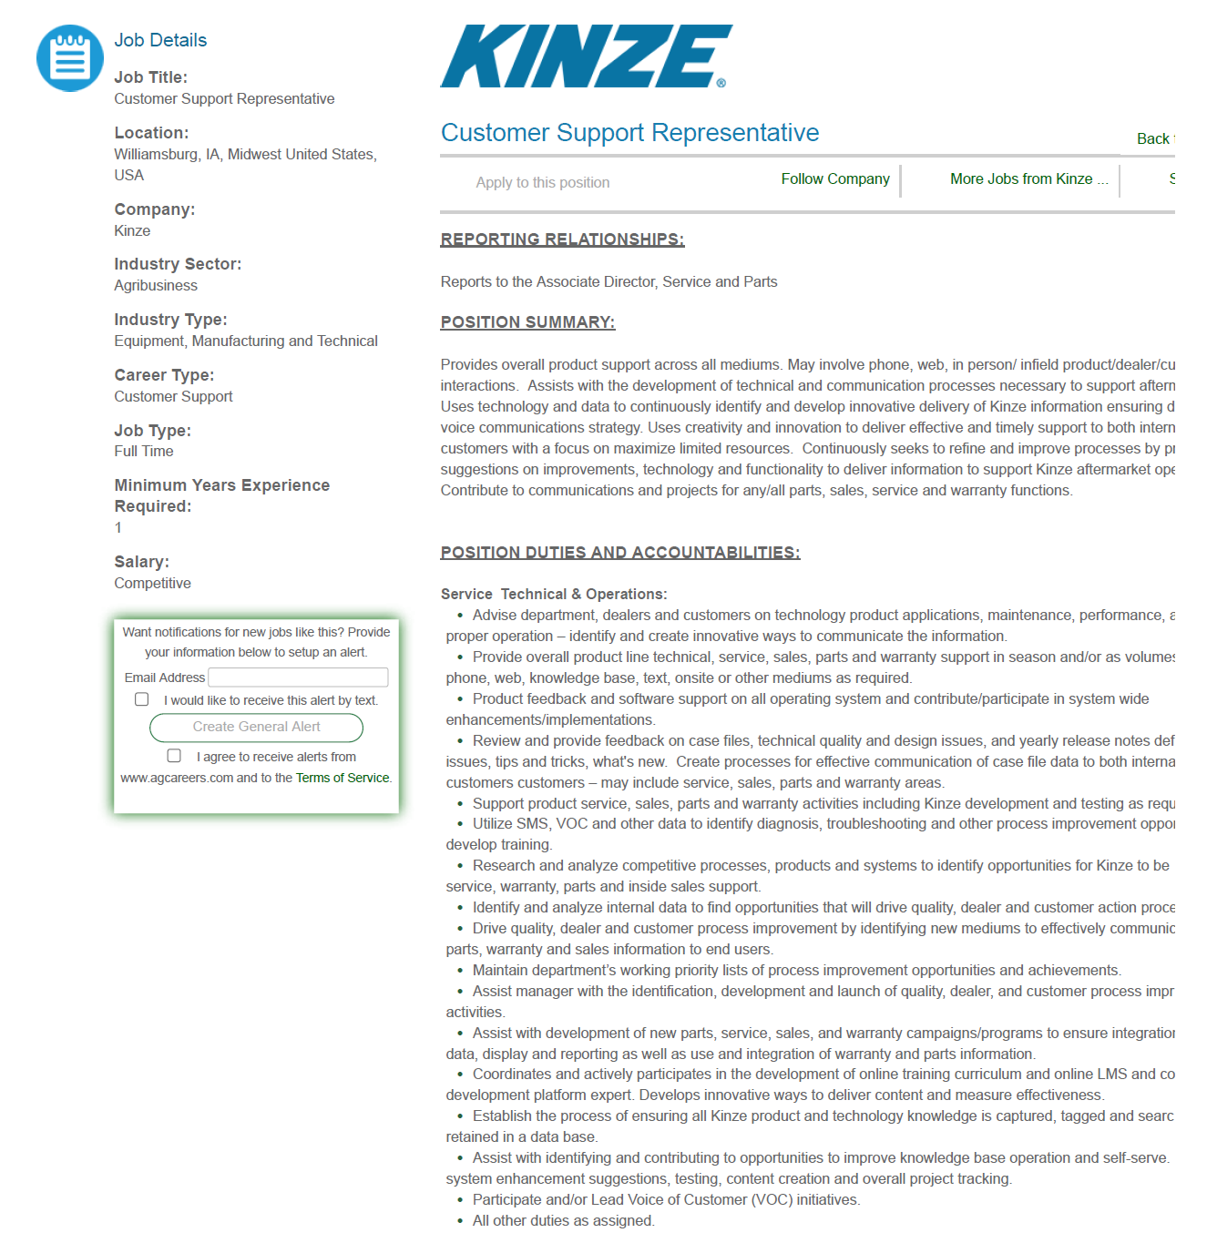

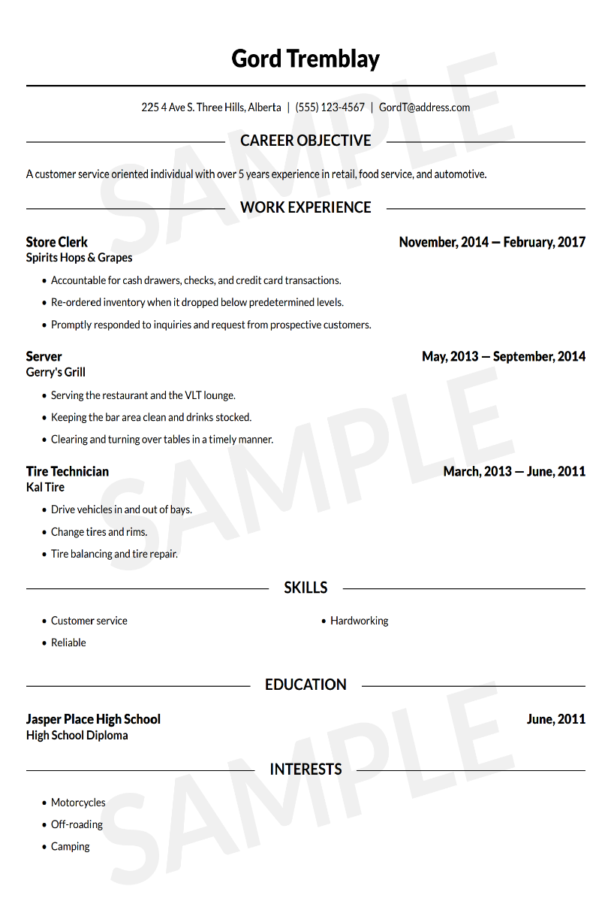
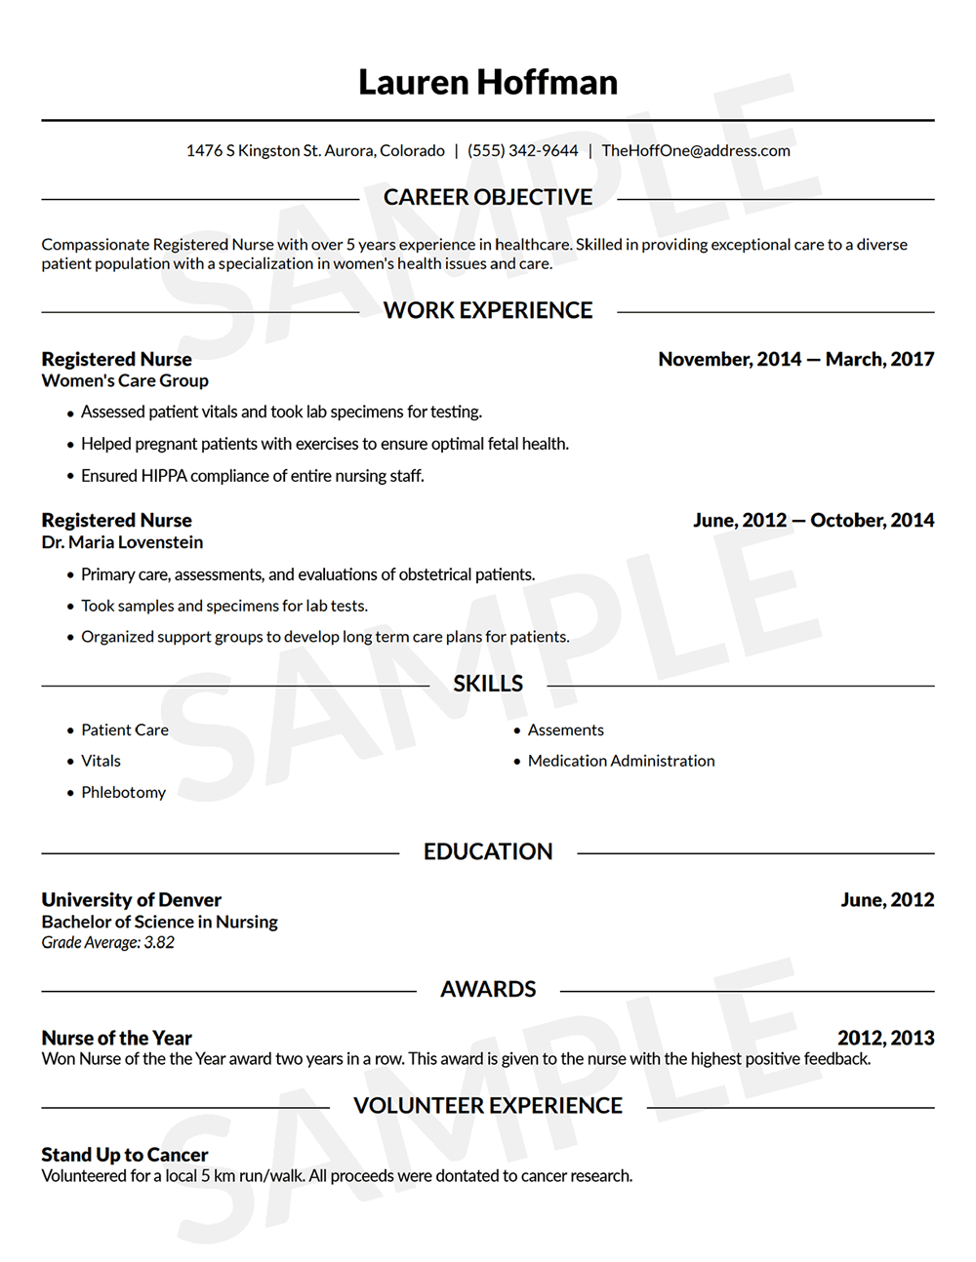
A. At first glance, which candidate is more ideally aligned with the job posting? ________________________________

B. Upon reviewing the job posting, do you feel either candidate is completely unqualified for the job posting? Explain your answer.

______________________________________________________________________________________________________________________ ______________________________________________________________________________________________________________________ ______________________________________________________________________________________________________________________
C. Identify two areas in which each resume could be improved to align to the job posting more closely.

Gord Tremblay | Lauren Hoffman

D. How can you use what you learned from this activity to improve your own resume? __________________________________________________________________________________________________

