Will It Conduct?
Aligned to the following standards:
PST.04; PL-A.; PG-J.; CCSS.RI.9-10.1; CCSS.SL.9-10.1; CCSS.SL.9-10.4; CCSS.RST.9-10.2; CCSS.RST.9-10.4; CCSS.RST.9-10.9; CRP.02; CRP.04; CRP.07; CRP.08

Part 1
Directions:
Watch the video about conductors and insulators found at https://www.youtube.com/watch?v=qZjDMQbn3a0. Answer the questions below as you watch.

- Materials can generally be classified into two main groups: ____________________________ and _____________________.

- What is a conductor?

- What are some examples of good conductors?

- What materials are most electrical wires made of?

- What is an insulator?

- What are some examples of insulators?

- The inner part of an electrical cord is made of _________________________ while the outer part is made of _____________________.

- Why is understanding the difference between conductors and insulators important? Give a specific example of when this would be important and why.

Part 2
Directions:
Follow the procedures below to create your conductivity tester. Visual directions can be found in this video: https://youtu.be/HsgiZCAwyh8.
- Using wire strippers or sandpaper, strip a 1/2 inch (1.3 cm) of insulation from the ends of each piece of wire to ensure a good connection.
- Tape one end of a short piece of wire to the positive terminal of a D-cell battery using masking tape. Connect the other end of the short wire to one terminal of the light bulb holder. To make a good connection, wrap the wire around the screw on the bulb holder terminal in a U-shape. Connect a long piece of wire to the negative terminal of the D-cell battery using masking tape. Connect a second long piece of wire to the open terminal of the bulb holder.
- Test your circuit by touching the free ends of wire together. What happens? If the bulb does not light, check all connections and try again. Now, leave the circuit open. We will use this circuit as a conductivity tester.
- Use the circuit as a conductivity tester for solid objects. Get materials from your teacher to test. Predict whether each item will conduct electricity. Then, touch the two wire ends to a test object to see if the circuit is completed. How will you know if an item is a conductor or an insulator?
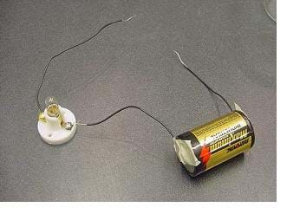
- Predict which objects you think will conduct electricity. Record your predictions on your student activity sheet.
- Use the circuit tester to determine whether each object is a conductor or an insulator. Record your test results on your student activity sheet.
- Make a conductivity tester for liquids: Modify the conductivity tester by adding one or two more batteries in series. Use short pieces of wire to connect the batteries in series.
- Carefully wrap aluminum foil around the end of the two open-ended wires to make an electrode. Make each electrode one-inch (2.5 cm) long by 1/4-inch (6 mm) wide.
- Test your circuit. Touch the pieces of a foil together to close the circuit. What happens?
- Predict which liquids will conduct electricity, recording your predictions on the worksheet. How will you know whether a liquid conducts electricity?
- Use the circuit as a conductivity tester for liquids. Test each liquid by submerging the electrodes in the solution and holding the electrodes close without touching each other. Be careful to only hold the wire where it is insulated. Put on new aluminum foil electrode strips for each test.
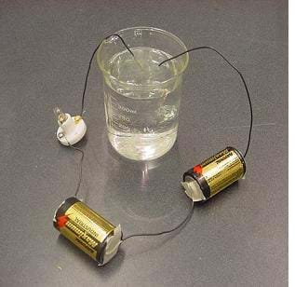
- Record your test results on the worksheet. How were your results different from your predictions?

- In the space below, draw a picture of the conductivity tester.

- What happened when you touched the free ends of the wires of the conductivity tester together?

- How will you know if an object is a conductor or an insulator?

- In the table below, list the objects you are testing in the left column. Predict whether each object is a conductor or an insulator by placing an X in the Prediction column for conductor if you think it is a conductor or an X in the Prediction column for insulator if you think it is an insulator.

- Test each object to determine whether it is a conductor of electricity. Once you have determined whether it is a conductor or an insulator, place an X in the correct Test Results column.

Solid Object | Prediction |  | Test Results
Solid Object | Conductor | Insulator | Conductor | Insulator

- What types of materials are good conductors?

- What are three examples of insulators?

- How will you know whether a liquid conducts electricity?

- In the table below, list the liquids you are given to test. Predict whether each liquid will conduct electricity or not by placing an X in the Prediction column for conducts if you think the liquid will conduct electricity or an X in the Prediction column for does not conduct if you think it will not conduct electricity.

- Test the liquids given to you to determine if they conduct electricity. Once you have determined whether each liquid conducts electricity, place an X in the correct Test Results column.
Liquid | Prediction |  | Test Results
Liquid | Conducts | Does Not Conduct | Conducts | Does Not Conduct

Reflection Question:

- Why is understanding insulators and conductors important?

