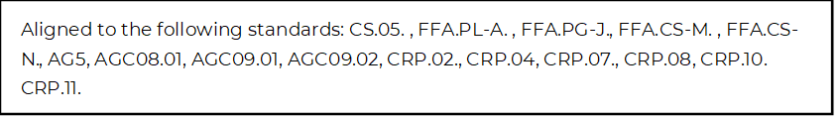
Internships: What’s in It for You?
Directions:
Utilize the article “How to Choose the Right Internship” (https://www.agcareers.com/career-guide/2022/US/#18) to learn more about future opportunities and complete the activities below.

1. Identify two benefits of completing an internship.

2. Why is it suggested you start looking for internships early in your freshman year?

3. What are recruiters looking for when it comes to club involvement of potential interns and employees?

4. What should you do about internships if you are unclear about your career path?

5. Why is it important to keep an open mind when approaching your career path and choices?

6. Check out the Forever Blue Network, https://foreverbluenetwork.org/, and learn more about the benefits of this program. Match the benefits with the correct descriptions.

By fully integrating with social networks, and cultivating a culture of helping and giving back, you will be amazed how vibrant and powerful our FFA community is!
Forever Blue Network allows you to reconnect with old friends you may have made at FFA conferences or events and enables you to utilize the trusted FFA environment to expand your professional network.
Find and reminisce with fellow FFA Alumni and Supporters, see what they have been up to and stay in touch.
Leverage your professional network to get introduced to people you should know.

Introduce, employ and offer to act as a mentor, coach or volunteer for our newest alum, other fellow FFA Alumni and Supporters, FFA advisors, chapters or state associations.

Word Bank
Connect Expand Give Back Reconnect With Old Friends Your FFA Community

7. Set three SMART goals for yourself about pursuing internships in the future.

