From Hobby to SAE
Aligned to the following standards:
CS.05.; FFA.PL-C; FFA.PL-E; FFA.PG-I; FFA.CS-P; AG5; AGC08.01; AGC09.02; CCSS.ELA.RI.9-10.4; CCSS.ELA.SL.9-10.1; CCSS.ELA.WHST.9.10.6; CRP.02.; CRP.04; CRP.07

Directions:
Answer the questions below as you watch the video “Fishing Lure SAE – Jackson Brossart,” available at https://vimeo.com/901201778.

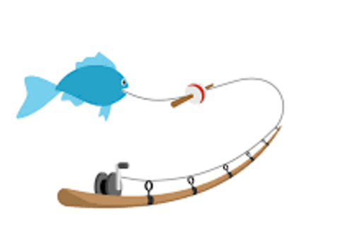
- What does Jackson do for his SAE?

- What state is Jackson from?

- What is a fishing jig?

- Draw three different resources Jackson mentions or uses for his SAE during the video.

- Why does Jackson use different colors for his fishing jigs?

- Why is record keeping important for Jackson’s SAE?

- What has Jackson learned the most from his SAE?

- What advice does Jackson give to students interested in doing a similar SAE?



From Hobby to SAE
Aligned to the following standards:
CS.05.; FFA.PL-C; FFA.PL-E; FFA.PG-I; FFA.CS-P; AG5; AGC08.01; AGC09.02; CCSS.ELA.RI.9-10.4; CCSS.ELA.SL.9-10.1; CCSS.ELA.WHST.9.10.6; CRP.02.; CRP.04; CRP.07

Directions:
Jackson’s SAE gave him the chance to turn a hobby into an SAE. Dive into learning how you can turn your own hobbies into an SAE and, ultimately, a future career. In the table below, identify three hobbies you have, how those hobbies can translate into an SAE and what career those SAEs can lead to.

Hobby | SAE Idea | Career

- Choose one of the SAEs you identified from a hobby above and list it here:

- What category does that SAE fit into?

- What career could that SAE develop into?

Research that career and answer the questions below:

- What business or company would you work for in that career?

- What education is required for that career?

- What skills are required for that career?

- What is the average yearly salary for that career?

