“Meat” Your Next Career
Aligned to the following standards:
CS.05.; FFA.PL-C; FFA.PL-E; FFA.PG-I; FFA.CS-P; AG5; AGC08.01; AGC09.02; CCSS.ELA.RI.9-10.4; CCSS.ELA.SL.9-10.1; CCSS.ELA.WHST.9.10.6; CRP.02.; CRP.04; CRP.07

Aligned to the following standards:
CS.05.; FFA.PL-C; FFA.PL-E; FFA.PG-I; FFA.CS-P; AG5; AGC08.01; AGC09.02; CCSS.ELA.RI.9-10.4; CCSS.ELA.SL.9-10.1; CCSS.ELA.WHST.9.10.6; CRP.02.; CRP.04; CRP.07

Directions:
Answer the questions below as you watch the video “Meat Processing SAE – Kylie Skadberg,” available at https://vimeo.com/901202016.
Part 1
From the video, complete the following quote from Kylie: “I don’t have goals on changing the world, but I do like to make sure that people …

Why did Kylie choose to join FFA?
How did Kylie get started in her SAE?
Would you enjoy working at a meats lab like Kylie? Why or why not?
What are some of Kylie’s daily tasks for her SAE?

What animals does Kylie process at Barton Meats?

What chapter is Kylie representing?

What pathway does Kylie’s SAE fall into?
Part 2
Directions:
Knowing the different cuts of meat is important for understanding the way those cuts can be used. Use the images of each species (cattle, swine, lamb) and the resource identified below to complete the following:

- Identify the difference between a wholesale and retail cut.
- Take each species (cattle, swine, lamb) and label the wholesale cuts we get from each animal. Write this on the inside of the animal.
- Identify one specific retail cut that comes from each wholesale cut. Draw a line and write this on the outside of the animal.
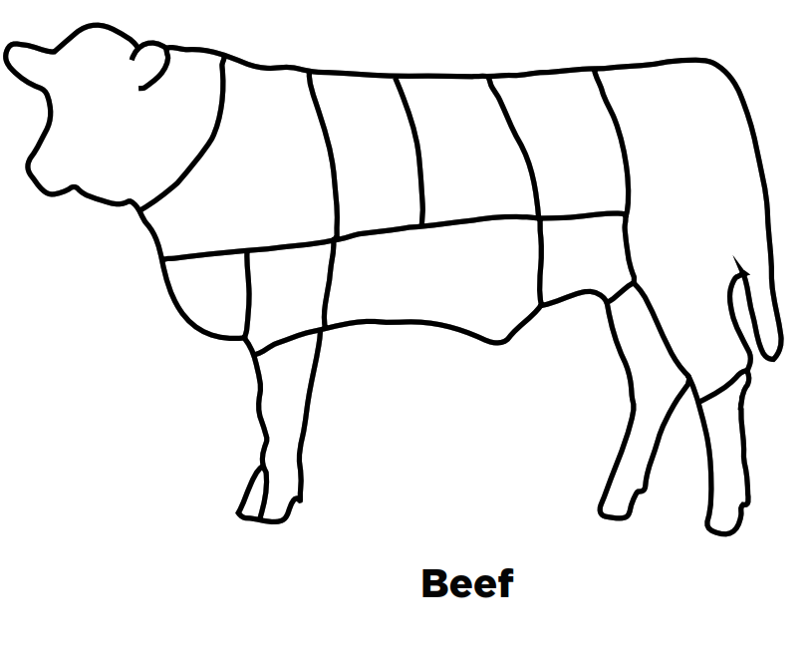
Resource: University of Florida, https://animal.ifas.ufl.edu/media/animalifasufledu/animal-sciences-website/extension/youth/meat-resources/identifying_retail_cuts.pdf
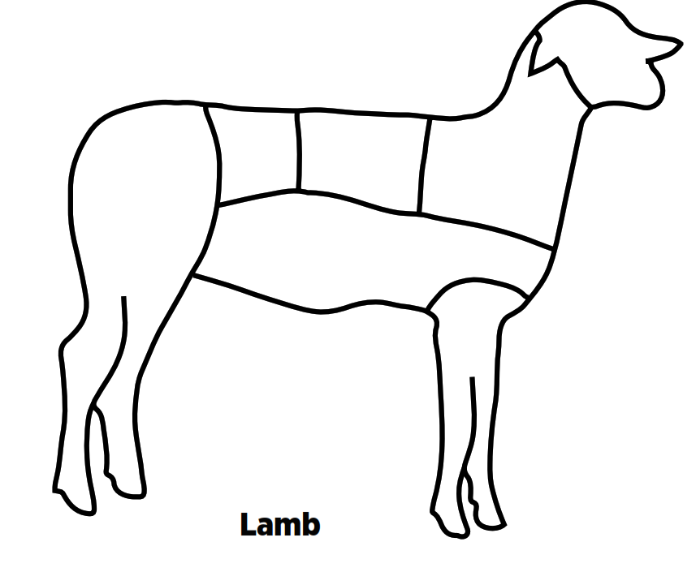
What is the difference between a wholesale cut and a retail cut of meat?

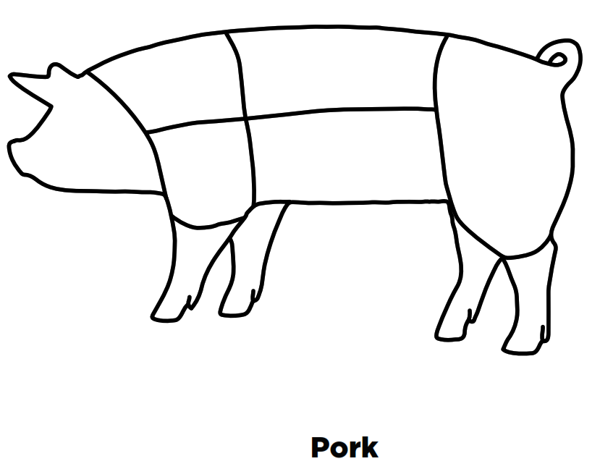

Part 3
Directions:
Learn which everyday products come from animal products. Choose one animal (beef cow, dairy cow, pig, sheep or goat), and use the resource below to complete the following activity:

- Sketch a picture of your chosen animal.
- Identify at least 10 byproducts that come from that animal.
- Write those products inside the animal, and list the part of the animal they come from.
- Answer the discussion question below.

Resource: Farm Credit of Virginia, https://www.farmcreditofvirginias.com/knowledge-center/educator-resources/everything-but-the

Discussion Question:
How many of these animal byproducts do you use in your everyday life, and how would your life be impacted if you didn’t have access to them?

