Circuit Showdown
Aligned to the following standards:
PST.04; PL-A.; PG-J.; CCSS.RI.9-10.1; CCSS.SL.9-10.1; CCSS.SL.9-10.4; CCSS.RST.9-10.2; CCSS.RST.9-10.4; CCSS.RST.9-10.9; CRP.02; CRP.04; CRP.07; CRP.08

Part 1
Directions:
Read about series and parallel circuits, then fill in the Venn diagram comparing and contrasting the two.

Series and Parallel Circuits
- There are two types of circuits we can make, called series and parallel. The components in a circuit are joined by wires. If there are no branches, then it is a series circuit. If there are branches, it’s a parallel circuit
Series Circuits
- In a television series, you get several episodes, one after the other. A series circuit is similar. You get several components one after the other. If you follow the circuit diagram from one side of the cell to the other, you should pass through all the different components, one after the other, without any branches.
- If you put more lamps into a series circuit, the lamps will be dimmer than before.
- In a series circuit, if a lamp breaks or a component is disconnected, the circuit is broken and all the components stop working.
- Series circuits are useful if you want a warning that one of the components in the circuit has failed. They also use less wiring than parallel circuits.
Parallel Circuits
- In parallel circuits, different components are connected on different branches of the wire. If you follow the circuit diagram from one side of the cell to the other, you can only pass through all the different components if you follow all the branches.
- In a parallel circuit, if a lamp breaks or a component is disconnected from one parallel wire, the components on different branches keep working.
- Unlike a series circuit, the lamps stay bright if you add more lamps in parallel.
- Parallel circuits are useful if you want everything to work, even if one component has failed. This is why our homes are wired up with parallel circuits.
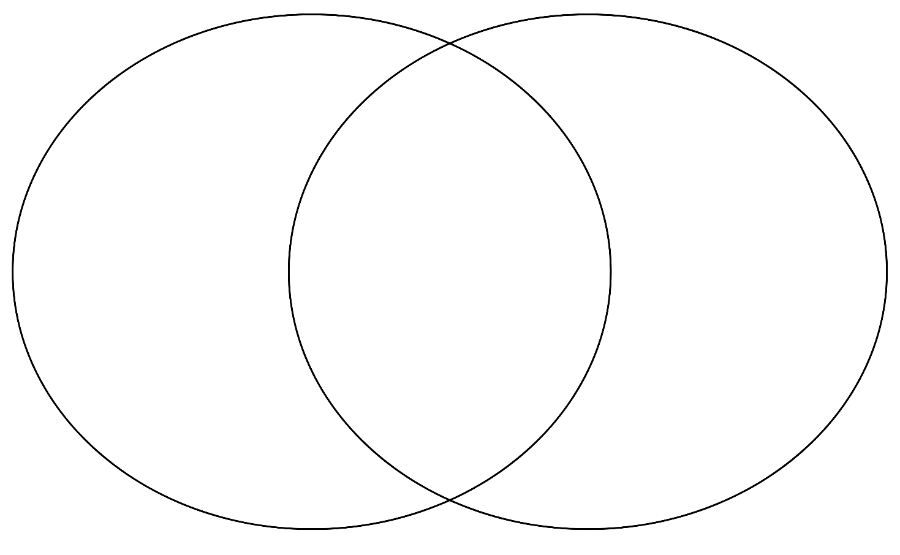

Part 2
Directions:
Learn more about series and parallel circuits below and complete the activities along with each picture.
In a series circuit, electric current has only one path to follow. All parts are connected one after another. Electric current flows from the negative side of the battery around in a loop to the positive side. Draw arrows to show the path of electric current in this series circuit.
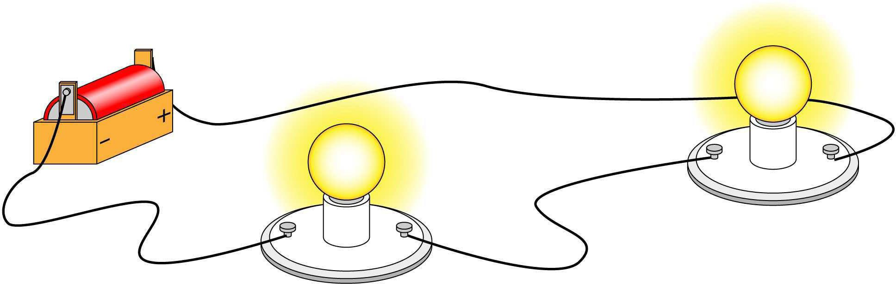

In a parallel circuit, electric current has more than one path to follow. The electric current can follow different paths as it flows from the negative side of the battery to the positive side. Draw arrows to show the different paths electric current can travel in this parallel circuit.
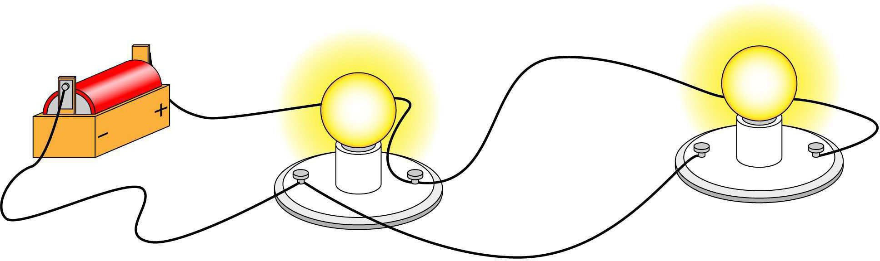

Indicate whether the light bulb or bulbs will light or will not light based on the circuit.
1. 2.


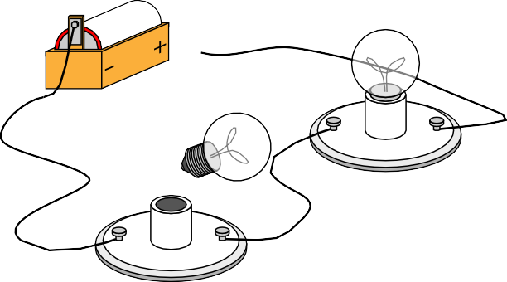

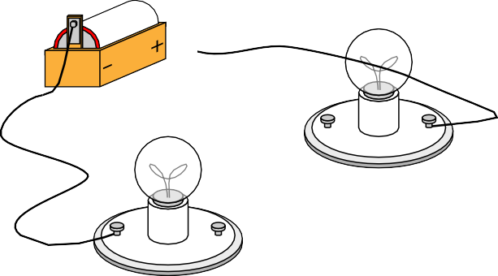



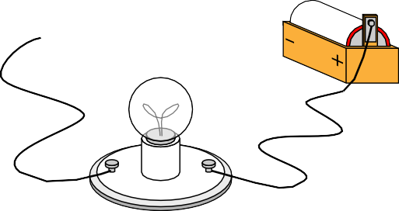

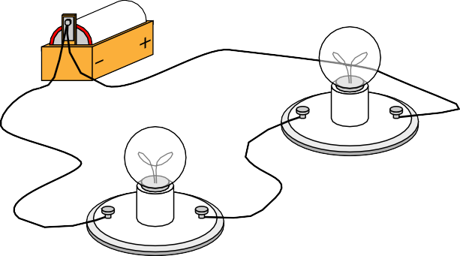

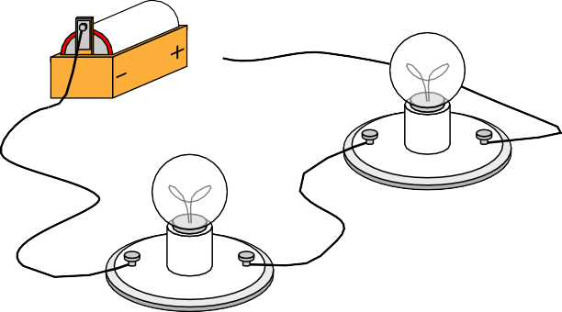

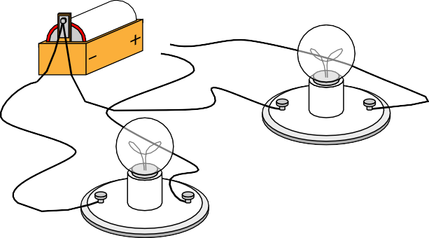

3. 4.

5. 6.


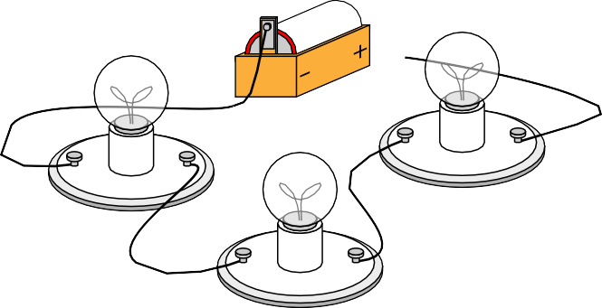

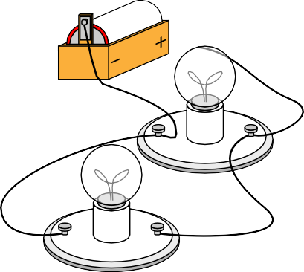
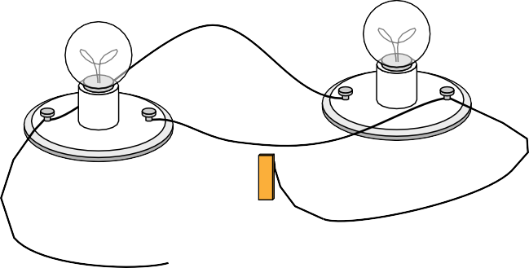

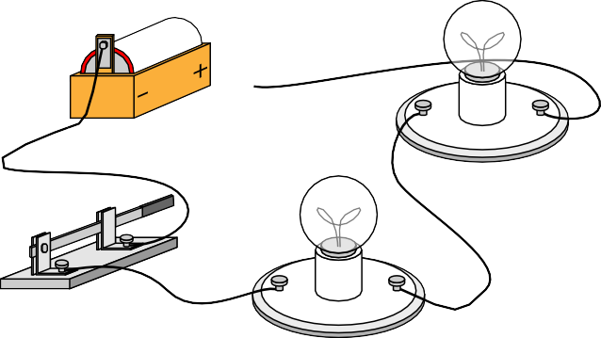



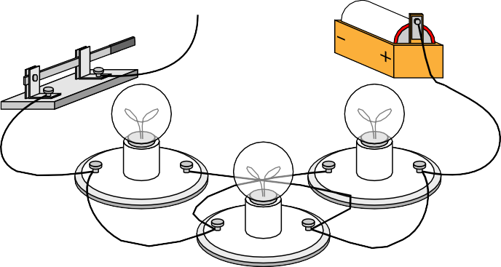





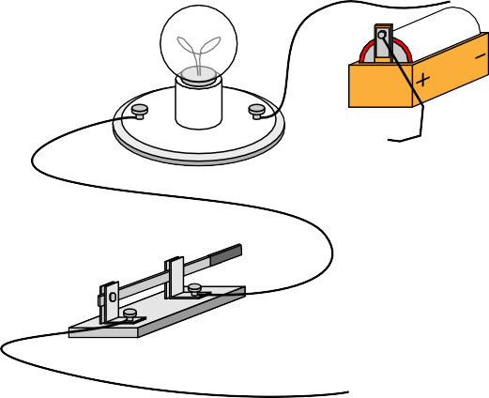
Indicate whether each picture shows a series circuit or parallel circuit by labeling the circuit below each picture and writing an explanation of how you know.

Type: _______________________________________________ Type: _________________________________________________

Type: _______________________________________________ Type: _________________________________________________

Type: _______________________________________________ Type: _________________________________________________
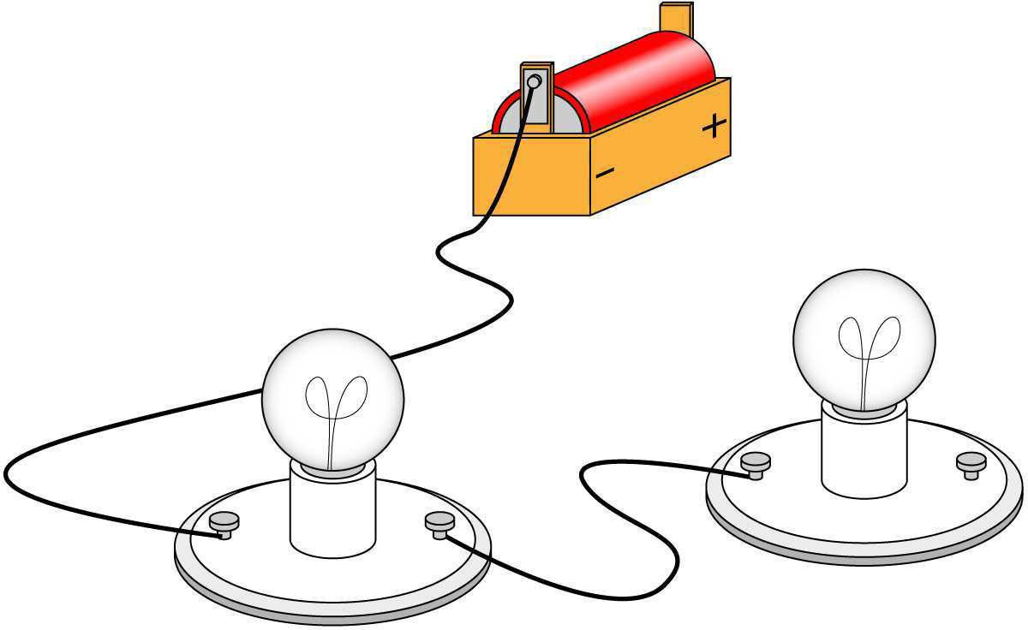
- Explain why the light bulbs won’t light in the circuit pictured on the right.

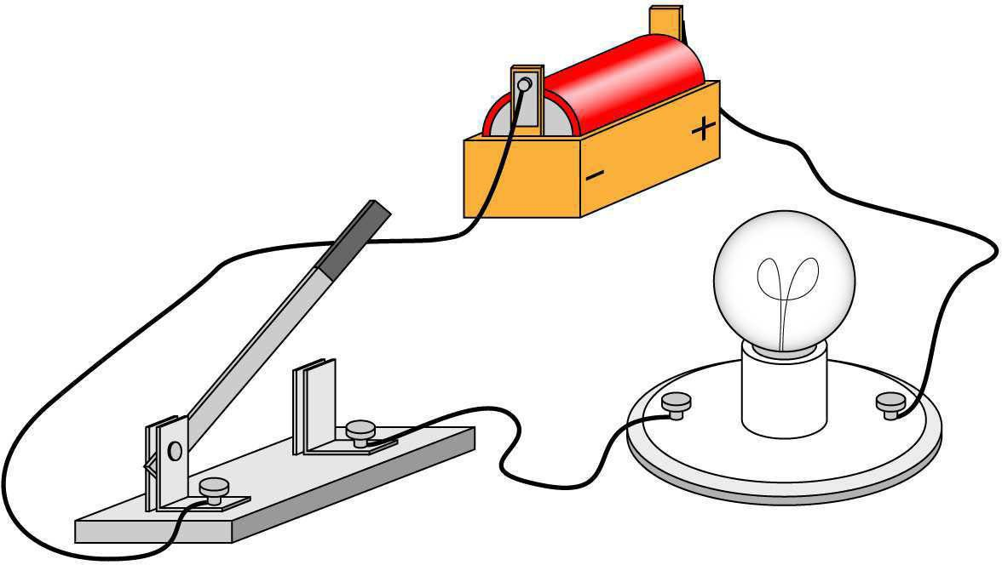
- Explain why the light bulb won’t light in the circuit pictured on the right

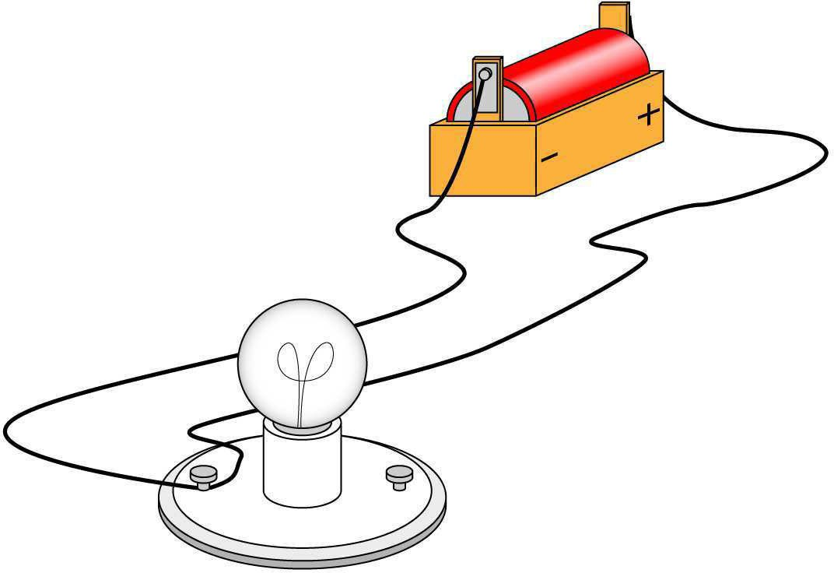
- Explain why the light bulb won’t light in the circuit pictured on the right.

Part 3
Directions:
Read each scenario or feature below. Decide whether it describes a series or parallel circuit. Then, write a brief explanation to justify your answer. Finally, answer the reflection questions.

Scenario or Feature | Series or Parallel? | Why?
1. Holiday lights that go out when one bulb breaks
2. A home’s electrical wiring system
3. A circuit with one continuous path for current and three bulbs
4. Each light in the circuit has its own switch.
5. If one bulb is removed, the others stay lit.
6. A single break causes the entire circuit to stop working.
7. Used to alert you if a component fails
8. Lights stay the same brightness when more are added.
9. Used in most household applications
10. Requires less wiring but is more likely to fail if one part breaks

Reflection Questions:

- In your own words, explain the biggest difference between a series and a parallel circuit.

- Which circuit type would you rather use in your bedroom and why?

