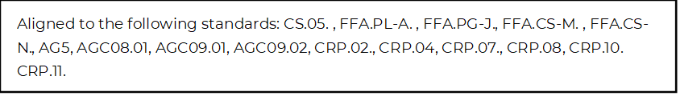
Let’s Talk Money
Directions:
Utilizing the article “How to Ask for a Raise” (https://www.agcareers.com/career-guide/2022/US/#34), complete this activity.

- What surprised you most while reading this article?

- Do you feel the approach discussed in the article is appropriate for a part-time job you may now hold as a high school student? Why or why not?

- What is one question you still have about asking for a raise?

What do you think justifies a raise? Select from the list below all the reasons you feel are appropriate for asking for a raise.

You do more than your job requires. | You show initiative. | You have to travel more.
Poor life choices | You develop new skills | Seniority
You have brought in new business. | Your coworker makes more money than you do. | Perfect attendance at work
You took on more job responsibilities. | You have another job offer. | Changed family status  (getting married, new child on the way, etc.)

Take Action and Get Your Raise

Business Situation: Budgets are expected to be tighter in the upcoming year. But, keeping our dedicated employees in mind, we want to give everyone the chance for a raise as we are aware of inflation and the increased cost of living. If you wish to receive a raise, please be prepared to present your case and explain why you deserve this raise.

Employee Scenario: You have surpassed your sales goal for the year by 12.5%, have added four new customers and have multiple other new potential customers in the works. Unfortunately, you have gone over your budget on a couple of projects. You are mentoring one of the new sales managers in another territory. Your mentee is responding well and seems to be on track for increasing sales in that territory for the next year.

Task: Develop a step-by-step plan to present to your boss about why you deserve the raise. Follow the steps and advice in the article. Use the table below to help you plan each step and develop your formal presentation. Follow the instructions of your teacher to create your final presentation.

Step | Plans/Needs/Ideas
Step 1: Do Your Research

Step 2: Book a Meeting

Step 3: Prepare

Step 4: Be Patient

Step 5: Handling Rejection

Step 6: Keeping a Positive Attitude

