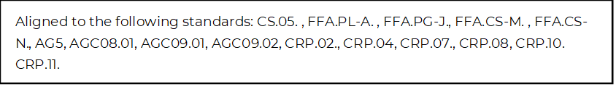
Mastering a Job Interview
Directions:
Utilize the article “Unwritten Rules of the Interview Process” (https://www.agcareers.com/career-guide/2022/US/#32) to complete this activity.

Pre-Reading
1. How do you feel about your interviewing skills? Circle the emoji that best describes your skills.

 |  |  |  | 

Explain your answer choice. ___________________________________________________________________________________________

2. Identify two areas of interviewing that you feel you need to improve upon.
-

-

3. Identify two areas of interviewing that you feel are your strengths.
-

-

Post-Reading
- Identify the five most important tips you gained from reading this article.

- What questions do you still have about job interviews?

What Do I Bring?

Directions:
Use the article “What and What Not to Bring to an Interview,” available at http://blog.agcareers.com/career-cultivation/what-to-bring-to-an-interview/, to complete the chart.

Item | Bring or Don’t Bring | Explanation (in Your Own Words)

