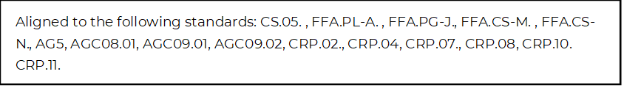
My First Job Offer: What Do I Do?
Directions:
Utilize the article “How to Handle Your First Job Offer” (https://www.agcareers.com/career-guide/2022/US/#28) to complete this activity.

Pre-Reading
Complete the K and W of the KWL chart prior to reading this article. Then come back and complete the L after you read the article.
K  What do you know about job offers? | W  What do you want to know about job offers? | L  What did you learn about job offers from this activity?

Post-Reading
*What surprised you the most in this article about accepting a job offer?

*Develop your ideal job offer using the outline below. Remember, this would be a job offer right out of college or upon completion of your training/certification. Look at current job postings similar to what you wish to do.

Title of Position
Location
Salary/Wages
Work Schedule (Days of the Week)
PTO (Paid Time Off)
Sick Days
Company Vehicle
Cell Phone Reimbursement
Internet Reimbursement for Home Office
Relocation Expenses
Bonus (How It’s Earned, How Much)
Tuition Reimbursement
Insurance | Health:  Life:  Accident:  Short-Term Disability:  Long-Term Disability:
Other Benefits

**Don’t forget to go back and complete the L of the KWL chart at the beginning of this activity.

