National FFA Secretary Finds His Spark
Aligned to the following standards:
CS.05; FFA.PL-A; FFA.PL-C; FFA.PL-E; FFA.PL-F; FFA.CS-M; FFA.CS-N; AG5; AGC09.02; RI.9-10.2; RI.9-10.3; W.9-10.2; SL.9-10.1; SL.9-10.2; CRP.02; CRP.04; CRP.07; CRP.08
Part 1
Directions:

Read the article “National FFA Secretary Finds His Spark,” found at FFA.org/the-feed/national-ffa-secretary-finds-his-spark/, and complete the following activities.
Who is the National FFA Secretary?

What is his hometown and state?
What was his experience with college?

What did he decide to do after college?
Why did he enjoy agricultural education?
From 2020 to ______, Sylvester — who learned to weld as a member of the

__________ _________ FFA — worked with ____ different _________ companies.
What tasks did he learn at those companies?
What did agricultural education grant him?
What is his next move, after national office?
What is his long-term goal?
“It’s OK to ______ _______ what you want to ________. When

we have the _________, we can _________ anything we _____ our minds to.
What is available from FFA to help with a trade education?
How can you apply this quote and statement in your life?


Part 2
Directions:
Go to AgExplorer, AgExplorer.FFA.org, and answer the following questions.
Click on the career focus area tile that you chose.

Describe the career focus area in two sentences:

In what career focus area do you think welder would fit?

Choose three careers within the career focus area you identified above and answer the questions below.

Career: _____________________________

Identify three responsibilities associated with this career:

a.______________________________________

________________________________________

b.______________________________________

________________________________________

c.______________________________________

________________________________________
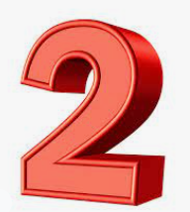Career: ______________________________

Identify three responsibilities associated with this career:

a.______________________________________

________________________________________

b.______________________________________

________________________________________

c.______________________________________

________________________________________

Choose one of the careers you identified and click See Available Jobs on the career profile page. What is one currently available job? __________________________________

Career: ______________________________

Identify three responsibilities associated with this career: b.______________________________________

________________________________________
a.______________________________________

________________________________________ c.______________________________________

________________________________________

What role do you think the three careers you highlighted above play in the economy? What would happen if they disappeared?
Part 3
Directions:
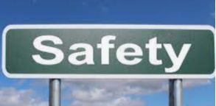
Safety is extremely important when welding. Let’s take a look at welding safety and personal protection equipment. Use this website, https://www.lincolnelectric.com/en/Safety-Resources/Welding-Safety-FAQs---Personal-Protective-Equipment, to complete the activity below.
Why are safe practices and equipment so important with welding?
What would happen if these protocols were not followed? Give specific examples.
Explain what steps you can take to prevent hot sparks from being trapped in your clothing.
Using the space below, draw a flyer to help promote safety in welding.

-Include at least five of the FAQ in your drawing.

-Include why safety in welding is important.

-Be creative!
Circle True or False for this statement:
Protective clothing needed for welding includes general fire-resistant clothing, flip flops, safety glasses, gloves and helmet.

What is the most common injury to a welder?

Part 4
Directions:
Now, it’s your turn to try welding! Follow the steps below to complete this activity.

Items you will need:
-One pair of scissors
-At least two full-size graham cracker sheets
-One small bag of icing (Cut a small corner off the bag.)
-One paper towel

Instructions:
Step 1: Choose a type of weld to do. Use this website to see different types of welds: https://weldguru.com/weld-types-joints/. What weld did you choose? ___________________________ Use the box below to sketch your weld.
Step 2: Lay the paper towel down on the table.
Step 3: Create the weld using the graham crackers and icing.
Step 4: Answer the questions below.

Sketch your weld:
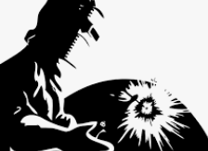
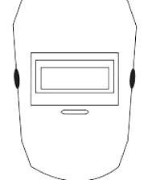

How can you apply this activity to actual welding?
Was this process easy? Why or why not?



Summarize what you learned from the welding activity in two or three sentences:

