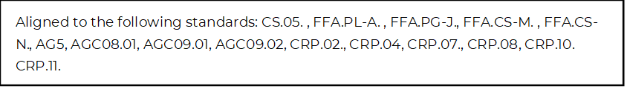
Navigating Career Fairs
Directions:
Utilize the article “Lessons Learned from Virtual Career Fairs” (https://www.agcareers.com/career-guide/2022/US/#14) to complete this activity.

The Lesson: The Speed of Connection Is Faster Than Ever
Why is it important to build in breaks at an in-person career fair?

Identify one way you can help yourself remember to complete follow-up correspondence.

The Lesson: Digital Resources Are Important

How can you digitally provide your resume to an employer at an in-person career fair?

Why should you take printed copies of your resume with you to an in-person career fair?

The Lesson: Career Fair Platforms Impact the Time Available
Why should you plan out your time spent at a career fair? Identify two examples.

Identify two ideas that could help set you apart and be a better use of your time.

The Lesson: The Health and Well-being of All Is a Top Priority
How can you respect the comfort level of others at in-person career fairs?

What are two rules of thumb to always follow?

The Lesson: Virtual Career Fairs Are Not Going Away
What are two positives of virtual career fairs for both employers and potential employees?

How can you best prepare for both types of career fairs?

Wrap It Up
*What are the three most important items to do at a college/career fair?

*Explain to another student why it is important to attend a college/career fair.

