Play to Win When It Comes to Networking
Directions:
Utilize the article “To Play or Not to Play. It’s Not Really a Question” (https://www.agcareers.com/career-guide/2022/US/#26) to complete this activity.

Pre-Reading Questions
1. In your own words, describe what the term “networking” means to you.

2. Who would you consider to be in your personal network?

Post-Reading Questions
1. Why is networking so important when pursuing career success?

2. Identify two ways you can build relationships with coworkers.
-

-

3. What should not be the outcome/result of attending a networking event?

4. How can you benefit professionally from volunteering?

5. Identify three keys to having success at a networking event.
-

-

-

Now, think about your future and building professional connections. Set three goals for yourself in terms of networking and building professional connections in the next year. List those goals below.

1.

2.
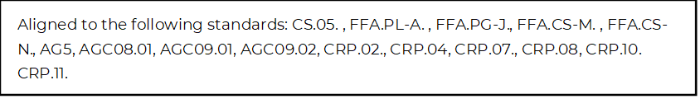

3.

