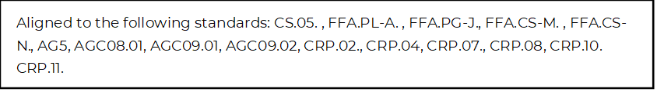
Preparing for the Next Phase of Life
Directions:
Read the article “Life Past College: How Do I Handle This Full-Time Job?” (https://www.agcareers.com/career-guide/2022/US/#20) to complete this activity.

*Identify two key takeaways from each of the five topics covered in the article.

Go In With an Open Mind

Set Your Boundaries Early

Don’t Get Too Comfortable

You Actually Have Been Preparing

Keep Dreaming

Now, think about life after high school. Identify at least two things that …

Excite You

Worry/Concern You

You Feel Most Prepared for

You Feel Least Prepared for

You Hope to Achieve in the Next Four Years

