Pepper Processing
Aligned to the following standards:
FPP.01; FFPP.03; FPS.05; FFA.PL-A1; FFA.PL-A3; FFA.PL-A4; FFA.PL-A5; FFA.PL-A8; FFA.PL-B5; FFA.PL-C1; FFA.PL-C4; FFA.PL-F3; FFA.PL-F5; FFA.PG-J1; FFA.PG-J2; FFA.CS-M1; FFA.PG-J4; AG5; CCSS.ELA-RI.9-10.1; CCSS.ELA-RI.9-10.4; CCSS.ELA-W.9-10.2; CCSS.ELA-W.9-10.4; CCSS.ELA-W.9-10.7; CCSS.ELA-SL.9-10.1; CCSS.ELA-SL.9-10.2; CCSS.ELA-L.9-10.6; CCSS.ELA-RST.11-12.9; HS-ETS1-2; CRP.02; CRP.04; CRP.06; CRP.07; CRP.11
Directions: Answer the questions below as you watch the video “Growing and Processing Jalapenos SAE,” available at https://vimeo.com/1148063426.
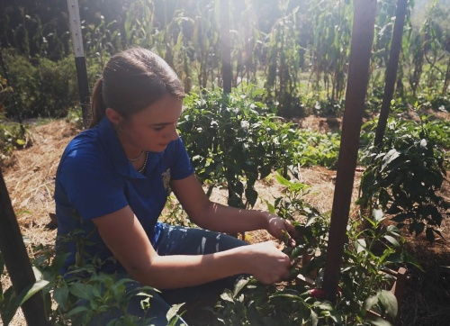
- Describe Addison’s SAE in two or three sentences.

- Describe what Addison does during the different seasons for her SAE.

- About how many pounds of peppers does Addison process in a day?
- Arrange Addison’s pepper processing steps listed below in the correct order by writing the numbers 1-4 in the blank spaces next to each step.

Put the peppers in the brine and boil them.
Pressure can the cooked peppers in the jars.
Cut up all the peppers.
Get the jars sanitized and ready for canning.

- How did Addison get started in her SAE?

- What safety precautions does Addison take with her SAE?

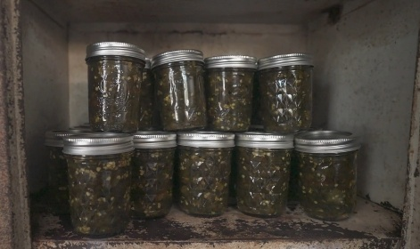
- What information does Addison have to include on the labels for her peppers? Why is this information important to include?

- Why is record keeping an important part of Addison’s SAE?

Processing Plan
Aligned to the following standards:
FPP.01; FFPP.03; FPS.05; FFA.PL-A1; FFA.PL-A3; FFA.PL-A4; FFA.PL-A5; FFA.PL-A8; FFA.PL-B5; FFA.PL-C1; FFA.PL-C4; FFA.PL-F3; FFA.PL-F5; FFA.PG-J1; FFA.PG-J2; FFA.CS-M1; FFA.PG-J4; AG5; CCSS.ELA-RI.9-10.1; CCSS.ELA-RI.9-10.4; CCSS.ELA-W.9-10.2; CCSS.ELA-W.9-10.4; CCSS.ELA-W.9-10.7; CCSS.ELA-SL.9-10.1; CCSS.ELA-SL.9-10.2; CCSS.ELA-L.9-10.6; CCSS.ELA-RST.11-12.9; HS-ETS1-2; CRP.02; CRP.04; CRP.06; CRP.07; CRP.11
Part 1
Directions: Using the table below, brainstorm at least 10 agricultural products that could be produced in your area on the left side and the food products they could be processed into on the right side. Then, answer the questions at the bottom.
Agricultural Products | Food Products
Example: Oranges | Example: Orange juice, orange extract, orange peel oil, etc.

- Which product ideas seem most realistic to make at home? Why?

- Which product ideas seem least realistic? What challenges do you notice?

- What crops surprised you when researching and brainstorming? Why?

Part 2
Directions: Use the prompts below to pick one product from Part 1 to research and see how you could make an SAE out of growing and processing that product.
- What one product from your brainstormed list is most interesting to you to grow and process?

- What basic equipment or materials would you need in order to grow and process this product?

- What additional ingredients would be required to process your agricultural product into the final food product?

- Research the processing steps to make your final food product. List the step-by-step process below.

- What safety considerations would you need to take into account when producing this product?

- How would you market and sell your product? Be as specific as possible.

Reflection Questions:
- What did you learn about food processing that you didn’t know before?

- What are two or three ways you could set your product apart from other similar products?

- How could using locally grown crops benefit your community?

- What questions do you still have about producing this product?

- After researching, would you keep this product idea or choose a different one? Explain.

- If you could ask Addison one question about her experiences building her SAE/business, what would that question be?

