Aligned to the following standards: FFA.PL-A; FFA.PL-D; CCSS.ELA.SL.9-10.2; CCSS.ELA.SL.9-10.5; CRP.02; CRP.04; CRP.06; CRP.11

Appendix 4: Fresh Perspectives
Part 1
Directions:
Read the article “Fresh Perspectives” in the fall/winter issue of FFA New Horizons and answer the questions below.

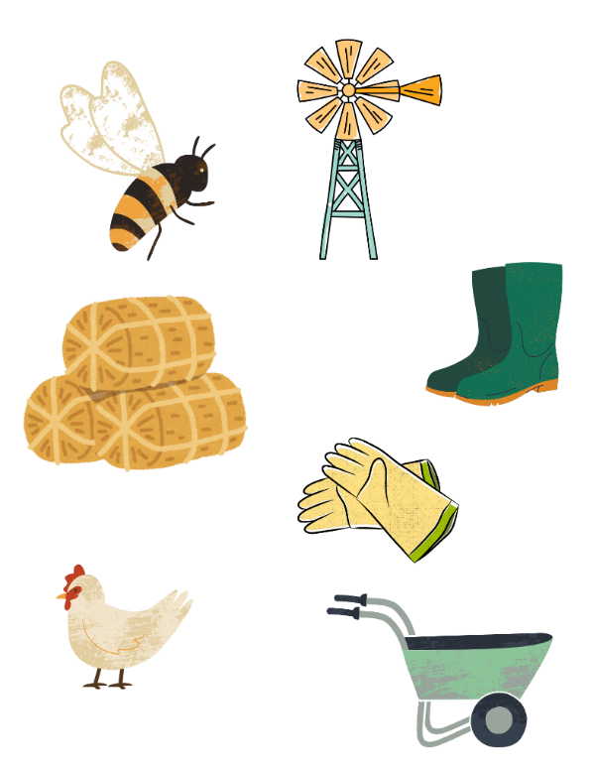
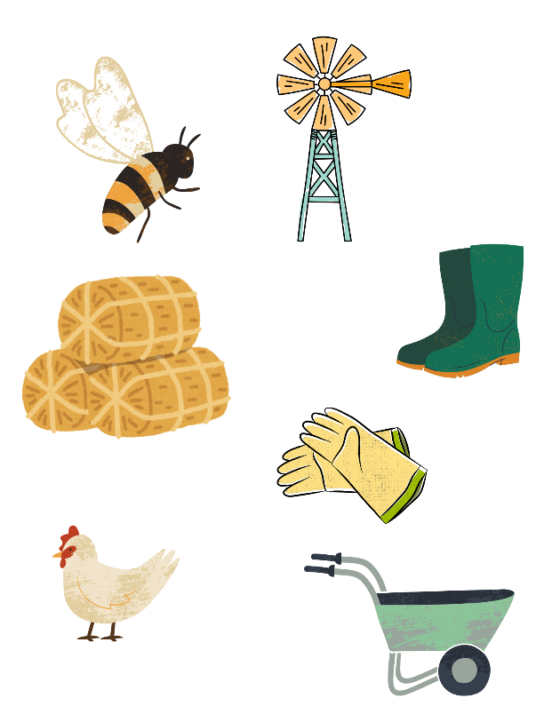
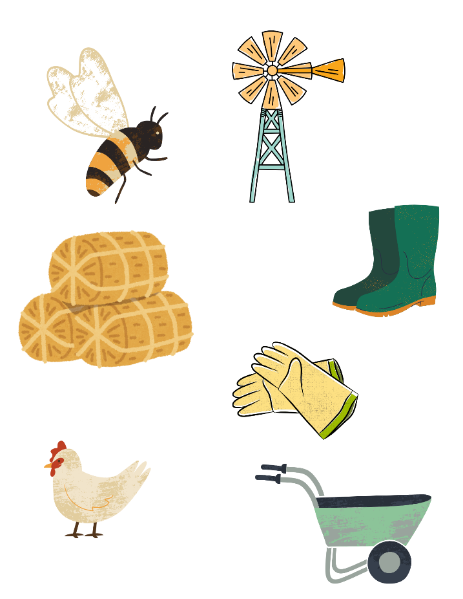
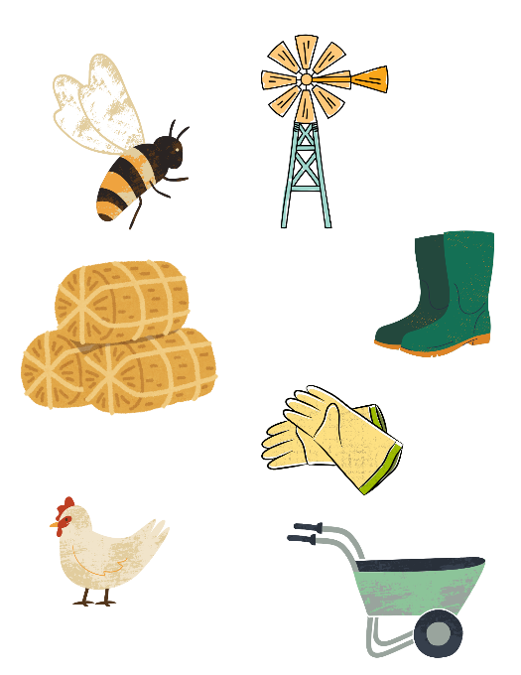
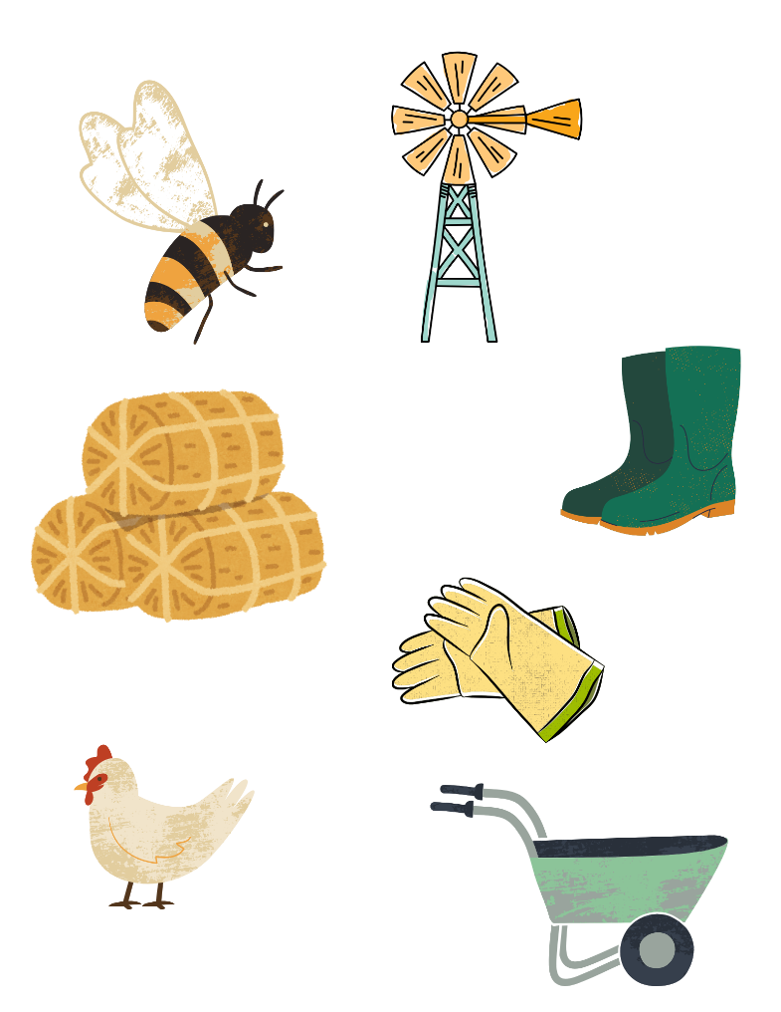
- What organization is Tahja Sims currently interning with, and what is its focus?

- How does Sims define “diversity” in agriculture?

- What university did Sims graduate from, and what was her major?

- What surprising discovery has Sims made during her internship?

- Give an example Sims shared that reflects unexpected diversity in agriculture.

- How did Sims first get introduced to agriculture and FFA?

- What was Sims’ first FFA project animal, and why did she later switch?

- What daily activities did Sims do when raising pigs in FFA?

- What competition did Sims participate in as an FFA member?

- What does Sims learn about agriculture’s industry impact?

Part 2
Directions:
You will follow five steps to research, create and share a profile of an individual who represents a unique background or perspective within the agriculture industry. Your research will help you better understand the wide range of people who contribute to agriculture in powerful and often unexpected ways.

Step 1: Choose a diverse agriculturist to profile.
- Someone from your local community (local FFA alumni or community leaders)
- A figure from an online article or video (found via AGDAILY, MANRRS, YouTube, AgExplorer, Modern Farmer)
- A historical or current figure from an agriculture-focused nonprofit (e.g., MANRRS, Women in Ag, Native American Food Sovereignty Alliance, Farmer Veteran Coalition, etc.)
- People with unique agricultural roles (refugee farmers, veterans in agriculture, STEM-focused growers, sustainability advocates, etc.)

Step 2: Research.
Based on the profile you selected in Step 1, answer each question below. This will help provide information to create your detailed profile.
Add Picture.
- Who is this person?
  - Name:
  - Age:
  - Background information:

- What is this person’s role in agriculture?

- What challenges or perspectives make this person’s story unique?

- How has this person made an impact?

- What can we learn from this person?

- Create a timeline showing notable dates and impacts in this person’s journey to get where they are today:

- List the sources used:

Step 3: Create a profile.
Choose one of the following formats to present your profile:
- Written biography (two pages)
- PowerPoint or Google Slides presentation (eight slides with visuals)
- Infographic (digital or hand-drawn with visuals)
- Poster or Bulletin Board Feature (with visuals)

Step 4: Gallery Showcase and Learn
Set up your profile in a spot around the room and begin your gallery walk and learn. Select four different profiles to learn about. Answer the questions below.

Who is this agriculturist, and what is this person’s role?  What stood out about this person’s journey?  How does this story expand your understanding of diversity in agriculture? | Who is this agriculturist, and what is this person’s role?  What stood out about this person’s journey?  How does this story expand your understanding of diversity in agriculture? | Who is this agriculturist, and what is this person’s role?  What stood out about this person’s journey?  How does this story expand your understanding of diversity in agriculture? | Who is this agriculturist, and what is this person’s role?  What stood out about this person’s journey?  How does this story expand your understanding of diversity in agriculture?

Step 5: Reflection Questions:
After you have completed all steps of this activity, answer the questions below.

- What is one career or topic you would like to explore more? Why?

- What qualities or skills did you notice across multiple agriculturists?

- Why is it important to have diversity in agriculture?

- How do the stories of these agriculturists relate to issues in your community or the world?

Agriculturist Profile Rubric

Criteria | 5 points  Excellent | 3 points  Developing | 1 point  Needs Improvement |  | Score
Content | Profile includes accurate, detailed info about the agriculturist’s background, role and impact. Clearly researched and well-explained | Profile is somewhat detailed but lacks clarity. | Key information is missing or inaccurate.
Impact | Clearly explains how this person adds diversity to agriculture and their unique impact | Mentions diversity but lacks detail or insight | Little to no evidence of the person’s impact
Organization | Profile is well-organized and easy to follow with clear presentation or writing. | Mostly clear and organized with some minor issues | Disorganized, difficult to follow or lacks participation
Visuals and Creativity | Creative, relevant visuals (photos, layout or design) strongly enhance the profile. | Visuals are present but minimally effective. | Visuals are unclear, missing or irrelevant.
Additional Comments |  |  |  | Total Score:  /20

