Aligned to the following standards: CS.01; CS.02; FFA.PL-B; FFA.PL-D; FFA.PG-H; FFA.CS-M; FFA.CS-N; CCSS.ELA.RI.9-10.1; CCSS.ELA.RI.9-10.7; CCSS.ELA.W.9-10.1; CCSS.ELA.W.9-10.4; CCSS.ELA.W.9-10.5; CCSS.ELA.W.9-10.6; CCSS.ELA.W.9-10.7; CCSS.ELA.W.9-10.8; CCSS.ELA.SL.9-10.1; CCSS.ELA.SL.9-10.2; CCSS.ELA.SL.9-10.4; CCSS.ELA.SL.9-10.5; CCSS.ELA.L.9-10.6; CRP.04; CRP.05; CRP.06; CRP.07; CRP.12
Appendix 5: Equine Lessons
Part 1
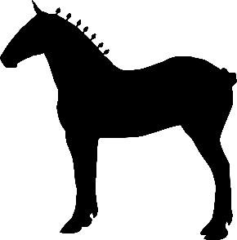
Directions: Read the article “Equine Lessons” in the fall/winter 2025 issue of FFA New Horizons and answer the questions below.

- What proficiency award category did Lucy win at the national level in 2024?

- What family tradition did Lucy turn into a supervised agricultural experience (SAE)?

- What are the names of the two family-run operations that Lucy worked on?

- Fill in the Venn diagram below based on Lucy’s daily tasks for both summer days and competition days. List tasks that are specific to each type of day under the appropriate day, but list tasks that are shared on both types of days in the center.

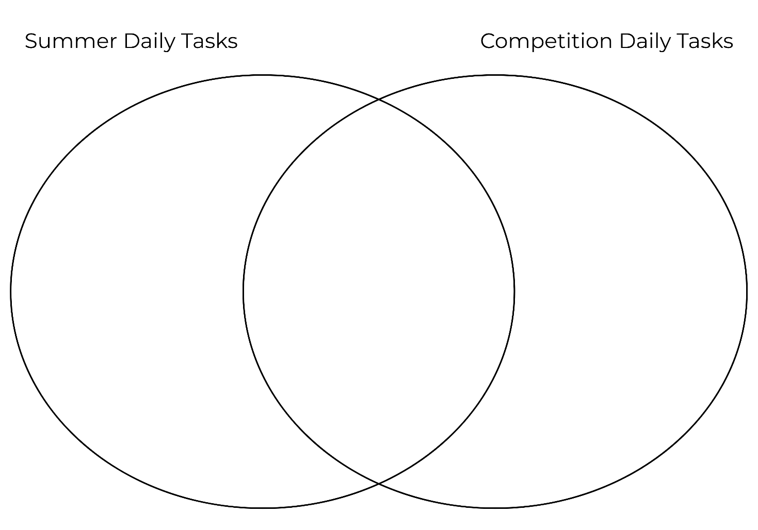

- Lucy mentions she wants to return to the family business after college. How might her experience and education in accounting benefit the future of her family’s operation?

- How does Lucy’s experience with draft horses reflect the purpose and value of having an SAE?



Part 2
Directions: Working in groups, research and create a mini-poster or digital slide about a specific draft horse breed that you are assigned. The information you need to research can be found below. Then, answer the questions at the bottom after seeing the other mini-posters or digital slides.

Each mini-poster or digital slide should include the following:
- Breed name and origin
- Key characteristics (height, weight, colors and markings, etc.)
- Historical and current uses of this breed
- Fun facts or famous examples
*Rubric is attached.

Breed Name: | Breed Origin:
Key Characteristics:  - Height range:  - Weight range:  - Colors:  - Markings:  - Any other characteristics: | Historical Use of This Breed:  Current Use of This Breed:
Two to Three Fun Facts or Famous Examples:

- Which draft horse breed did you find most interesting and why?

- List two ways the uses of draft horses have changed over time.

- What roles do draft horses still play in modern agriculture or society?

Rubric

Content Accuracy: Information is accurate and well-researched and includes the required details: breed name, origin, characteristics, historic and current uses and fun facts. | _______/5
Visual Presentation: Mini-poster or digital slide is neat, organized and easy to read. Text is legible. Two or three photos or visual elements are included and relevant. | _______/5
Creativity and Design: Mini-poster or digital slide shows effort and creativity in layout, color use and design. It is visually engaging and well thought out. | _______/5
Team Collaboration: All group members contributed equally to research, design and creation. Collaboration was respectful and effective. | _______/5
 | _______/20

