Aligned to the following standards: CS.01; CS.06; FFA.PL-A; FFA.PG-J; FFA.PG-K; FFA.CS-M; FFA.CS-N; FFA.CS-P; CCSS.ELA.RI.9-10.1; CCSS.ELA.RI.9-10.4; CCSS.ELA.W.9-10.1; CCSS.ELA.SL.9-10.1; CCSS.ELA.SL.9-10.4; CCSS.ELA.L.9-10.6; CRP.02; CRP.04; CRP.07; CRP.08
Appendix 6: A Sweet Opportunity
Part 1
Directions: Read the article “A Sweet Opportunity” in the fall/winter 2025 issue of FFA New Horizons and answer the questions below.

Quick Facts About Milton Hershey School (MHS) | 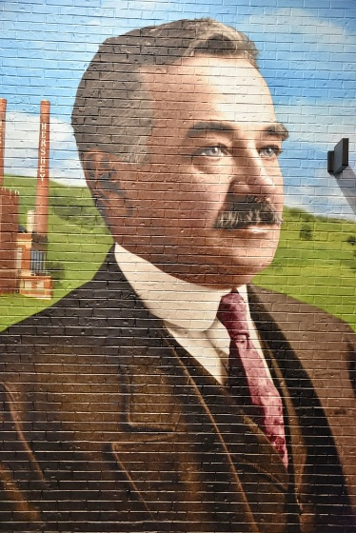
Who founded the school?
When was the school founded?
Where is the school located?
Why was the school created?

- List the four one-of-a-kind centers that are included in the Agricultural and Environmental Education program at MHS.

- List the extracurricular activities that are offered for pre-K through 12th-grade students at MHS. Then circle your top two favorites that interest you.

- Describe the growth in the MHS AEE program and why they believe the growth has happened.

- What are two things that stand out about the experience Kalena Williams-Ross had as a student at MHS?

- What are two things that stand out about the experience Logan Keister had as a student at MHS?

- How does the residential and community setting on the MHS campus support student success?

- Share one way that MHS benefits its surrounding community.

- Why do you think hands-on learning is emphasized at MHS?

- How do you think Milton Hershey’s legacy connects agriculture and education?

- What could other schools learn from MHS about integrating agriculture?

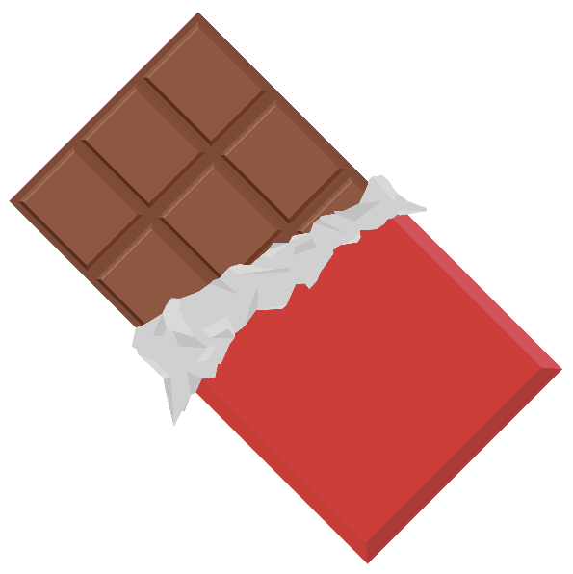

Part 2
Directions: Explore the process of making chocolate and the different ingredients needed for the three main types of chocolate: dark, milk and white. You will be assigned two sections from the chart below to answer. Then you will connect with other students who complete the other sections to learn from them and complete the chart.

Use this website to complete your sections below: https://www.lakechamplainchocolates.com/making-chocolate/

Cacao Cultivation  Draw a picture to match this step, and answer the questions on the right. | - Where does chocolate begin?  - What weather conditions are needed for a cacao  tree?  - What part of the fruits is cacao?  - Explain the difference between “cacao” and “cocoa.”
- What color are ripe cacao pods?  - How often are cacao pods harvested?  - How big are the seeds?  - What is the pulp of the pod called, and how was it used 3,000 years ago? | Harvesting  Draw a picture to match this step, and answer the questions on the left.
Fermentation  Draw a picture to match this step, and answer the questions on the right. | - What is left on the beans to help develop flavor?  - What color do the beans turn once exposed to light?  - What are the two methods of fermentation called?  - Describe what happens in both methods of fermentation:
- Explain how fermented beans are dried.  - What happens to the beans once they are dried?  - What does “direct trade” mean? | Drying and Shipping  Draw a picture to match this step, and answer the questions on the left.
Preparing Cocoa Mass  Draw a picture to match this step, and answer the questions on the right. | - Fill in the blanks of the steps that happen once beans are received by the processor.  - Beans may be ________________________ with other origins and estates.  - Beans are ________________________.  - Then they are __________________________ at low temperatures to develop _______________________.  - _______________ are separated from the _________ by a process called _____________________________.  - Nibs are finely ground into cocoa _____________ (a.k.a. cocoa liquor), which is solid at room temperature.  - Placed under extremely high pressure, this paste yields two products: _____________________________ ________________ and ____________________________ _________________________.
- What are the first steps to making chocolate?  - List the ingredients used in dark chocolate.  - What is added to the list above to create milk chocolate?  - List the ingredients used in white chocolate. | Producing Chocolate  Draw a picture to match this step, and answer the questions on the left.
Conching  Draw a picture to match this step, and answer the questions on the right. | - Explain what “conching” is.  - What is a “conche”?  - Why is this step important in the process?  - What two ingredients can be added in this step for required fluidity?
- What are “pistoles”?  - What is “tempering”?  - What happens to the cocoa butter during the tempering process? | Tempering and Moulding  Draw a picture to match this step, and answer the questions on the left.
Never-Ending Creativity
Draw a picture of your favorite way to eat chocolate.

- How does the chocolate-making process (from fermentation to tempering) demonstrate key principles of food science, such as chemical changes, preservation and quality control?

- Although cocoa is not typically grown in the U.S., what agriculture and food industry sectors in the U.S. could play a role in chocolate production?

Part 3
Directions: You will be completing a sensory evaluation on the three main types of chocolate: dark, milk and white. As you taste each chocolate, complete the sensory evaluation chart. Then, complete the questions that follow. You will discuss your answers with a partner.

Step 1: Taste one sample at a time.
Step 2: Use your senses — sight, smell, touch and taste — to evaluate and rate each attribute.
Step 3: Record observations in each column of the chart. Write short descriptions such as “smooth, glossy finish” or “creamy, vanilla aroma.”
Step 4: Repeat the process for each type of chocolate, using water to cleanse your palate between samples, if able.

Tips:
- Be descriptive: Use adjectives that describe sensory experience.
- Stay neutral: Taste with an open mind — even if it’s a type you don’t normally like.
- Use all senses: Look at the chocolate, smell it, feel the texture in your mouth, notice the flavor.

Dark Chocolate
Appearance (color, sheen, smoothness, etc.) | Aroma (strength, scent notes, etc.) | Texture (snap, melt, smoothness, etc.) | Taste (sweet, bitter, rich, etc.) | Aftertaste (lingering flavors, pleasant?) | Overall Rating  (1-5 stars)

Milk Chocolate
Appearance (color, sheen, smoothness, etc.) | Aroma (strength, scent notes, etc.) | Texture (snap, melt, smoothness, etc.) | Taste (sweet, bitter, rich, etc.) | Aftertaste (lingering flavors, pleasant?) | Overall Rating  (1-5 stars)

White Chocolate
Appearance (color, sheen, smoothness, etc.) | Aroma (strength, scent notes, etc.) | Texture (snap, melt, smoothness, etc.) | Taste (sweet, bitter, rich, etc.) | Aftertaste (lingering flavors, pleasant?) | Overall Rating  (1-5 stars)

- Which type of chocolate did you rate the highest and why?

- Were there any surprises in your evaluation compared to what you were expecting before the tasting?

- How do you think the ingredients influenced the taste and texture of each chocolate?

- If you were developing your own chocolate product to sell, which type of chocolate would you use and why?

